Upskill/Reskill Series - Livable Wage Jobs 501(c)(3)

Business Use Case:
Advanced Transportation Logistics and Distribution Warehouse Operations

Topics:
2 and 3 Dimensions; Longitude and Latitude; Logistics and Footprints; Planning and Constraints; Equipment and Supplies

This Work-Based Learning Content is designed for use or to be adapted for self-directed learning, workshops, workforce training, or project-based learning.

Livable Wage Jobs 501 (c)(3) supports exploring, practicing, and applying work-based learning focusing on livable wage job skill development. Our content is Creative Commons CC BY 4.0 attributed.

Reach out to us at LivableWageJobs.org/ with edits, ideas, or comments. Thanks, Kelly

Author: Kelly Cooper, EdD - KellyCooper@LivableWageJobs.org | Designer: Veronika Focht

Table of Contents
Advanced Transportation Logistics 3
Milestone 1 3
Introduction 3
Terms 4
Two-dimensional Isometric Objects 6
Three-dimensional Objects 7
Tasks 8
Terms 12
Latitude 12
Longitude 13
Tasks 14
Skechers Distribution Warehouse 15
GIS Decimal Representation 18
Warehouse Locations 20
Data Gathering 21
Milestone 1 Check-in 25
Milestone 2 26
Terms 26
Freight Shipping 26
Operational Costs 27
Images as Data 27
Tasks 29
Two-dimensional and three-dimensional objects 29
Terms 31
Cross-section 31
Two-dimensional cross-sections of three-dimensional objects 33
Generating three-dimensional objects by rotating two-dimensional objects 35
Milestone 2 Check-in 41
Milestone 3 42
Terms 43
Distribution warehouses 43
Warehouse Management 44
Tasks 49
Tinkercad Project 1 49
Terms 64
Staging, Storing, and Moving Pallets 64
Terms 69
Constraints 69
Constraints 72
Environmental Constraints 76
Milestone 3 Check-in 79
References 80

Advanced Transportation Logistics

Imagine a city with about 215,000 people and 41 million square feet (ft²) (approx. 3,808,000 m²) of warehouse space. That's a lot, right? In Moreno Valley, California, The World Logistics Center is a massive warehouse project that will take about 15 years to complete and will be the country's largest zero-emissions greenhouse gas project. The warehouse buildings will be 80 feet high (24.384 meters) with bridges connecting them. There will be large water features, daycare centers for workers' kids, electric bikes for employees, and many electric vehicle chargers. The project covers 2,610 acres (approx. 1057 hectares) (Olalde, 2021). The project developer, Highland Fairview, also built a 1.8 million ft² (approx. 164,225 m²) distribution hub for Skechers USA.

About 30 miles (48 kilometers) away, another company called Prologis is building a 4.1 million ft² (380,902 m²) warehouse for Amazon. This warehouse will have 97-foot-tall (29.57 meter) ceilings and will be almost as big as two 73-story hotel skyscrapers in downtown Los Angeles. The warehouse will be able to fit all of Disney's California Adventure theme park with 21 acres (approx. 8.5 hectares) to spare. The plan is to have 1,500 people working with robots to help sort, pack, and move products around the warehouse. These products will then be delivered all over North America by truck, train, and airplane.

The number of warehouses in the U.S. increased in the early 2000s because retailers needed places to store all the goods they were selling online. From 2020 to 2023, about 1.6 billion ft² (approx. 148,644,800 m²) of new warehouse space was built nationwide. Another 825 million ft² (approx. 76,647 m²) was developed in 2023. As more people shop online, retailers need even more giant warehouses. In 1990, the average warehouse size in Southern California was 143,000 ft² (approx. 13,277 m²). By 2023, that number had grown to 455,000 ft² (approx. 42,268 m²).

Milestone 1

Introduction

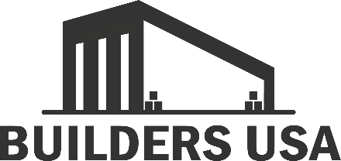

Builders USA is a wholesale company that buys equipment and supplies for building contractors and do-it-yourself homeowners and renters. Some equipment and supplies arrive from American states, and others are imported from international countries. Builders USA transports and sells their products to home centers like Home Depot, Lowes, Ace Hardware, and smaller hardware stores and lumber yards in California, Nevada, and Arizona. You will help gather data for a project to help the Builders USA team decide where to build a new distribution warehouse in Southern California.
Milestone 1 assesses The Port of Long Beach and compares how long it takes trucks to travel from the Port to two possible new distribution warehouse locations. You will use Google Maps and Google Earth to recommend one of two locations for the new warehouse. To prepare for this project, you will need to understand some terms related to project management, shipping, transportation, and mapping.

Terms

Builders USA brings in much of its power tools and building supplies from Asia and the Americas. These products are packed in cargo containers and transported on cargo ships. When the ships reach their ports, they are unloaded by port cranes. The picture shows how cranes unload containers at major ports worldwide.
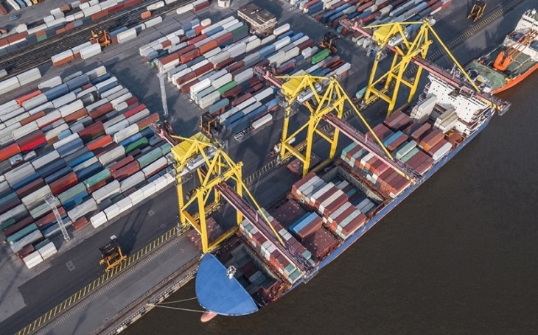

The containers are unloaded off the ships and loaded onto trucks. These trucks transport the containers to a distribution warehouse.

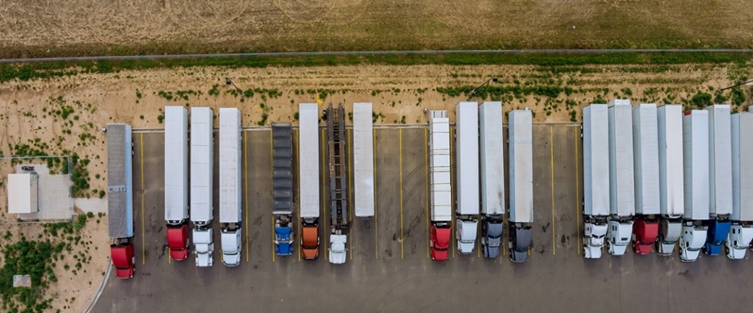

The container trucks drive to an assigned dock at the warehouse where pallets of products are unloaded. These pallets are then stacked and stored in the warehouse until it's time for them to be delivered to home centers and stores.

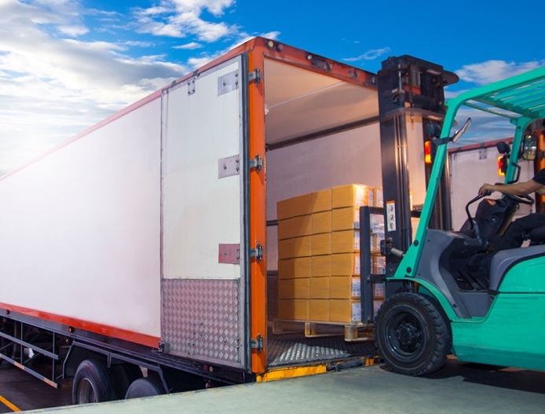

Two-dimensional Objects

Two-dimensional objects are flat shapes with two measurements: width and length. These measurements are shown on an x-axis and a y-axis. Two-dimensional objects don't show depth, which would be a z-axis.

Note: when we talk about more than one axis, we say "axes".

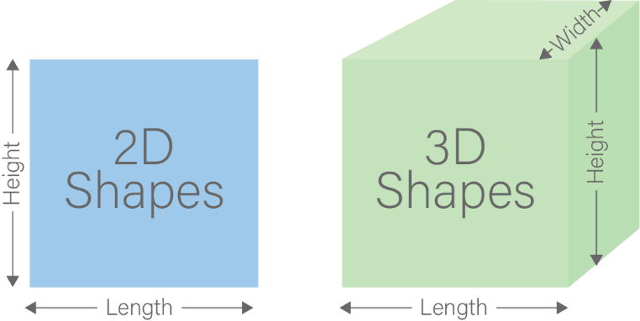

The image below shows a two-dimensional map of The Port of Long Beach, from a Google Map search. The Port of Long Beach is the nearest port to the Builders USA distribution warehouse options.

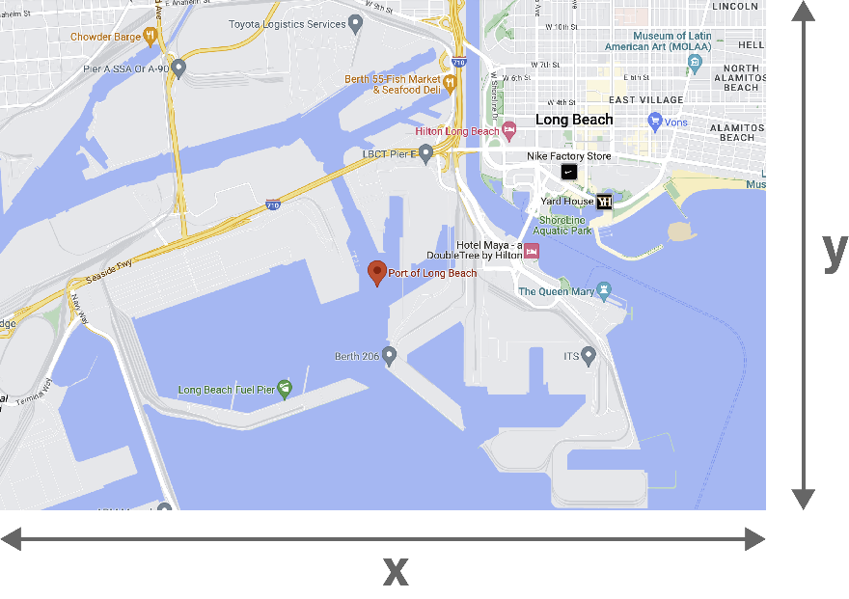

Two-dimensional Isometric Objects

Two-dimensional isometric objects are two-dimensional objects that look like they have depth. You might have seen them in video games. Isometric drawings show two-dimensional objects at 30-degree angles.

The next images look three-dimensional because they give you a feeling of width, length, and depth. But they're actually two-dimensional images that use color, shadow, and perspective to look three-dimensional. For Builders USA to make important decisions about their warehouse, isometric illustrations don't show the x-, y-, and z-axes clearly enough to help plan or run a business.

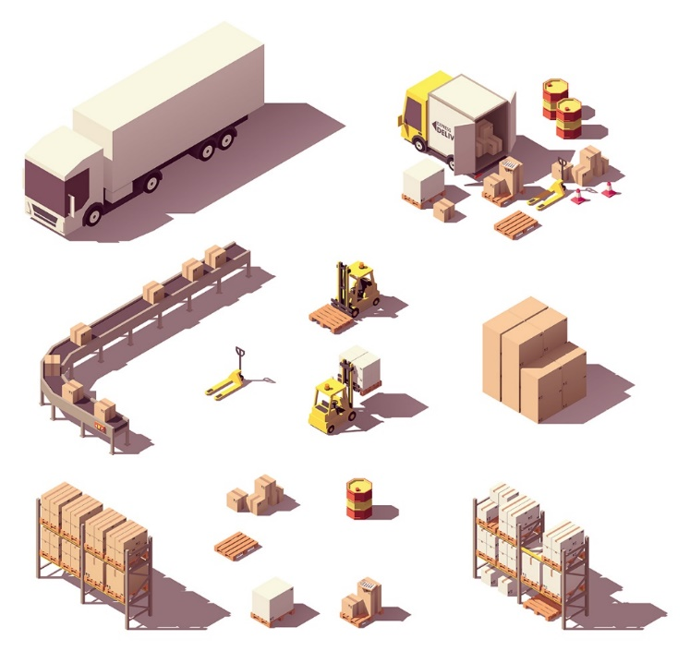

The next image show a simple two-dimensional isometric image on the left and its angles on the right.

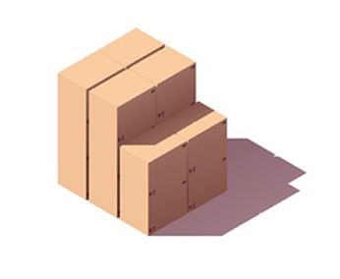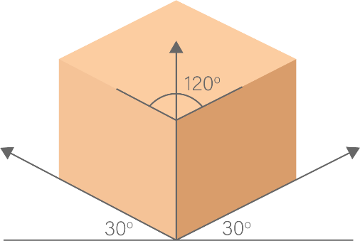

In the image below, do you notice that you look toward the images from the same angle as the previous image?

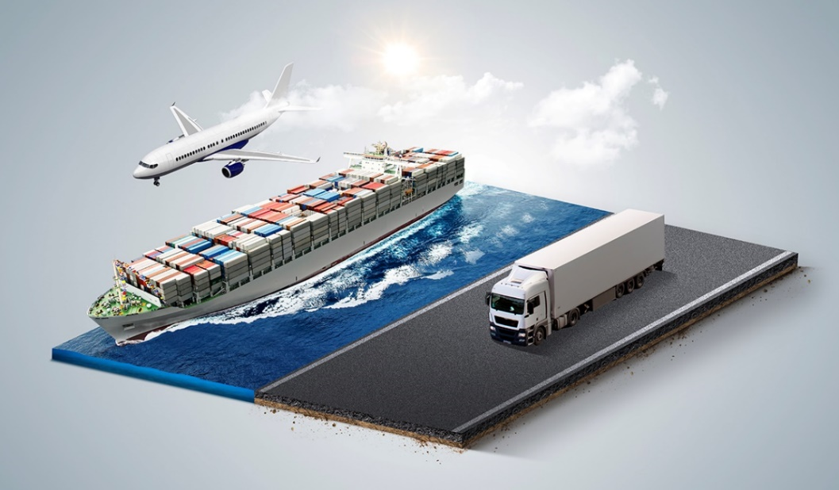

Three-dimensional Objects

Three-dimensional objects show width, length, and depth, which are the x-, y-, and z-axes. The Port of Long Beach photo below is a three-dimensional map. The map gives a basic idea of depth through layers of sea, port, highway, etc. Three-dimensional images can be looked at and understood from all sides and angles.

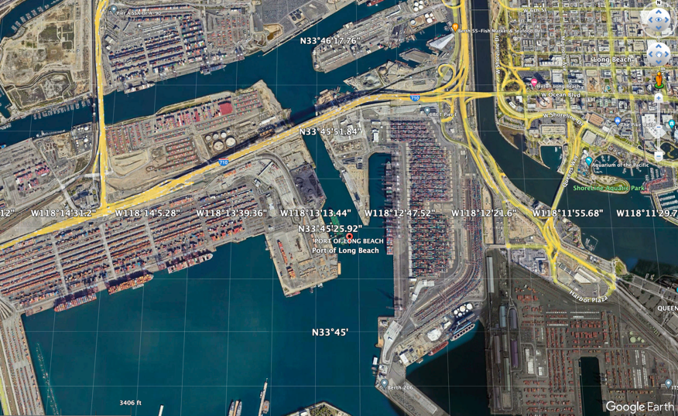

If you zoom in closer to view the cargo containers, you can see some depth.

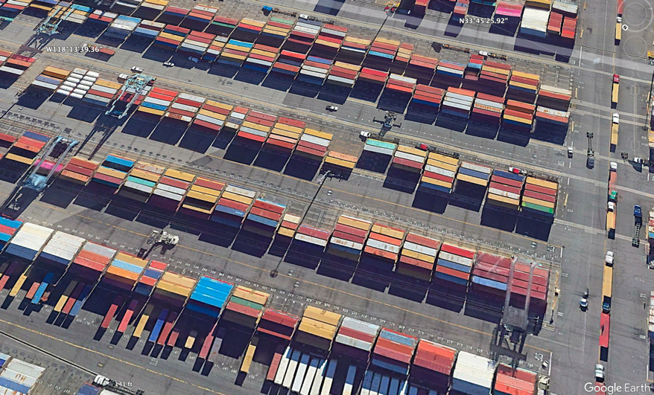

Tasks

Review the following images and identify which are two-dimensional, two-dimensional isometric, and three-dimensional. Identify the width (x-axis), length (y-axis), and depth (z-axis) of one object in each image.
Task 1

Examples

Three-dimensional image

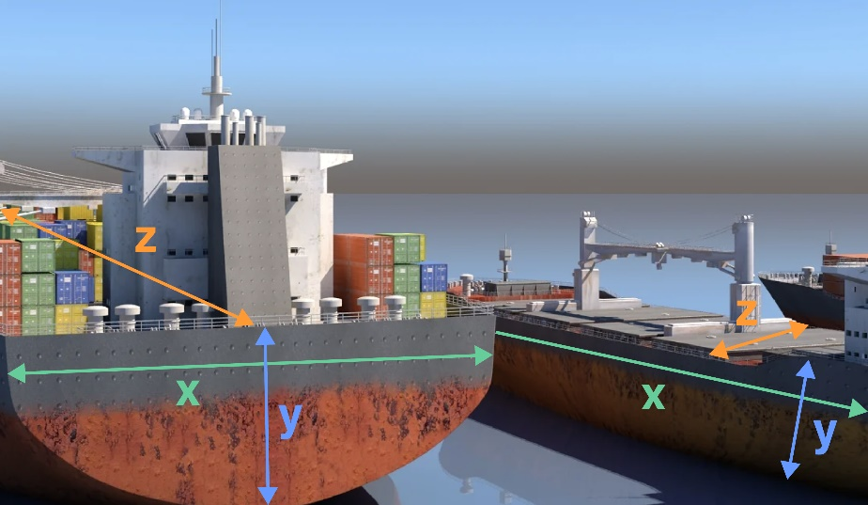

Two-dimensional isometric | Two-dimensional image
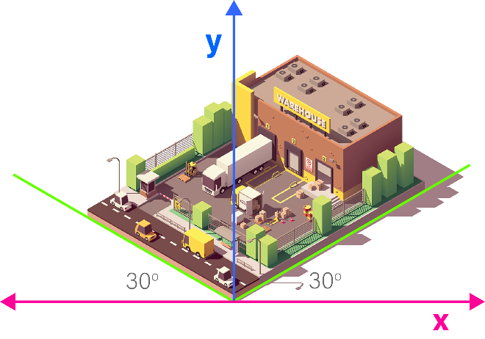 | 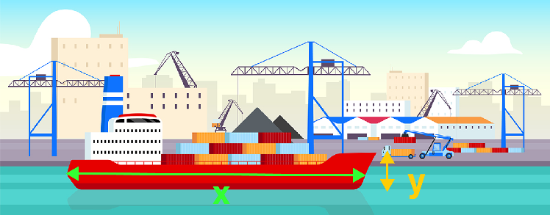

Your turn

How would draw in the width (x-axis), length (y-axis), and depth (z-axis) (if there is a z-axis) in the following images?

IMAGE 1 | 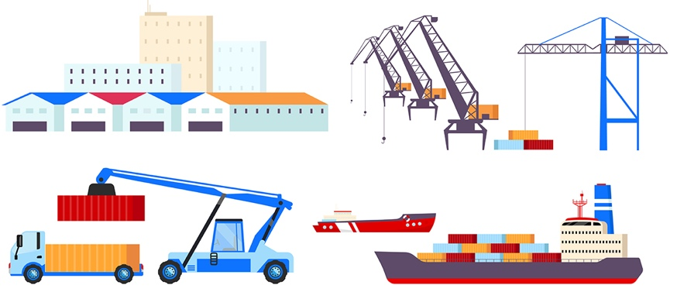
IMAGE 2 | 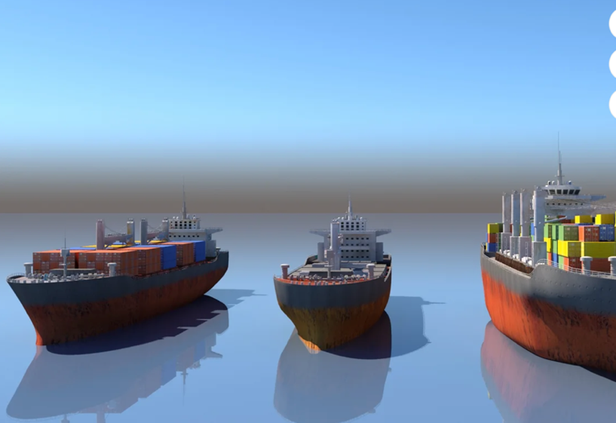
IMAGE 3 | 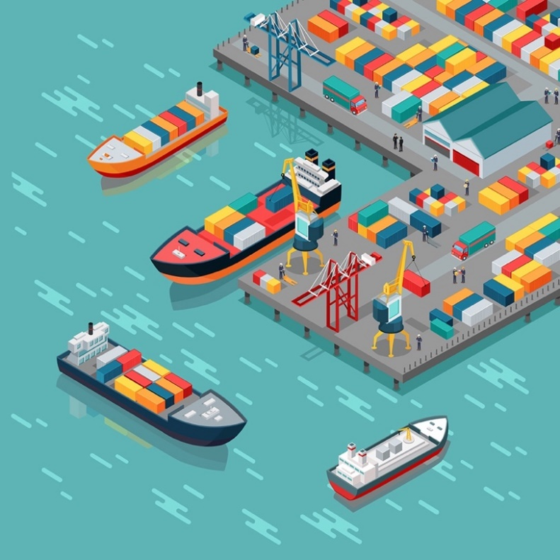
IMAGE 4 | 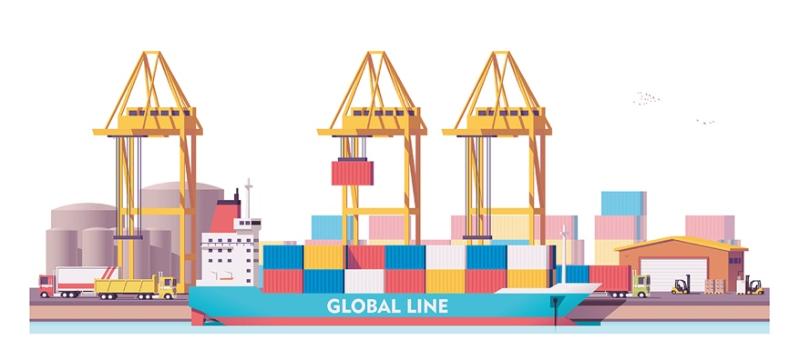
IMAGE 5 | 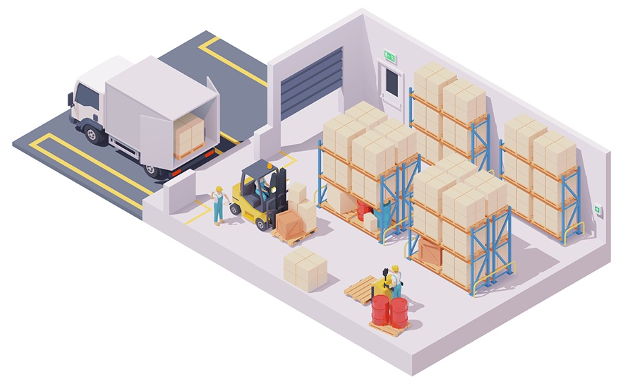

Builders USA uses a mix of 2D and 3D images to guide informed decisions. In simpler terms, imagine you're choosing the fastest route to your friend's house. A flat map (2D) helps, but a map showing hills, valleys, and buildings (3D) would give you a better idea of what to expect. That's why Builders USA uses both types of images when planning distribution warehouses.

Curious about the current statistics of cargo containers (amazing data) at The Port of Long Beach? See this link: https://polb.com/business/port-statistics/#latest-statistics for impressive logistics.

Note: Milestone 1 involves terms that may be new to you. There's no need to memorize them; you'll see how they inform Builders USA distribution warehouse location plans as you work through the milestone. | 

Terms

GIS | Geographic Information Systems, or GIS, are computer programs that help you store, see, analyze, and understand geographic data. Think of GIS like a super-smart map combining different data types and showing them all at once.
GPS | Global Positioning Systems, or GPS, help you find the exact location of things. A GPS unit is like a radio that picks up signals from satellites. These satellites send signals to GPS units on the ground. GPS units need a clear view of the sky to work well.
GIS or GPS? | GIS and GPS are different in how they collect data. GIS is used for making maps and analyzing geographic data. GPS helps you to navigate to locations.
Geographic data | The series of standards that help to identify a location's position relative to Earth.
Latitude and Longitude | The units of the geographic coordinate system that measure and communicate positions on the earth, using latitude and longitude.

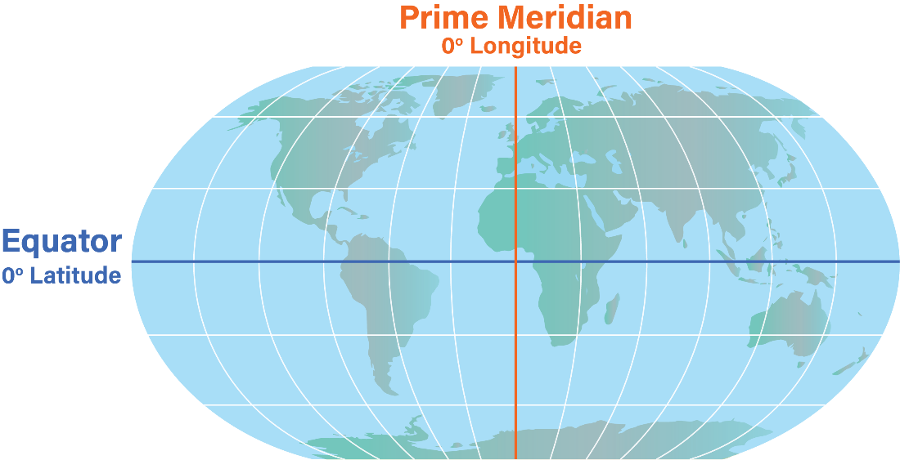
Latitude: negative coordinates
Longitude: positive coordinates
Latitude: negative coordinates
Longitude: negative coordinates
Latitude: positive coordinates
Longitude: positive coordinates
Latitude: positive coordinates
Longitude: negative coordinates

Latitude

Lines of latitude are like invisible belts that wrap around the Earth from east to west. They help determine how far north or south a location is from the Equator. Imagine the Equator as the starting line, marked as 0°. As you move towards the North or South Pole, the latitude number increases to 90° degrees. If you're trying to find out where your warehouse is on the globe, you can use these lines of latitude. The bigger the latitude number, the closer your warehouse is to the North or South Pole.

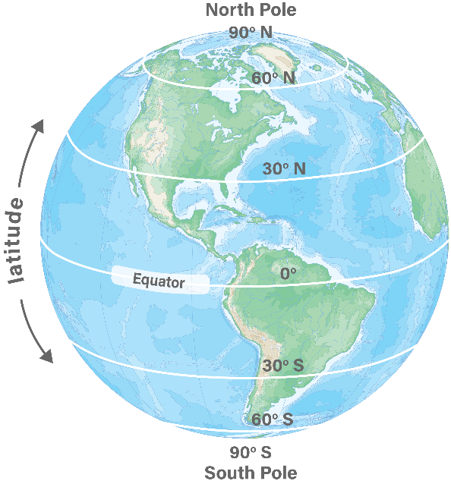

If the latitude value is positive, the location is in the Northern Hemisphere (half of the Earth above the equator). If the latitude value is negative, it's in the Southern Hemisphere (half of the Earth below the equator).
These lines of latitude are also known as parallels. They're like rings around the Earth, each about 69 miles (or 110 kilometers) apart from the next. So, if you were to travel from one line of latitude to the next, you'd be going about 69 miles!
When talking about latitude, you use a special system of measurement with degrees (°), minutes ('), and seconds ("). For example, you might say that a city is located at 40 degrees, 30 minutes north latitude, to be precise about where a place is located.

Longitude

Longitude lines differ from latitude lines because they run from the North Pole to the South Pole. They tell you how far east or west you are from a special line called the Prime Meridian. The Prime Meridian is the line of 0° longitude, and it runs through Greenwich, England. Lines of longitude are called meridians and meet at the North and South Poles. There are 360° degrees of longitude (+180° east of the Prime Meridian and -180° west of the Prime Meridian).

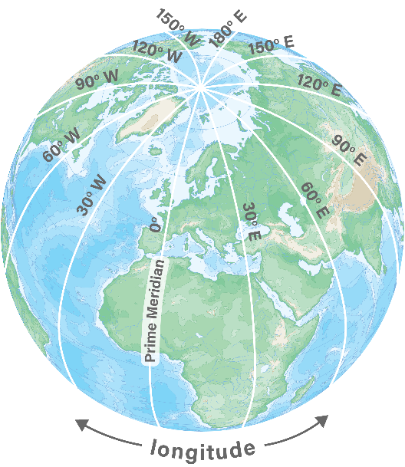

Lines of longitude cross the equator - the imaginary line around the middle of the Earth - at right angles. This means they cut across the equator at a 90-degree angle. All the lines of longitude are the same length, and each one is half of a circle.
Locations east of the zero line have a positive longitude. Locations west of the zero line have a negative longitude. There are 360 degrees of longitude from 180° east to 180° west of the zero line.
A location's place on Earth is shown using lines called lines of longitude. Longitude is measured in degrees (°), minutes ('), and seconds ("). Degrees tell how many degrees east or west a place is from the zero line.

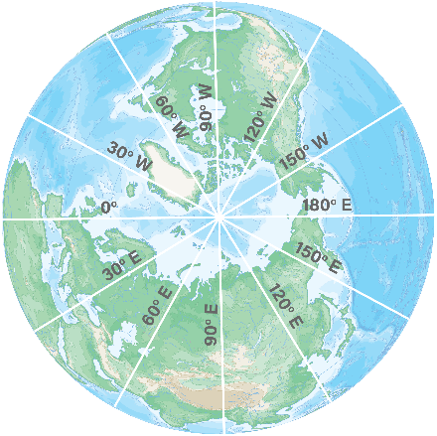

Tasks

Your role is to provide a series of images, with documentation, using Google Maps and Google Earth, that will contribute assessing transportation logistics between The Port of Long Beach and the Builders USA distribution warehouse potential locations.

Milestone 1 begins with Google Earth.

 | You can use Google Earth without a Gmail account; however, to save your work, you will need one. The link to set up a Gmail account is https://accounts.google.com/signup  With your Gmail account open, key this link into a new browser window to launch Google Earth: https://earth.google.com/web/  Your Google Earth may look different because they change the interface; however, you'll create a project and be able to navigate the maps and symbols regardless of the look and feel of the web or app page.

Task 1

Skechers Distribution Warehouse

This task, a Skechers distribution warehouse, mirrors the steps for your Unit 1 deliverable (think of it as a practice run).

The Skechers USA 1.8 million ft² distribution warehouse, located in Moreno, California, sits on approximately 85 acres (approx. 34.4 hectares). The building is more than 40 acres (approx. 16 hectares) in size and was awarded a Leed Certification Gold by the U.S. Green Building Council for being environmentally friendly (a big deal accomplishment). | 
The Skechers warehouse address is:

29800 Eucalyptus Avenue
Moreno Valley, CA 92555

It's common for street addresses to not provide enough information for clients before a building is built. Often, street addresses don't exist in early stages of property development. In the US, an Assessor Parcel Number (APN) is used. GPS and GIS are used internationally to identify exact locations anywhere in the world (land or sea).

In Google Earth key:

29800 Eucalyptus Avenue
Moreno Valley, CA 92555

View the Skecher's Distribution Center. First, as a two-dimensional image (in the bottom right legend, toggle between two- and three-dimensional).

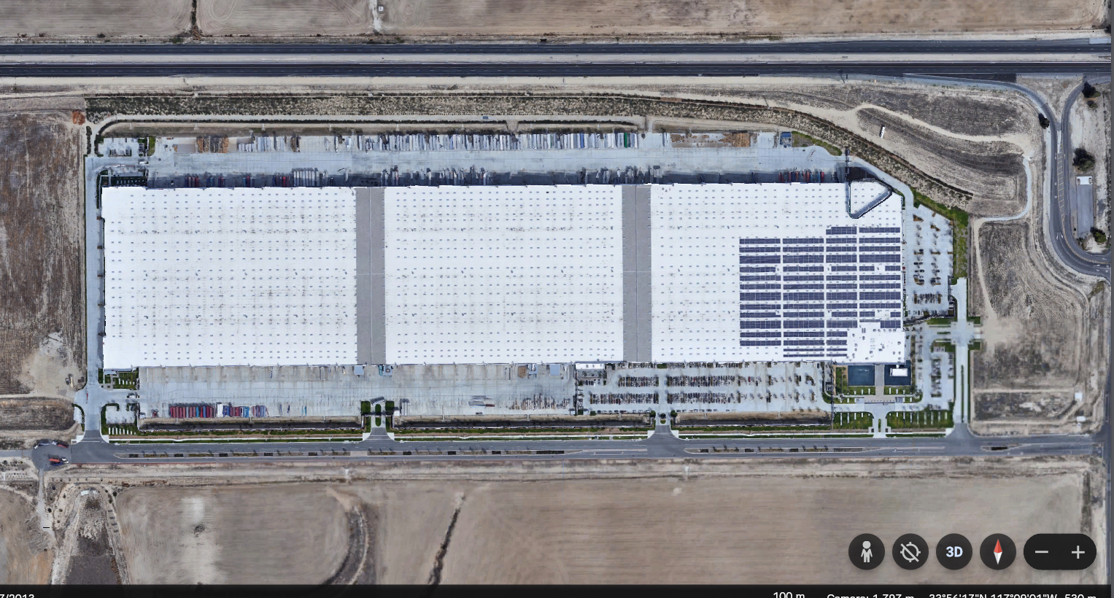

Next, as a three-dimensional image.

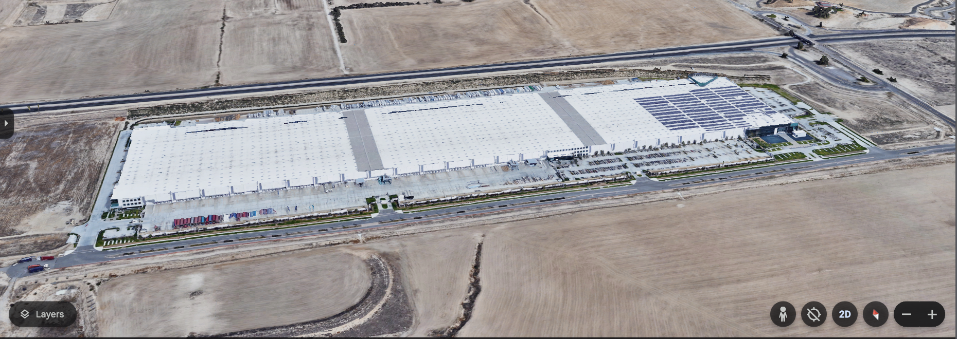

In the bottom-right corner, are the latitude and longitude

If you click into the warehouse and move your mouse around the screen, the numbers that show where you are on the map change. This is because those numbers tell you the exact spot on the ground below your mouse. The numbers use degrees (°), minutes ('), and seconds (") to show how far north or south and east or west you are from a starting point.

On the left side of the screen, you can see icon Layers, which upon clicking it gives you various options to choose how you want to view the location either with or without borders, labels, roads, etc.



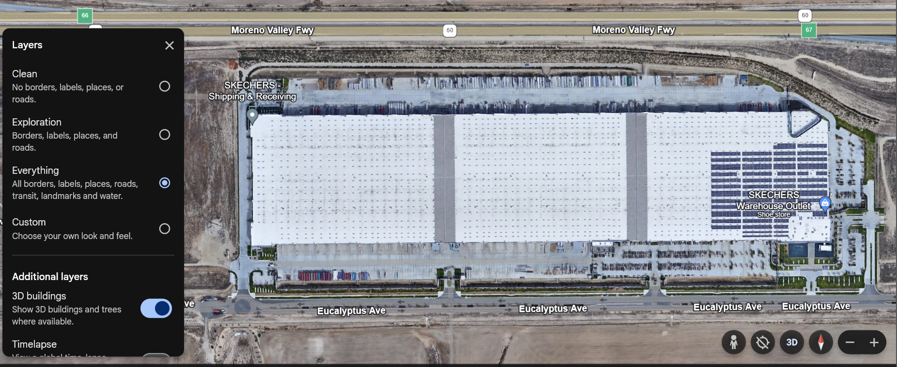
The legend area of your screen shows several icons.


Icons explained:
 | Zoom in and out.
 | Show your location.
 | Select and drag to enter street view and look around. Select < or > arrows to pivot around.
 | Tilt your view between 2D and 3D.  Click to reset the view.
 | Compass tracking as you fly around your location.
The legend at the bottom of your map offers:
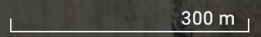 |  | Scale bar, the ground length of the line shown is 300 meters (984.3 feet).
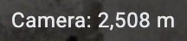 |  | Height from earth for the current camera is 2,508 meters (8,228.3 feet).
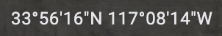 |  | Coordinates of the point on the ground directly below your cursor.
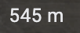 |  | Elevation above sea level of the point on the ground directly below your cursor is 545 meters (1,788 feet).

Although Google Earth shows a lot of details about locations, it's mainly thought of as a GPS program to help you find directions. If you're interested in learning more about GIS, please see the following National Geographic article:
https://education.nationalgeographic.org/resource/geographic-information-system-gis/

Task 2

GIS Decimal Representation

In addition to writing latitude and longitude as degrees (°), minutes ('), and seconds ("), also called DMS, latitude and longitude are presented as decimal degrees (DD). DD are used in programs that help make maps on computers and phones.

Latitude and longitude normally show the location of places on Earth. Degrees, minutes and seconds tell the exact position in a more complex way. Decimal degrees show latitude and longitude as a single number, making it easier to use in mapping apps. Programs that create maps need latitude and longitude to put places in the right spot. Using decimal degrees instead of DMS is simpler for mapping programs to understand your work. Keep in mind:

Positive latitudes are north of the equator.
Negative latitudes are south of the equator.
Positive longitudes are east of the Prime Meridian.
Negative longitudes are west of the Prime Meridian.

You will convert locations from DMS to DD because the DD format is most useful for this business use case project.

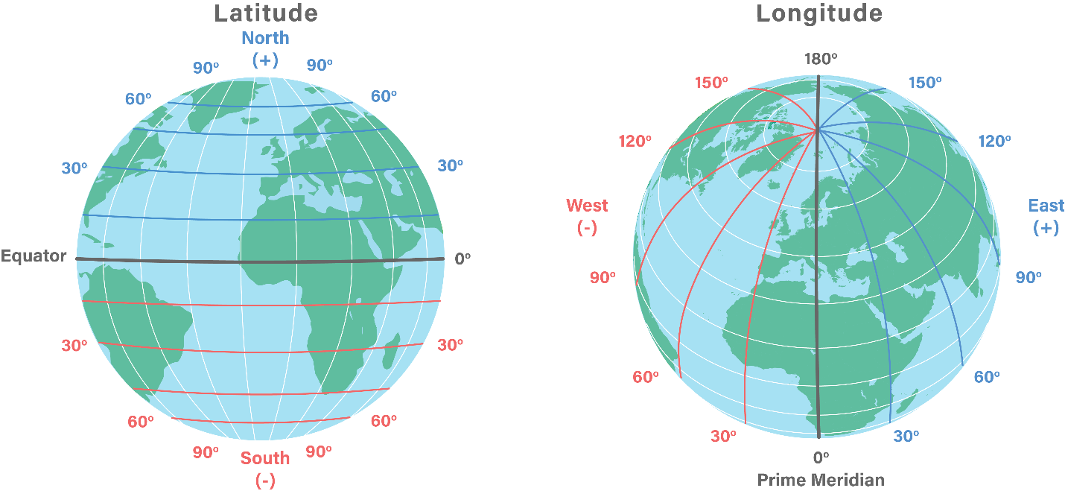

You will use the U.S. Federal Communications Commission (FCC) website to convert latitude and longitude from degrees, minutes, seconds (DMS) to decimal degrees (DD).
Please go to the website:

https://www.fcc.gov/media/radio/dms-decimal

where you will see a web form to perform the conversion for you.

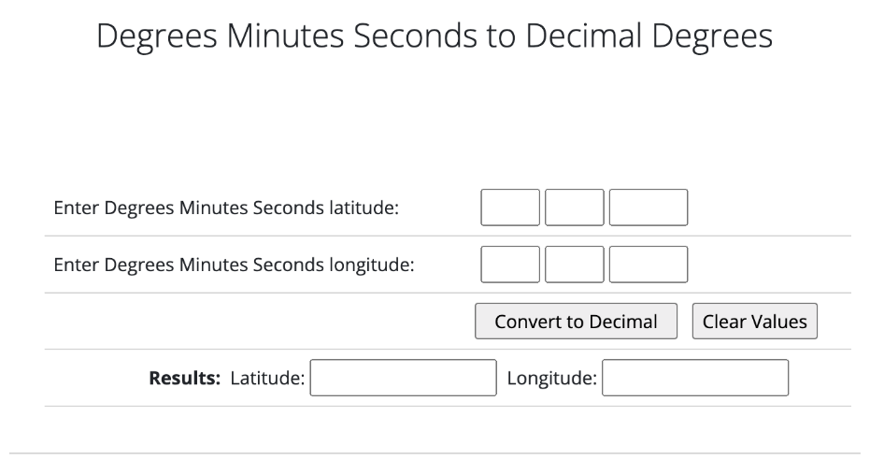

With an address in numbers, people can communicate no matter what language they speak or what directions are given.

Note: The form has a max character count - your seconds may be 3 decimal places rather than 4.

  - Key the DMS from the Skecher's Warehouse into the FCC site Degree Minutes Seconds (DMS) to Decimal Degrees (DD).
  - Enter Degrees Minutes Seconds latitude (tab between text fields).
  - Enter Degrees Minutes Seconds longitude.

What is the DD for the Skecher's Warehouse?
__________________________________________________________________________

Task 3

Warehouse Locations

Here are the locations of the three warehouses you will assess. The first two are Milestone options, the third is for a separate upcoming question on comparing locations.

33°55'30" N -117°07'30" W - World Logistics Center (option for Builders USA)
33°59'12.5" N -117°37'48" W - South Ontario Logistics Center (option for Builders USA)
33°59'12.87" N -117°36'56" W - Amazon Warehouse (comparison example)

1. Identify the DD (decimal degrees) for the DMS of each location

World Logistics Center (option for Builders USA)
__________________________________________________________________________

South Ontario Logistics Center (option for Builders USA)
__________________________________________________________________________

Amazon Warehouse (comparison example)
__________________________________________________________________________

2. Also, identify the DD (decimal degrees) and name a few more locations

33°45'4.6980" N -118°11'19.7232" W _____________________________________________
33°48'45.0396" N -117°55'8.3136" W _____________________________________________
33°56'36.6972" N -118°24'31.1868" W _____________________________________________
33°56'13" N -117°08'54" W _____________________________________________

Task 4

Data Gathering

Data gathering, also called data collection, is when you gather information from sources in an objective, unbiased manner toward reaching a conclusion that supports your goal.

Decisions on where to purchase or lease a warehouse are often made years before building begins. Architects and engineers design the building's exterior (outside) and interior (inside) based on their client's priorities. Your next step is to get information to help you know how long it takes to transport products from the Port of Long Beach to the proposed distribution warehouse locations.

STEP 1 | Open Google Maps, https://maps.google.com/

STEP 2 | Set your starting location (top left textbox) as:
33.751305, -118.188812
STEP 3 | Select Directions and add your destination.
33.925, -117.125
STEP 4 | You may need to use the direction arrows, immediate right from the textboxes, to indicate changes in direction.
You will see a map starting from The Port of Long Beach and ending at the World Logistics Center. The route distance is around 80 miles (approx. 129 kilometers). The travel time depends on the day of the week and time of day you enter this data. Los Angeles Metropolitan Area traffic, like many major city centers, is intense. Here is a Saturday afternoon expected travel time. A day/time with minimal commute traffic:
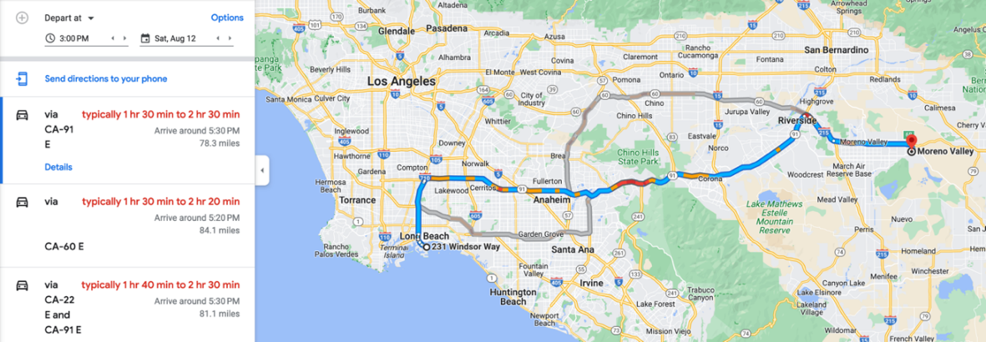
The range of expected travel is an expensive consideration. A range from 1 hour 30 minutes (90 minutes) to 2 hours 30 minutes (150 minutes) is 90/150 = a potential 60% increase in travel time. Reversing directions, from the warehouse to the port changes recommended freeways and maintains a wide time range. These data suggest both directions need further analysis.
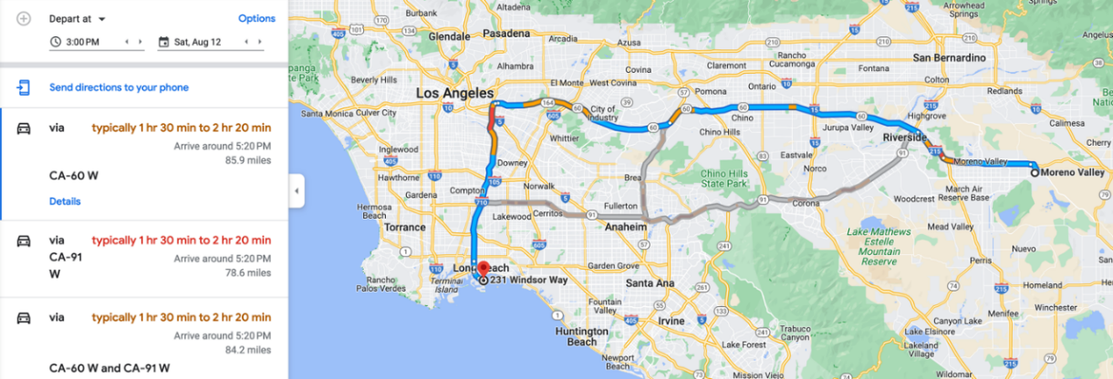

STEP 5 | To change the day and time of travel in Google Maps, select the Depart at dropdown menu below the locations you entered, and enter a day and time you want to assess.
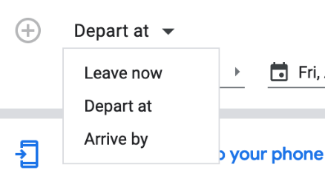

Your Turn

Using Google Maps, create a table that details the travel times from:

- The Port of Long Beach to the World Logistics Center (option for Builders USA)

Day/Time | Eastbound | Westbound
 | Port to World Logistics Center | World Logistics Center to Port
Tuesday at 10:00 AM
Tuesday at 7:00 AM
Friday at 5:00 PM
Friday at 7:00 PM

How many different routes were mapped for the times above?
__________________________________________________________________________

Using Google Maps, experiment to identify two days/times where traffic appears light and then two days/times where it appears heavy. Note times for each.

Day/Time  (2 light, 2 heavy) | Eastbound | Westbound
 | Port to World Logistics Center | World Logistics Center to Port

- The Port of Long Beach to the South Ontario Logistics Center (option for Builders USA)

Day/Time | Eastbound | Westbound
 | Port to South Ontario Logistics Center | South Ontario Logistics Center to Port

How many different routes were mapped for the times above?
__________________________________________________________________________

- The Port of Long Beach to the Amazon Warehouse (for comparison)

Day/Time | Eastbound | Westbound
 | Port to Amazon Warehouse | Amazon Warehouse to Port

How many different routes were mapped for the times above?
__________________________________________________________________________

Milestone 1 Check-in

Critically assess and discuss the following Milestone 1 questions:

- What are two primary logistics concerns you have currently for Builders USA transporting from The Port of Long Beach to the World Logistics Center location?
__________________________________________________________________________
__________________________________________________________________________

- How are your logistics concerns similar or different in assessing transporting from The Port of Long Beach to the South Ontario Logistics Center?
__________________________________________________________________________
__________________________________________________________________________

- The massive Amazon Warehouse is not far from the South Ontario Logistics Center. According to your data, do they face similar logistics challenges? To invest in a 4.1-million ft² warehouse in Ontario, with 97-foot-tall ceilings, must have been driven by data. In reviewing the area with Google Earth and Google Maps, what types of business considerations do you think Amazon may have developed or measured to determine this size of investment?
__________________________________________________________________________
__________________________________________________________________________

- Based on the Milestone 1 Check-in Meeting, what additional logistics data might you explore and incorporate into your recommendation?
__________________________________________________________________________
__________________________________________________________________________

Milestone 2

In Milestone 2, Your Google Earth mapping of location and Google Maps mapping of traveling routes and times will combine with logistics to support a Builders USA location recommendation.

Terms

Freight Shipping

Calculating freight rates is a complex balance of efficiency (saving time) and profitability (making money). Key to efficiency and cost are five basic freight shipping methods:

Full truckload  (FTL) | When an entire truck is used for a single shipper's cargo resulting in direct origin to destination shipments and shorter transit times. Freight typically exceeds 15,000 pounds (6,804 kilograms).
Partial truckload  (PTL) | When a load doesn't fill up a container, carriers take on multiple shipments to earn more per mile and maximize their earnings per trip. Freight loaded onto a truck stay on board until its final delivery destination. PTLs are charged per mile, pro-rated by weight and dimension.
Less than truckload  (LTL) | Like PTL, except, the shipment might be loaded onto multiple trucks across the shipping process.
Intermodal | Involves multiple shipping methods. For example, rail and road.
Expedited | Direct routes, overnight or express shipping and more expensive delivery.

Operational Costs

Traffic jams, gas prices, and inflation make transportation more expensive. When there is a lot of traffic on the highways, it costs billions of extra dollars each year to move freight from place to place. Truck drivers, who move over 70% of all goods in the United States, sit in traffic for over 1 billion hours yearly. They only go about 36 miles per hour (approx. 58 kilometers) on average during rush hour—traffic jams waste fuel and release pollution into the air as more carbon dioxide (Business Insider).

Images as Data

So far, you collected data on truck traveling time and explored two-dimensional and three-dimensional images to help Builders USA plan warehouse options.

Imagine the amount of information required to build an efficient and profitable warehouse, from unloading products at The Port of Long Beach to transporting different combinations of products through the distribution warehouse and then to home centers. This image shows one row of 106 containers on a cargo ship, not counting what's below deck or on the rest of the ship. Consider the size of each container you've seen driving on the road and how much freight each holds in its 2,390 cubic feet (67.7 cubic meters) of space.

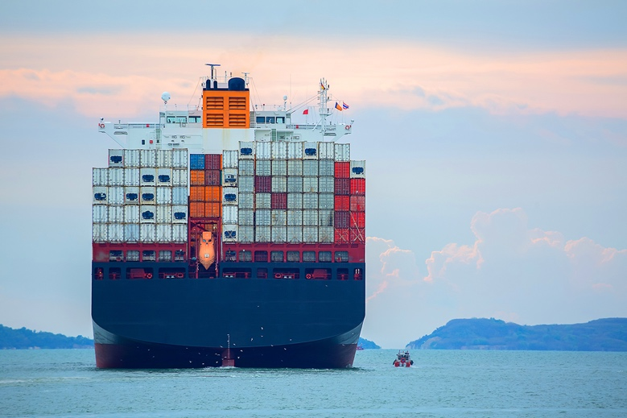

The average number of containers on a cargo ship is approximately 15,000. Small ships may hold 600 containers and massive ships over 20,000.

The planning information needed to build a large distribution warehouse includes a combination of maps, blueprints, building code requirements, and more, all of which are a mix of two-dimensional and three-dimensional images. Consider this data:

- An average Walmart is 106,000 ft² (approx. 9,842 m²), with a Walmart Supercenter at an average 182,000 ft² (approx. 16,909 m²).
- An average Target is 130,000 ft² (approx. 12,077 m²).
- A 1 million ft² (approx. 92,903 m²) distribution warehouse is 7.69 Targets under one roof.

The Skechers distribution warehouse described in the use case is 1.8 million ft² (approx. 167,225 m²) and the Amazon distribution warehouse is 4.1 million ft² (approx. 380,902 m²). That's Sketchers at 9.89 and Amazon at 22.5 Walmart Supercenters under one roof. Add with 80-97 foot (approx. 24-29.6 meter) ceilings and you can see the impossibility of changing a warehouse interior or layout after construction is complete.

Warehouses are air-conditioned/heated spaces (called conditioned spaces). Industrial vacancy rates (availability of warehouse space) continue to be at an all-time low. Considering Los Angeles at a minimum of $15 per ft², a poorly planned too-wide warehouse aisle, with only 2' wide and 100' long unused space costs Builders USA $3,000 a month with no return because no work is happening in the unused space. And that cost is before conditioning.

For all warehouses, of all types, in all industry sectors, a top priority is

Maximize the Cube!

Why is this important? Maximize the Cube! refers to what is packed into every cargo ship (it's a cube) loaded with containers (cubes again) arriving at The Port of Long Beach. The warehouse dimensions (another cube) and every storage rack in the warehouse with loaded pallets are cubes.

Planning for warehouse efficiency means planning in two- and three-dimensional shapes to include cross-sections. Let's identify relationships between:
1
2

3
two-dimensional and three-dimensional objects

two-dimensional cross-sections of three-dimensional objects

three-dimensional objects generated by rotations of two-dimensional objects

Tasks

Task 1

Two-dimensional and three-dimensional objects

The top-view of a cargo ship below, moored at the Port of Long Beach is a two-dimensional object. The x-axis (width) and y-axis (length) are visible; the z-axis (depth) is not.

Please draw the x-axis and y-axis on the photo.

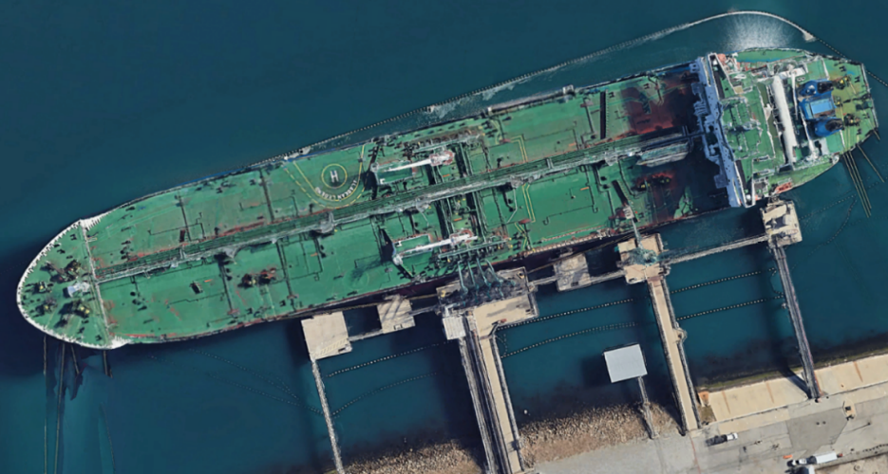

Below, is a series of three-dimensional images.

Please draw the x-axis (width), y-axis (length), and z-axis (depth) on each.

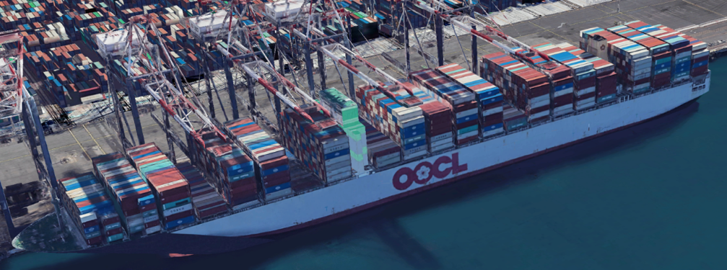

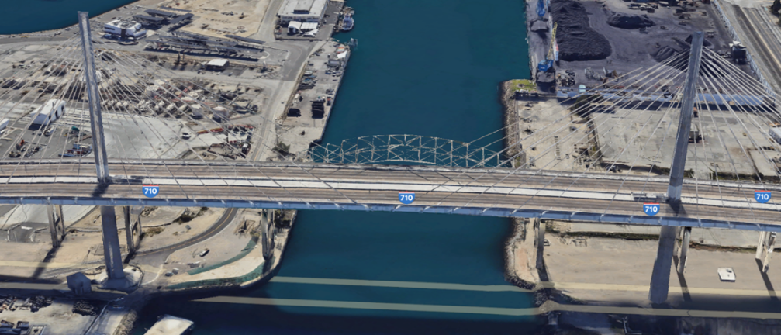

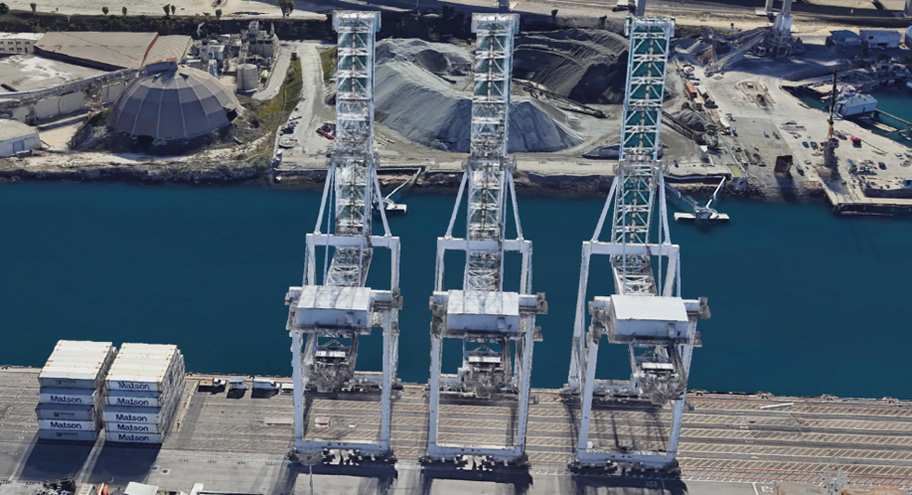

Three-dimensional objects can be used to generate two-dimensional objects. This face of the three-dimensional object below is a two-dimensional object with an x-axis (width) and y-axis (length).

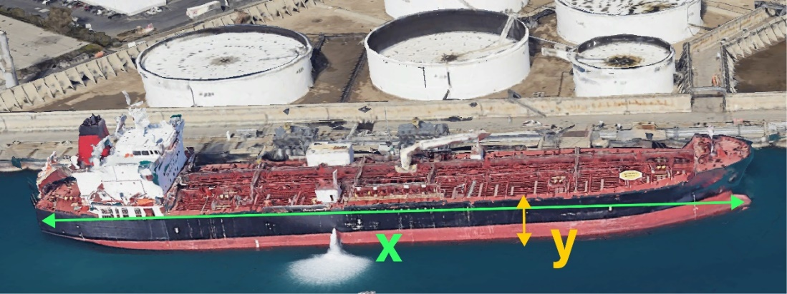

Please outline the two-dimensional face of the following three-dimensional images and label the
x-axis and y-axis.

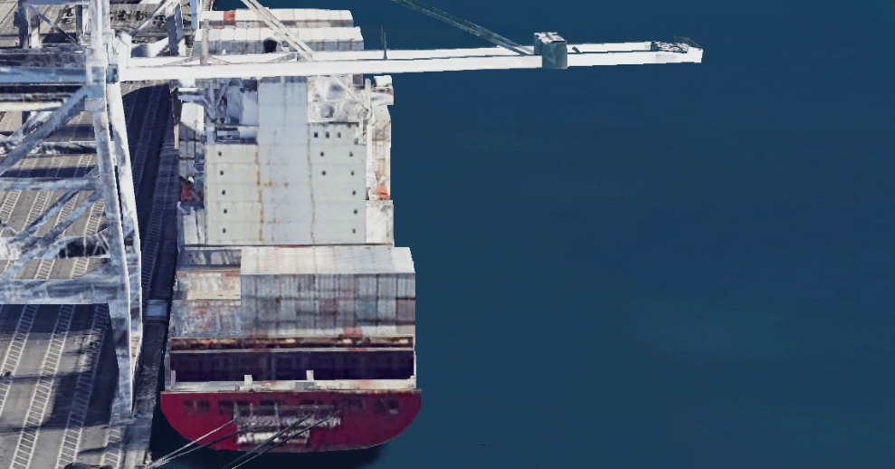

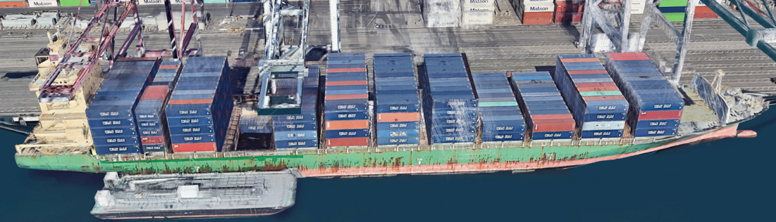

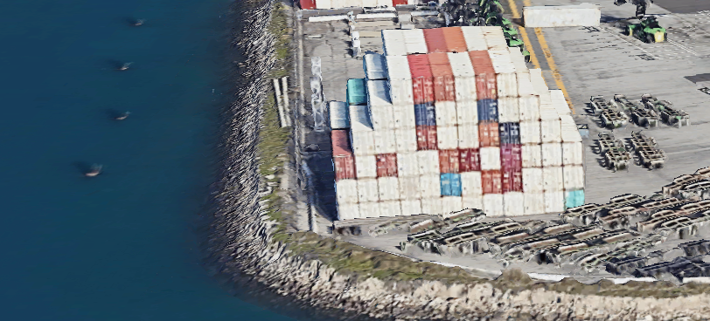

In addition to providing the Builders USA with images that inform company priorities, in Milestone 2, you will create two-dimensional cross-sections of three-dimensional objects and three-dimensional objects generated by rotating two-dimensional objects.

Terms

Cross-section
A cross-section of an object is the intersection of that object with a plane (think of a slice of the object). Generally, a cross-section cuts off at a right angle to an axis (cuts straight through the object). The cross-section can be an angled slice. The following image shows a cross-section of a container, looking from inside the container out toward another container.

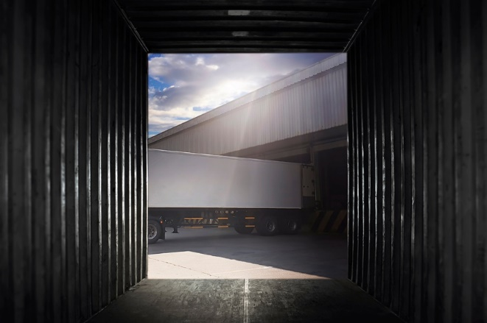

The lines in the next image represent the 'slice' that creates the cross-section.

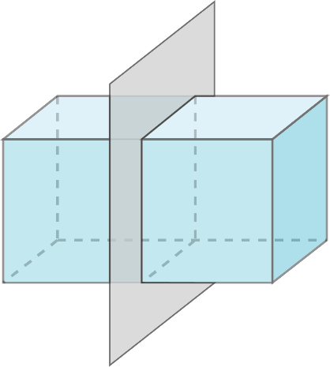

The following cross-section image displays most of the inside of a cargo container with the cross-section defined above added in.

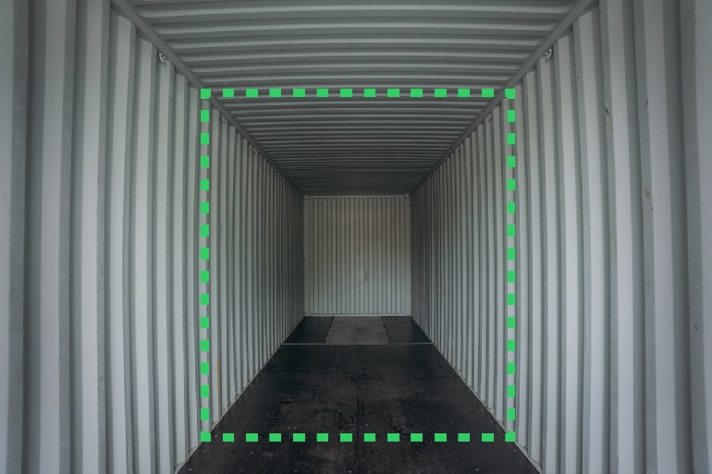

A cross-section of the same container can take multiple forms:


Horizontal
cross-section
Vertical
cross-section
Cross-section at another angle

Which appear as:
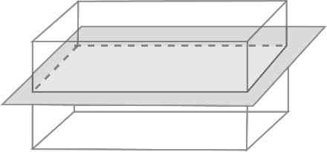 | 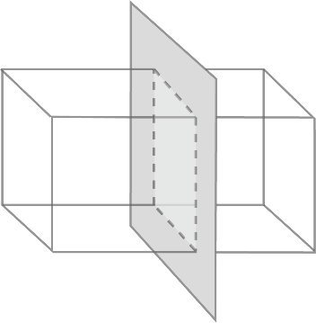 | 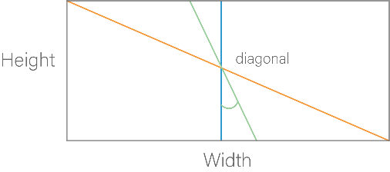
Your intent in utilizing two-dimensional objects, three-dimensional objects, and cross-sections is to inform Builders USA on space and equipment shape and size. In other words, your data will inform Builders USA how to Maximize the Cube.

When creating company plans, clients request maps and drawings to inform what it will be like to navigate and work in the spaces (port, dock, container, warehouse). Clients will visit, survey, measure, and develop workflows to make a final decision, working with images as data informs the business to consider or say no to a location.

Task 2

Two-dimensional cross-sections of three-dimensional objects

This image represents a three-dimensional object

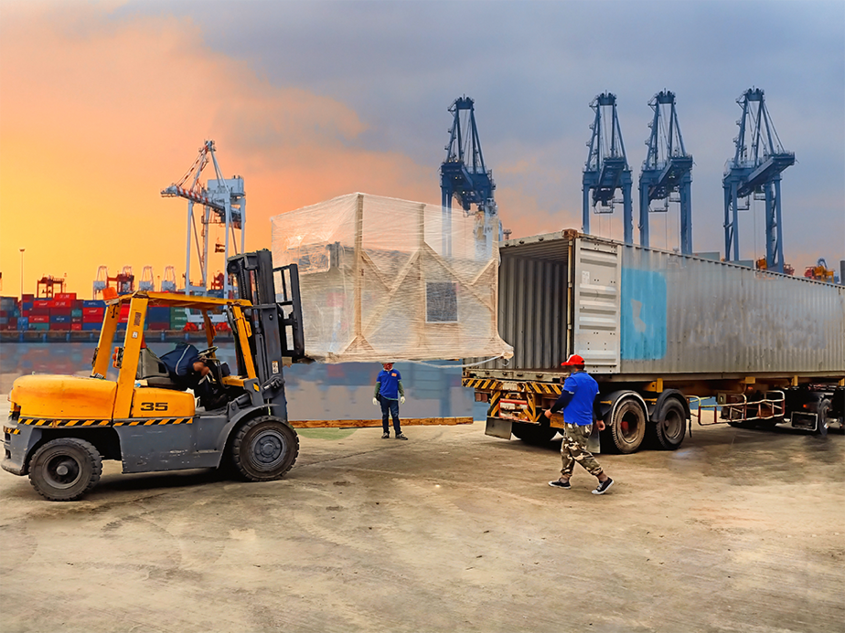

In the space below, or on a paper or tablet, sketch a cross-section of the loaded pallet, for the purpose of balancing weight on the forklift.

Also sketch a cross-section of the container, for the purpose of viewing how much of the container (front to back) the pallet will occupy.

In the space next to the image, sketch a cross-section through this dock of pallets, for the purpose of navigating an evacuation route for fire trucks.

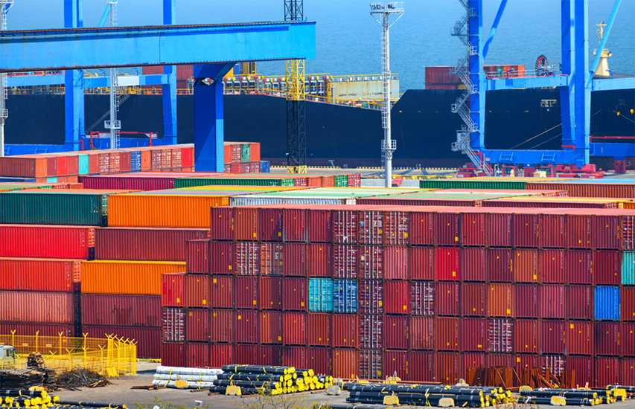
Task 3

Generating three-dimensional objects by rotating two-dimensional objects

Next, generating three-dimensional objects by rotating two-dimensional objects is a little unexpected.
With a simple example you will see how rotating two-dimensional objects, can generate three-dimensional objects.

Step By Step Instruction
STEP 1 | Fold a piece of paper into a rectangle, any size paper works.
STEP 2 | Tape a pen to one edge or hold the edge with your fingers (the tape is easier) and position the paper vertically.

STEP 3 | Place the tip of your pen (or finger) on the table surface and watch the outside edge of the paper as turn a full circle (360°).
Although you started with a rectangle similar in shape to the containers you've worked with, rotating a two-dimensional rectangle produces a shape much different than the container. Thinking about the x-axis (width), y-axis (length), and z-axis (depth) of the paper, the resulting three-dimensional shape is a cylinder.

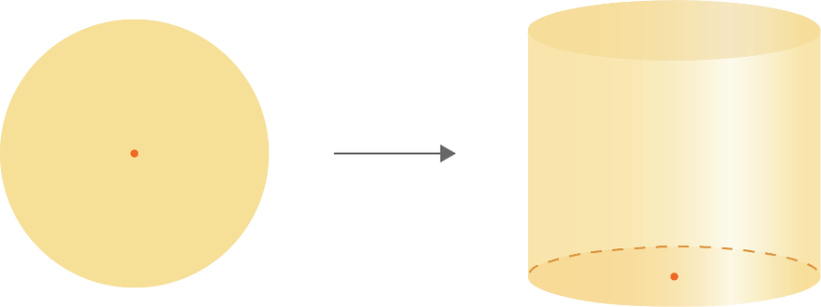

STEP 4 | Using the same pen and rectangular paper, lay the pen on its side, and the paper flat to one side of the pen. Then roll the pen so the paper lands on the opposite side of the pen.


What three-dimensional shape resulted?

STEP 5 | Cut or fold your rectangle to create a right triangle.


STEP 6 | Place the tip of your pen (or finger) on the table surface and watch the outside edge of the paper as turn a full circle (360°). Does this cone shape a surprise?
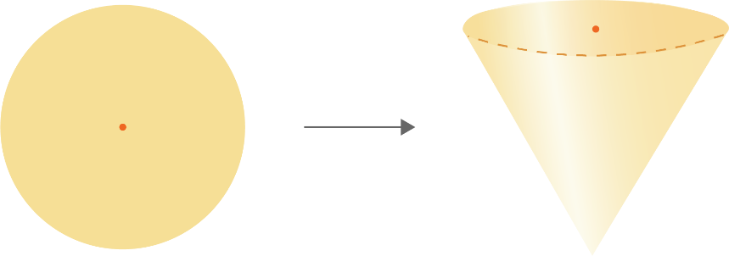

You rotated a two-dimensional rectangle to a three-dimensional cylinder and a two-dimensional triangle to three-dimensional cone. You can also slice three-dimensional shapes into two-dimensional shapes.

Generating three-dimensional objects by rotating two-dimensional objects is an essential skill in distribution warehouses. This two-dimensional image shows this rectangular loaded forklift ready to swing around and become a half circle or a quarter circle depending on its route to enter the warehouse.

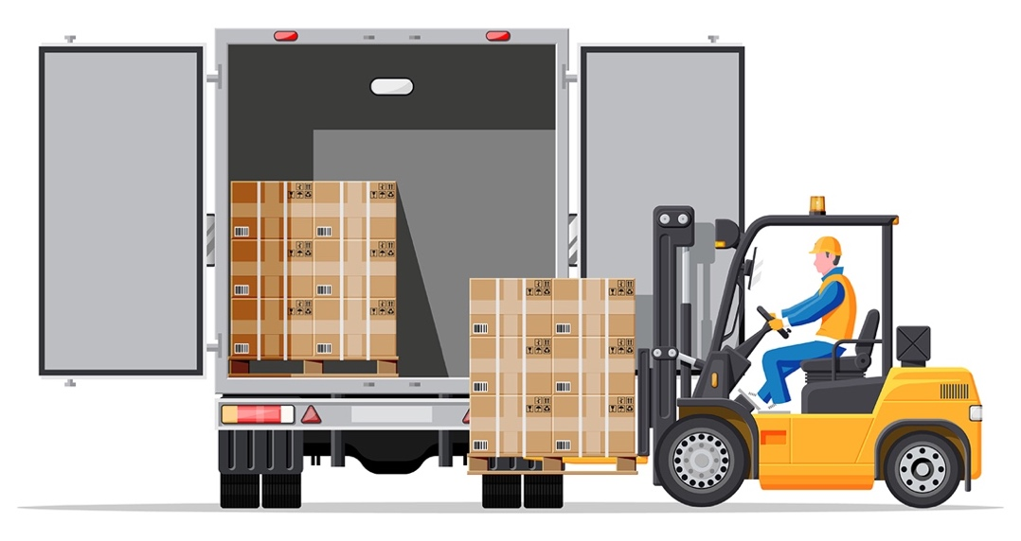

A three-dimensional understanding of how each item in this two-dimensional image moves is critical for operations. The forklift needs to be able to drive up to the truck, lift and pick up a pallet, back out, turn around, drive to a warehouse rack, lift to the correct height, insert the pallet, back away from the rack, swing around, and head back to the truck to Maximize the Cube. The truck requires significant space to address security, traffic control, safety, worker comfort, and space availability.

Most American containers on trucks are 40' (approx. 12.2 meters) long. A cab with container is 48'-53' (approx. 14.6-16.2 meters) long and 8.5' (approx. 2.59 meters) wide. Trucks don't pivot. In dock planning, an entrance driveway needs to be large enough to handle the turning radius of the longest truck serving the site.

Here are two-dimensional example graphics that represent the three-dimensional movement needed for planning (Kelley Dock Solutions).

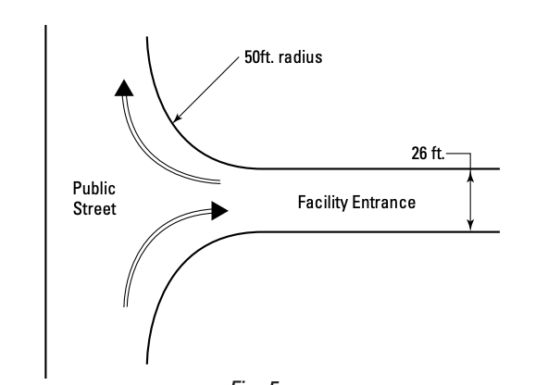

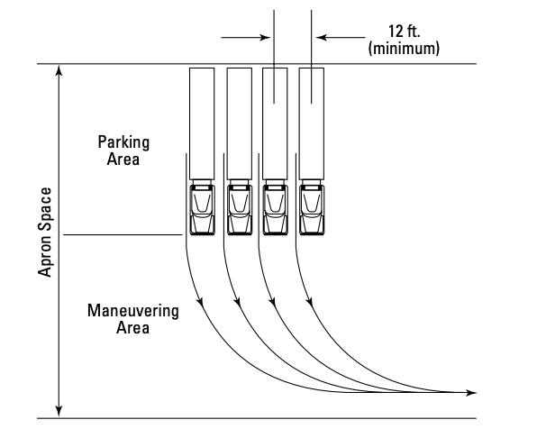

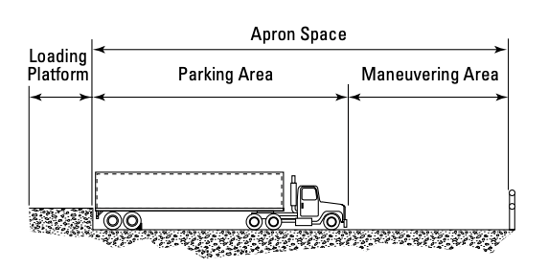

Generate a two-dimensional object with a cross-section of a three-dimensional object

In the same way you need the option to assess a two-dimensional object in three dimensions, your recommendations will include two-dimensional objects generated as cross-sections of three-dimensional objects.

Builders USA may visit another distribution warehouse to take photographs and videos of trucks entering, unloading, and exiting the dock area. The data created from the photographs and videos likely become two-dimensional drawings and cross-section modeling to plan adequate space and efficient work.

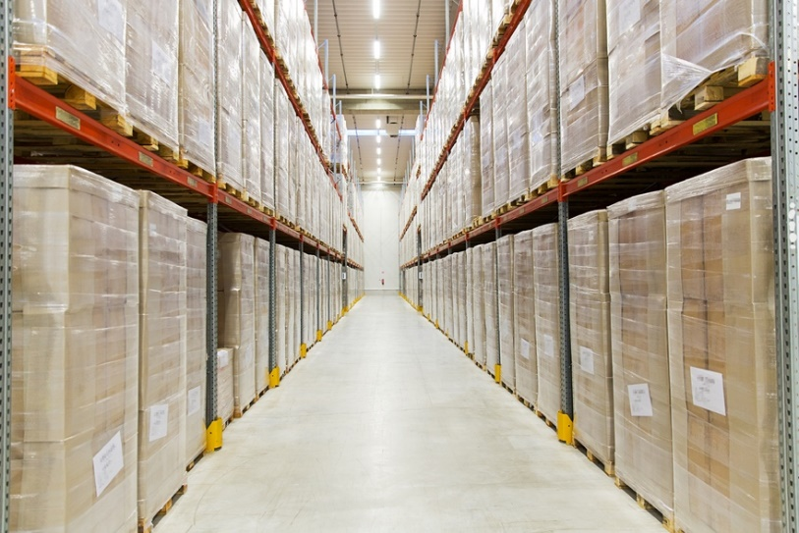 | This cross-section of a warehouse rack with pallets can be readily sketched as two-dimensional for aisle planning and placement.
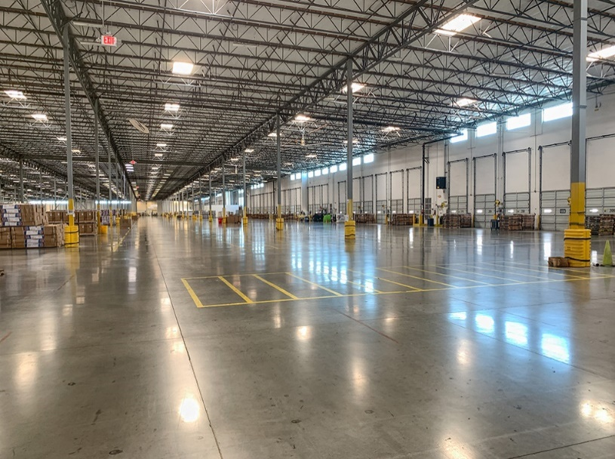 | The interior dock doors on the right side of this warehouse can become a two-dimensional map for planning forklift routes for unloading.

In planning the workflow inside the warehouse, you will work with two-dimensional shapes created from three-dimensional objects.

For the three-dimensional shapes below, which best describes the two-dimensional shape created by the cross-section shown?

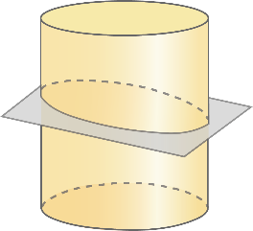 | - Circle  - Rectangle  - Ellipse  - Square
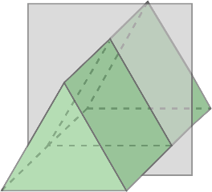 | - Square  - Rectangle  - Triangle  - Trapezoid
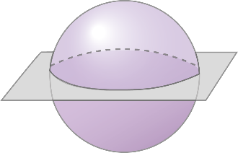 | - Circle  - Sphere  - Ellipse  - Square
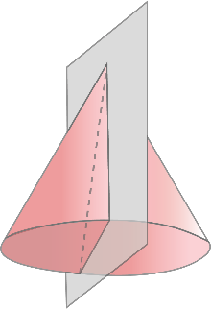 | - Trapezoid  - Circle  - Rectangle  - Triangle
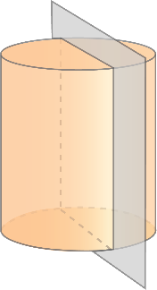 | - Triangle  - Circle  - Square  - Rectangle

Analyzing two-dimensional, three-dimensional, and cross-section shapes creates different options to Maximize the Cube for Builders USA. Converting two-dimensional objects to three-dimensional objects in the workplace often involves working with complex software utilizing machine learning, artificial intelligence, and photogrammetry. As software becomes more sophisticated, customers expect more realistic three-dimensional shapes. Software is a tool that extends your capacity; you remain the idea person and contributor to the organization.

You may know this warehouse employee? Mario works at https://mario.nintendo.com/

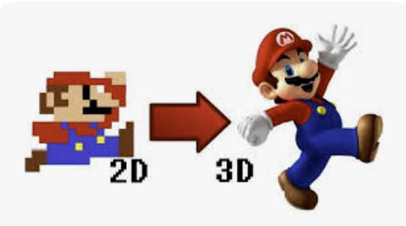

Milestone 2 Check-in

Critically assess and discuss the following Milestone 2 questions:

- What are two primary ways you can use two-dimensional and three-dimensional objects to analyze your recommendation for Builders USA?
__________________________________________________________________________
__________________________________________________________________________

- What are two primary ways you can use two-dimensional cross-sections of three-dimensional objects to inform Builders USA?
__________________________________________________________________________
__________________________________________________________________________
__________________________________________________________________________

- What are two primary ways you can use three-dimensional objects generated by rotations of two-dimensional objects to inform Builders USA?
__________________________________________________________________________
__________________________________________________________________________
__________________________________________________________________________

Milestone 3

Logistics is the important link in the supply chain that organizes and implements the forward and reverse movement, handling, and storage of goods from origin (manufacturers who build) to distributors (like Builders USA who deliver to home centers and stores), and then to destinations (stores that sell to customers). A supply chain is a global network used to deliver products and services from raw materials to end customers through an engineered flow of information, physical distribution, and cash. If logistics fail, the supply chain fails.

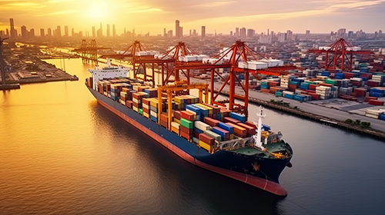

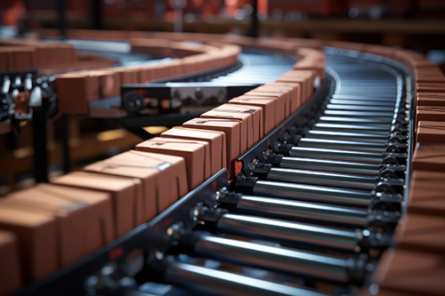

Now that Builders USA identified a potential distribution warehouse location to transport products from The Port of Long Beach, Milestone 3 supports identifying how to efficiently plan for logistics inside the warehouse.

A distribution warehouse is organized by the types of products that will move through it. A warehouse used for receiving, storing, and distributing construction equipment will have a different footprint than one that is used for receiving, storing and distributing imported shoes and boots.

A footprint is the area of a project site defined by the perimeter of the building (including everything inside the building). Parking lots, landscapes, and other non-building facilities are not included in the building footprint. In Milestone 3 you will work with the web-based application Tinkercad to apply geometric concepts that support logistics in the Builders USA distribution warehouse.
To prototype the warehouse buildout, the Builders USA team will consistently navigate between two- and three-dimensional objects represented as shapes. Logistically, it's not feasible or affordable to install warehouse racking, aisles, docks, etc., only to find the layout ineffective. Reorganizing a warehouse of this magnitude isn't an option for Builders USA.

Terms

Distribution Warehouses

Distribution warehouses are a combination of:

Stylish front facing spaces for customers, employees, and communities-

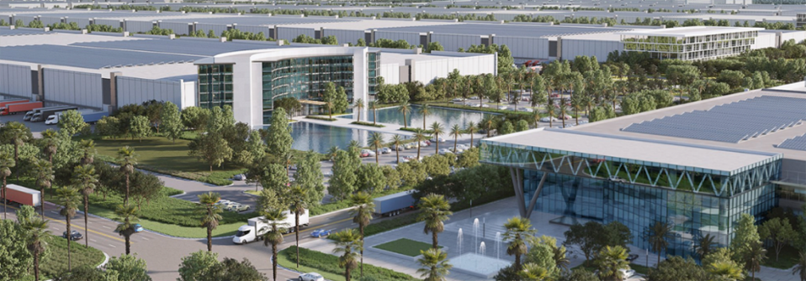
photo credit https://www.theworldlogisticscenter.com/

Docks for efficient product movement-

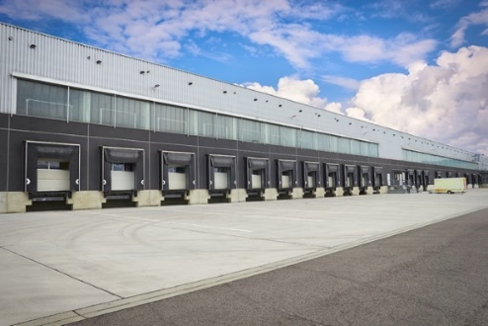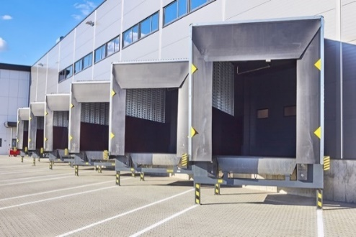

Massive spaces for people, product, and robotics-

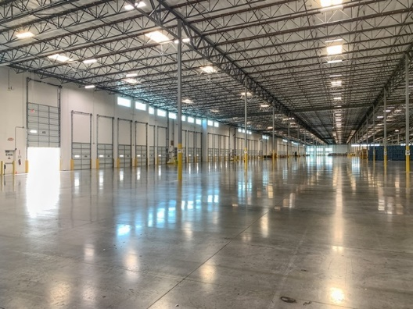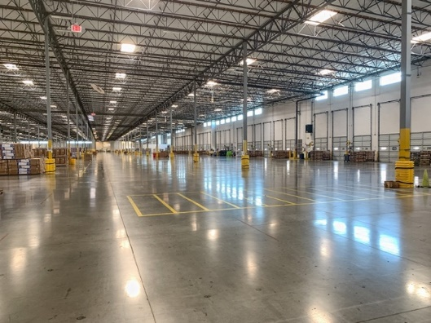
The operations work that takes place in distribution warehouses include:

Inbound logistics
Outbound logistics
the process of receiving and storing products
the distribution of finished products to customers

Inbound logistics bring supplies or materials into Builders USA. Outbound logistics send products from the Builders USA to home centers. Inbound is all about receiving, and outbound focuses on delivery.
Inbound logistics  Sourcing and Purchasing  Supplier Selection  Inbound Transportation  Receiving and Quality Check  Material Handling | Outbound logistics  Warehousing and Storage  Packing and Packaging  Outbound Transportation  Order Fulfillment  Reverse Logistics

The inbound process starts with trucks arriving at the inbound docks. Outbound logistics are the final step in the warehouse workflow. Between inbound and outbound logistics, products, people, robotics, and equipment move quickly throughout the space.

Warehouse Management

Warehouse management is the daily operations of a warehouse. Warehouse management considers everything from warehouse layout and employee management to activities like receiving and managing inventory, fulfilling orders, and coordinating with shipping partners. Effective warehouse management optimizes warehouse operations to maximize productivity and efficiency. Priority is facilitating fast, accurate order fulfillment while keeping costs low. Objects you will work with in planning the distribution warehouse as intern for Builders USA include:

1
Pallets

Pallets are a portable platform for handling, storing, or moving materials and packages. Pallets are designed to move through doorways and be reused many times. There are a few different types of pallets, the most common North American pallet is the wood pallet, which is:

Affordable
Lightweight
Customizable
Repairable
Recyclable
A standard wooden pallet measures 48" × 40" × 6" (1.22m x 1.02m x .15m) The simplified block pallet you will build is:

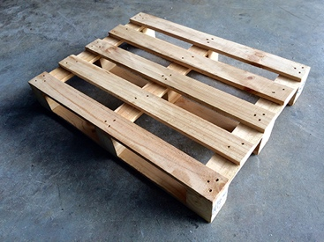

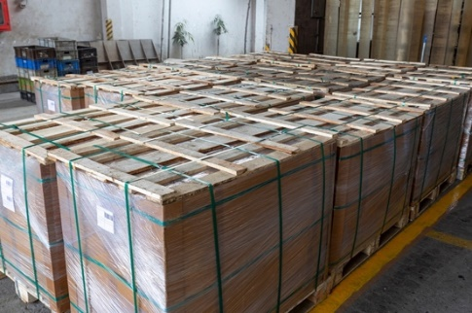 | A standard wooden pallet static load capacity is the weight of the pallet when resting in a fixed position on a level, even surface. If pallets are stacked, for example three high, the bottom pallet is holding its own weight and the two pallets sitting on it.
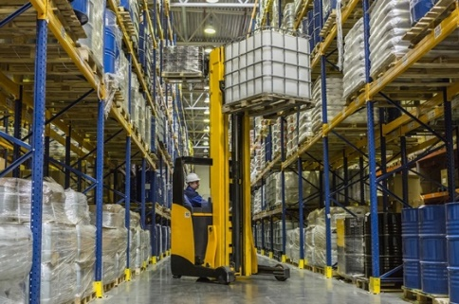 | The dynamic load rating is the weight the pallet can hold while moving, typically while being lifted and carried using a forklift, pallet jack, stacker crane, or conveyor system. Load distribution is critical because unevenly distributed weight can cause the pallet to tip or flip.
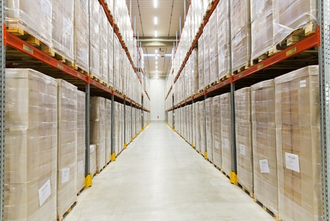 | A rackable load is the strength load rating for when a pallet is placed in a racked system and stored for later access.

Builders USA primarily uses wooden block pallets with a static load capacity of 5,500 pounds (approx. 2,595 kilograms), a dynamic load capacity of 4,600 pounds (approx. 2,087 kilograms), and a rackable load capacity of 2,800 pounds (approx. 1,270 kilograms).
When working in a distribution warehouse understanding the difference between a static load and dynamic load is essential to keeping products and people safe. Pallets are static and dynamic at different stages of the loading and unloading processes.

2
Pallet Jacks

Pallet Jacks are manually operated and steered with a tow bar.

Pallet jacks are often considered the workhorses of a warehouse. They include three position hand control for lowering, lifting, and neutral positions, heavy duty hydraulic systems, tough wheels and rollers, and additional low-maintenance features.

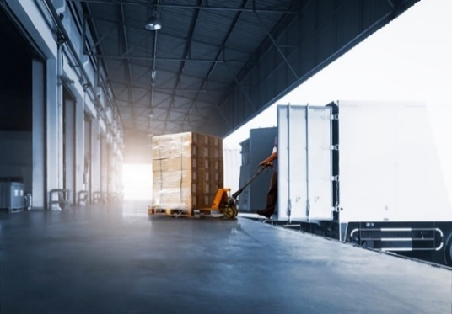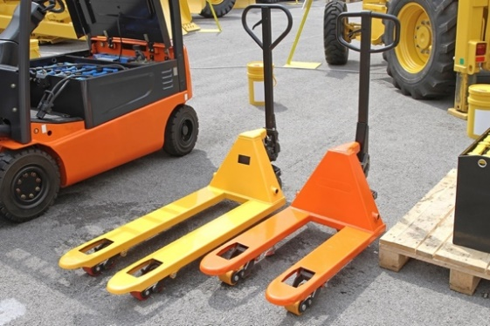

3
Forklifts

Forklifts commonly run on propane, and in some cases on electricity.

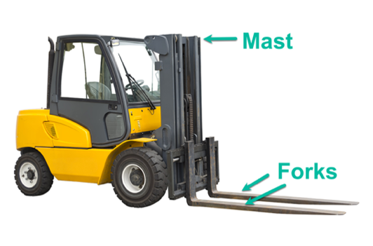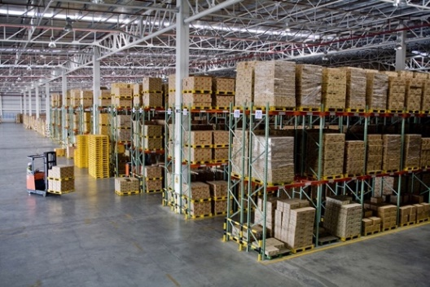

4
Articulated Robotic Arms

Articulated Robotic Arms, a type of pick-and-place robot, are multi-jointed limbs used to manipulate products within distribution centers and warehouses. They are used for picking, packing, and storing.

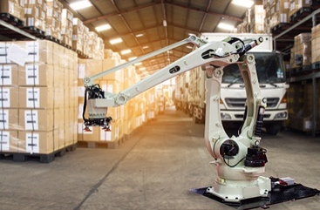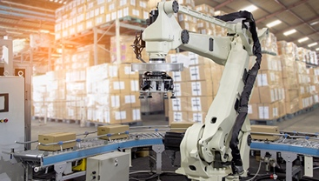

5
Stacker Cranes

Stacker Cranes run on electricity. Manual pallet stackers use a hydraulic system to lift pallets around. Stacker cranes increase load and height capabilities and need less space to maneuver than a forklift.

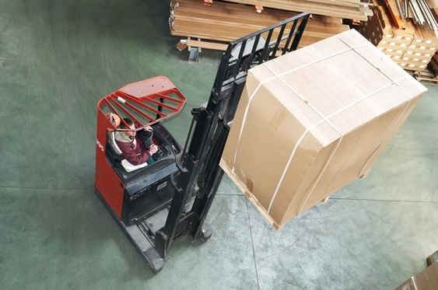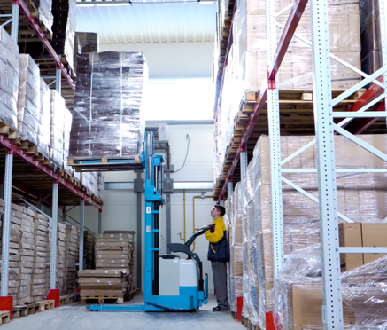

6
Automated Stacker Cranes

Automated Stacker Cranes are a type of overhead crane system that can maneuver in 5' aisles, reach 65' high and, in advanced configurations reach 130' high. These robots move horizontally and vertically within the storage aisles. Although their function is to store goods, they also increase the flow of movements by working nonstop, supplying pick stations with products more rapidly.

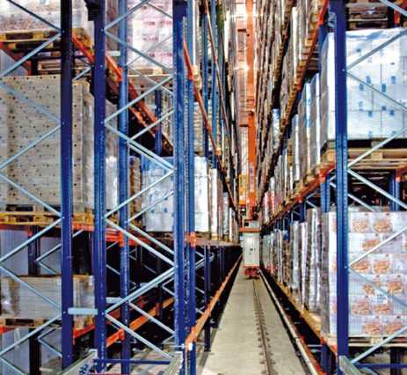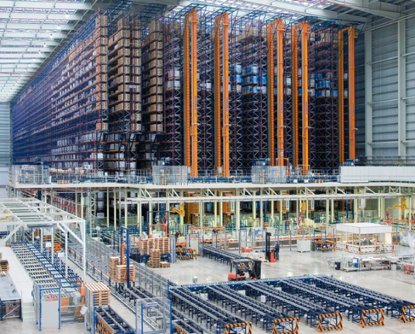

7
Conveyor Systems

Conveyor Systems move boxed and palletized products. Conveyors with belts over roller/slider beds provide better support, more precision, and stronger grip.

The Builders USA conveyor system will primarily be powered rollers and belts. These machines move, accumulate, and distribute goods to the specific positions required by the logistics operations.

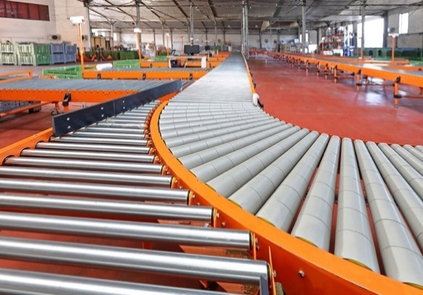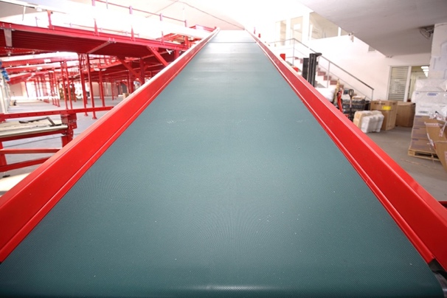

8
Autonomous mobile robots (AMRs)

Autonomous mobile robots (AMRs) move in the environment without the need for supervision by an operator or fixed and pre-established routes. AMRs are capable of “awareness” of the surrounding environment due to sensors that enable it to avoid collisions and move along the shortest possible route.
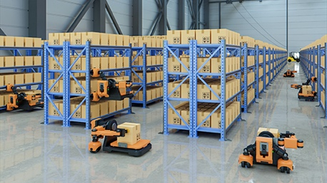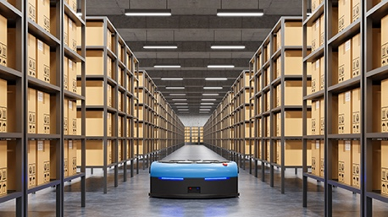

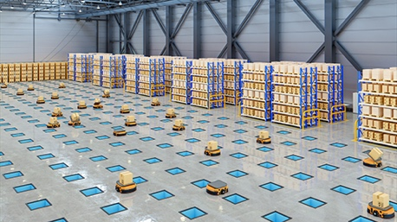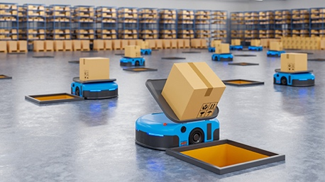

Tasks

Task 1

Tinkercad Project 1

You'll use Tinkercad to model and work with shapes as objects toward warehouse planning. Your first task is to build the simplified wooden block pallet. Tinkercad is selected because it is available at no cost. If you prefer a different application, no problem. The purpose of the tasks is to practice seeing and shaping dimension.

Tinkercad is the web-based application (nothing to download) you will use for your Milestone 3 project.

Step By Step Instruction to Set an Account

STEP 1 | Go to https://Tinkercad.com/ and select the Sign Up button (top right)



STEP 2 | If you're setting up on your own, select the Create a personal account button. The next screen will ask you to sign up with a personal email account, your Google account, or an Apple, Microsoft, or Facebook account.  If you are in a formal course, select the Students join a Class button. The next screen will ask you to Join Class with the code your instructor shared.

Your interface may vary from these screenshots due to software updates.

STEP 3 | This example uses Sign in with Google, you will be asked to select your Gmail account. Or select Use another account (if you have multiple Google accounts). Select Next and Enter your password.  Select Continue to enter Autodesk, the parent company for Tinkercad.

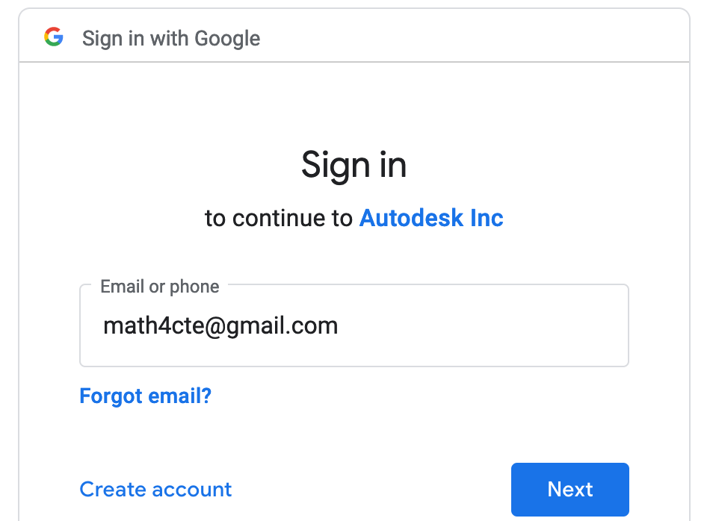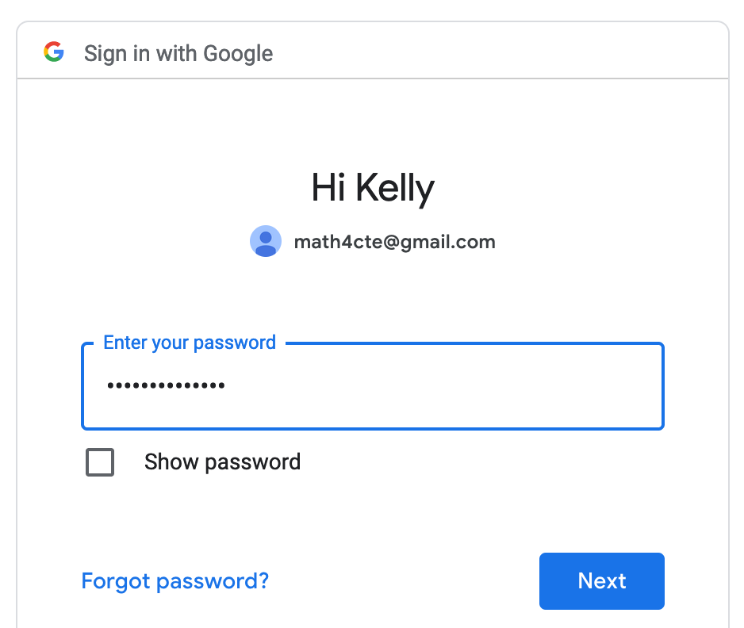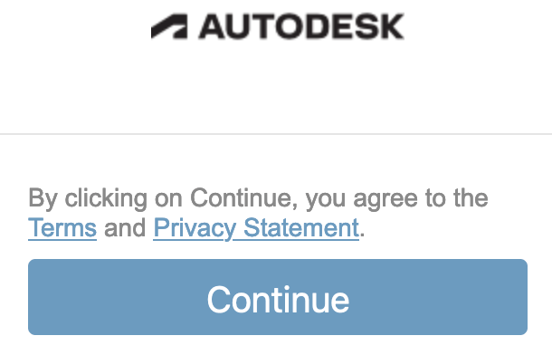

STEP 4 | You are now in Tinkercad and have the option to Create your own Designs, view Tutorials, or you can enter a class.

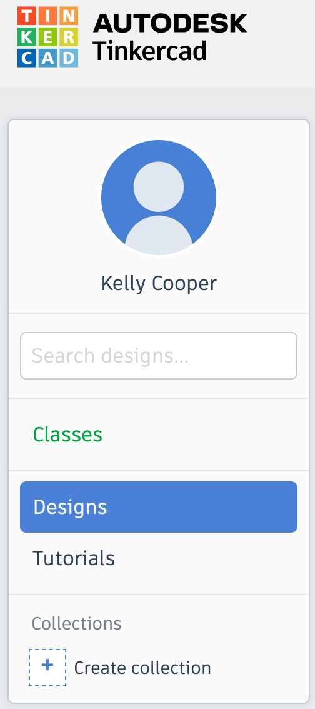

STEP 5 | On the bottom of the profile window, select Create collection (1), and the settings cog button to the right of the Collections 1 label (2). Into the Properties popup window, key the Name as Builders USA and Description as Warehouse Shapes for Milestone 3 (3). Select the Save changes button.
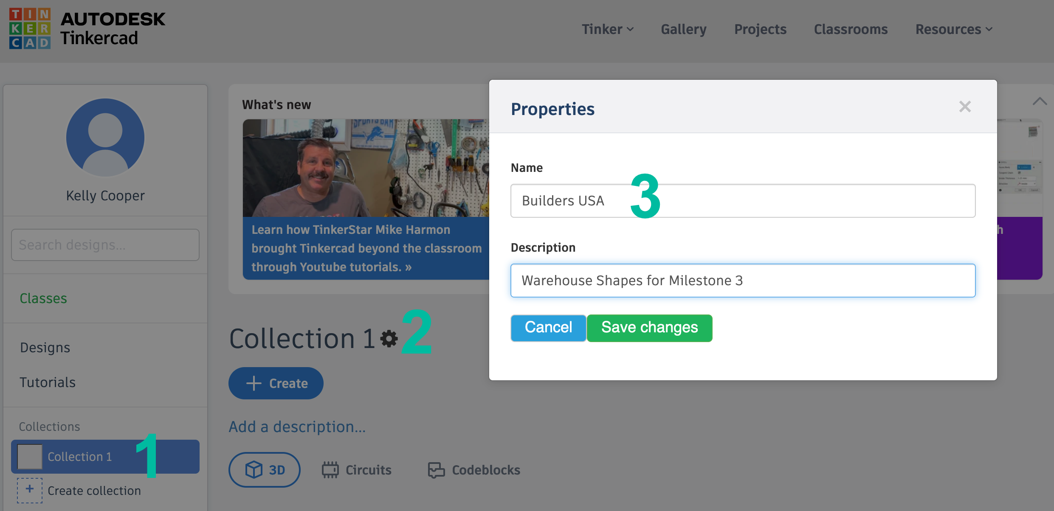

STEP 6 | Builders USA is now a collection within your Tinkercad account. With the 3D icon selected, click on the + Create button to begin and select 3D Design from the popup window.
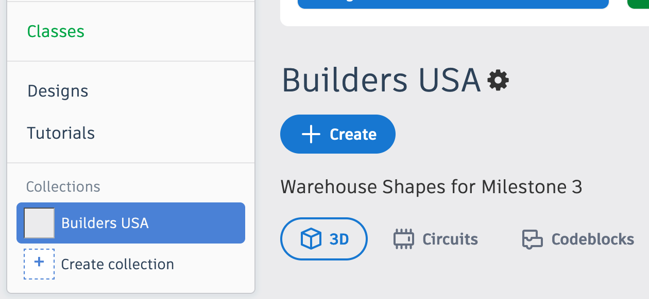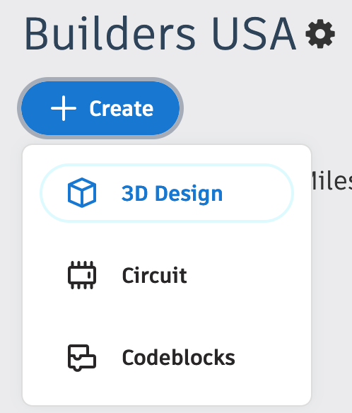

STEP 7 | This is your workspace. The Basic Shapes on the right will serve as building blocks for your Builders USA shapes.

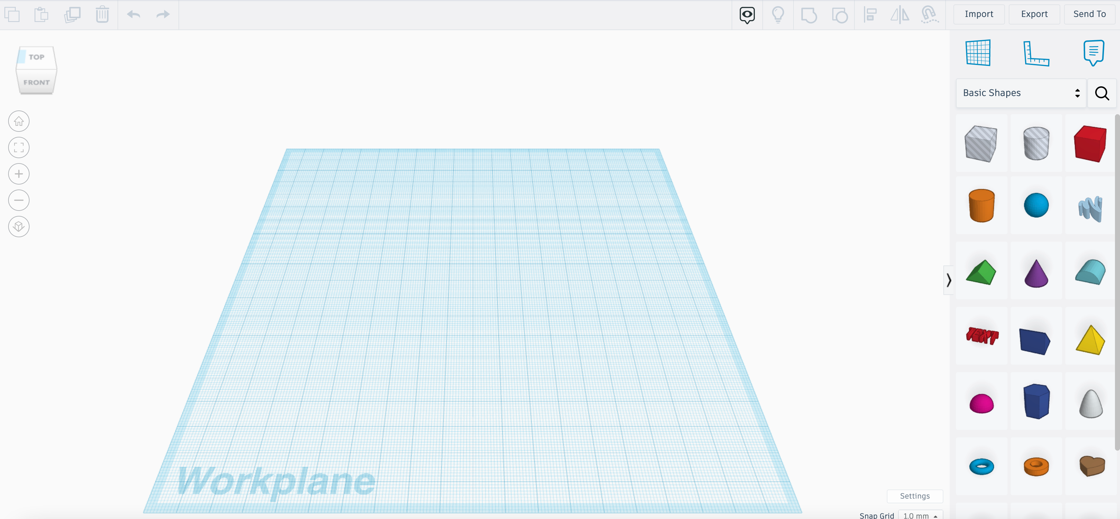

For communicating warehouse planning and layout in this tutorial, you will use the U.S. customary system of inch, foot, yard, and mile. You can easily switch to metrics with the Units dropdown.

STEP 8 | At the bottom right of your Tinkercad workspace, select the settings button. In the popup window, change Units to Inches, leave the Presets as they are, select Make default, and Close settings.

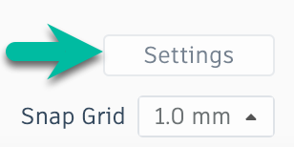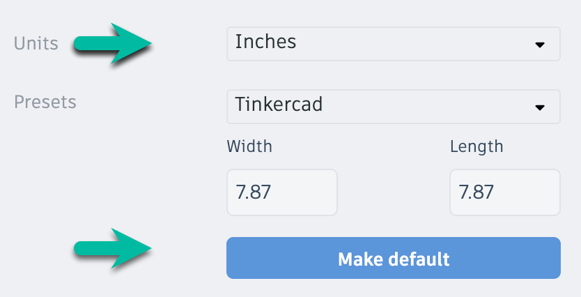

STEP 9 | In the top right corner of your screen, click into the textbox and name your design Pallet.

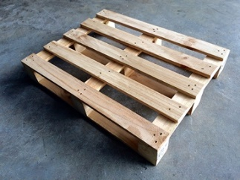

STEP 10 | Since Tinkercad and your computer are smaller than an actual pallet, the pallet will be scaled to 1:10. This means that 1" in Tinkercad represents 10" in real life. You will use one basic shape, a cube (Tinkercad notes it as Box) to create the pallet.

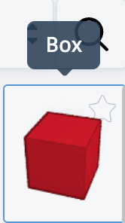

Millions of pounds of products are moved worldwide every day with pallets made from this one geometric shape. In the past six months, 2,119,728 containers arrived at The Port of Long Beach alone, carrying 98,069,162 metric tons for 216,203,274,245.2 pounds on pallets in containers on ships. That's a lot of shopping in six months and doesn't include another 360 ports in the U.S., products flown in, driven in, or those Made in the U.S.A. The simple wooden pallet and a few sidekick plastic pallets do a lot of work. Let's build one.

Step By Step Instruction to Build a Pallet in Tinkercad

There are a few approaches to working with Tinkercad. The screenshots and steps below serve as a guide, one approach. Follow this example or your own methodology. We had three people practice the tutorial and all three took a different approach. Our intent is for you to practice creating three dimensions objects on a two-dimensional device.

A North American wooden block pallet measures 40" (width) $∙$ 48" (length). You will start with the top deckboards. Each is 40" long, 3.5" wide, and 5/16" thick.

STEP 1 | Drag a Box anywhere onto your workspace. | 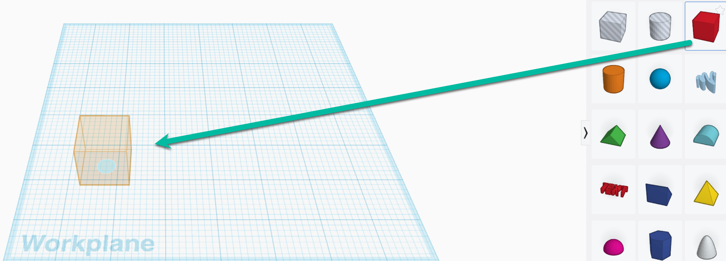
STEP 2 | Click onto your Box and a popup window appears. Keep in mind you are working on a 1:10 scale, change the Length, Width, and Height of Box: | 40” 4”  3.5” .35”  5/16 = .31” .031”
STEP 3 | This end top pallet deckboard is called the lead deckboard. From the outside edge of your lead deckboard to the outside edge of the opposite edge lead deckboard is 48". | 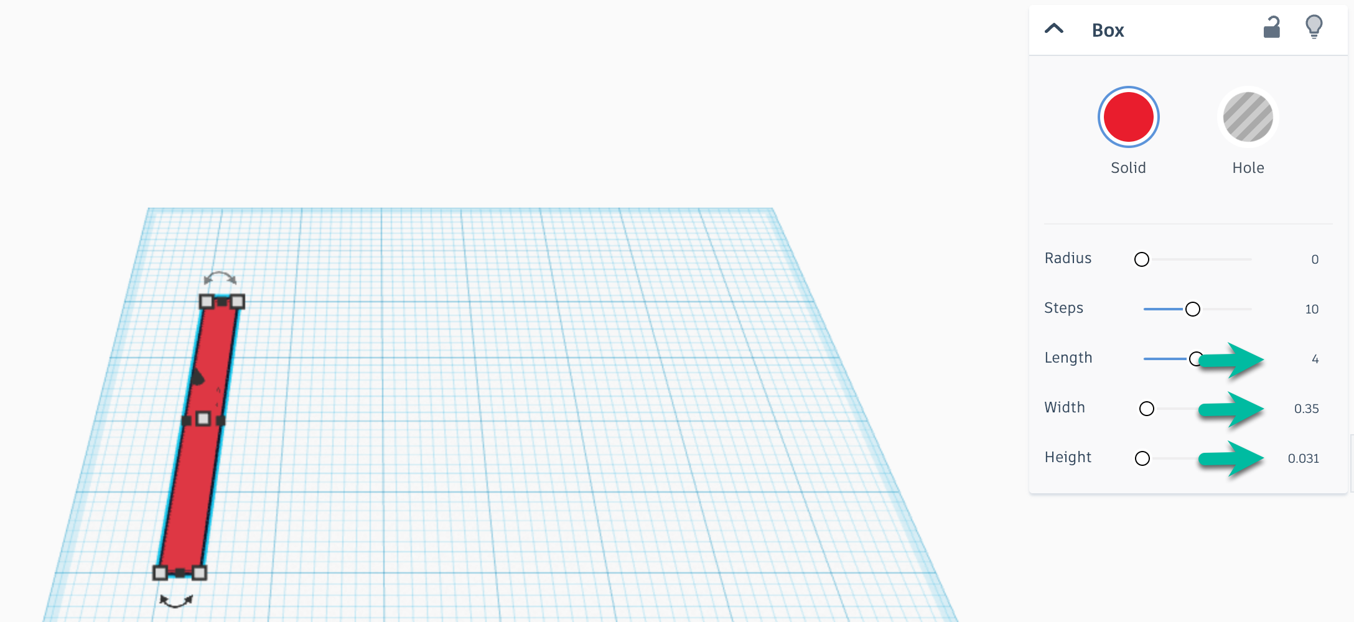
Pallet length = 48"
Each deckboard is 3.5" wide. There are 5 deckboards to evenly space.
3.5" $∙$ 5 deckboards = 17.5" of the 48" will be deckboards.
48" - 17.5" = 30.5" of space between the deckboards.
Space will be between deckboard: 1-2 & 2-3 & 3-4 & 4-5
for a total of 5 deckboards and 4 spaces between deckboards.

30.5" of space divided by 4 spaces = 7.625" of space between each deckboard.
Since you are working on a 1:10 scale, 7.625" becomes .76"
STEP 4 | Select your deckboard, key Ctrl+D on a PC or Cmd+D on a Mac, to duplicate the deckboard. It duplicates on top of your existing deckboard, use your right arrow key to move it to the right.  Note: If you have previous Tinkercad experience, you may know keyboard shortcuts. The purpose here is to work with math as you would on the job; you're thinking about numbers more than about software. | 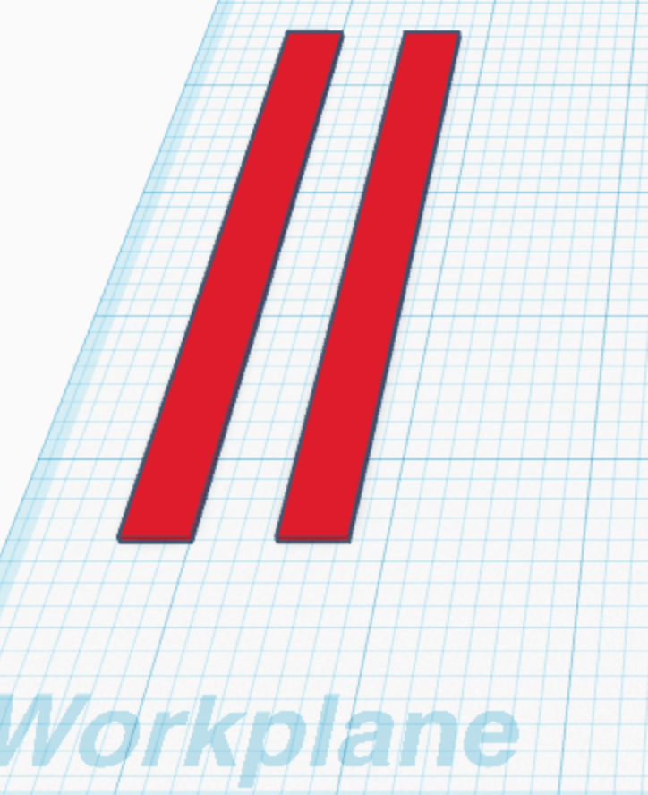
STEP 5 | Select the ruler tool, above the shapes library, and position the round red circle at the outside edge of your deckboard, over the right angle the board creates.  The apex (where your ruler angle meets) rotates by clicking on the O. For each click it rotates 90°. Click until it aligns on the left and bottom of the Workplane. | 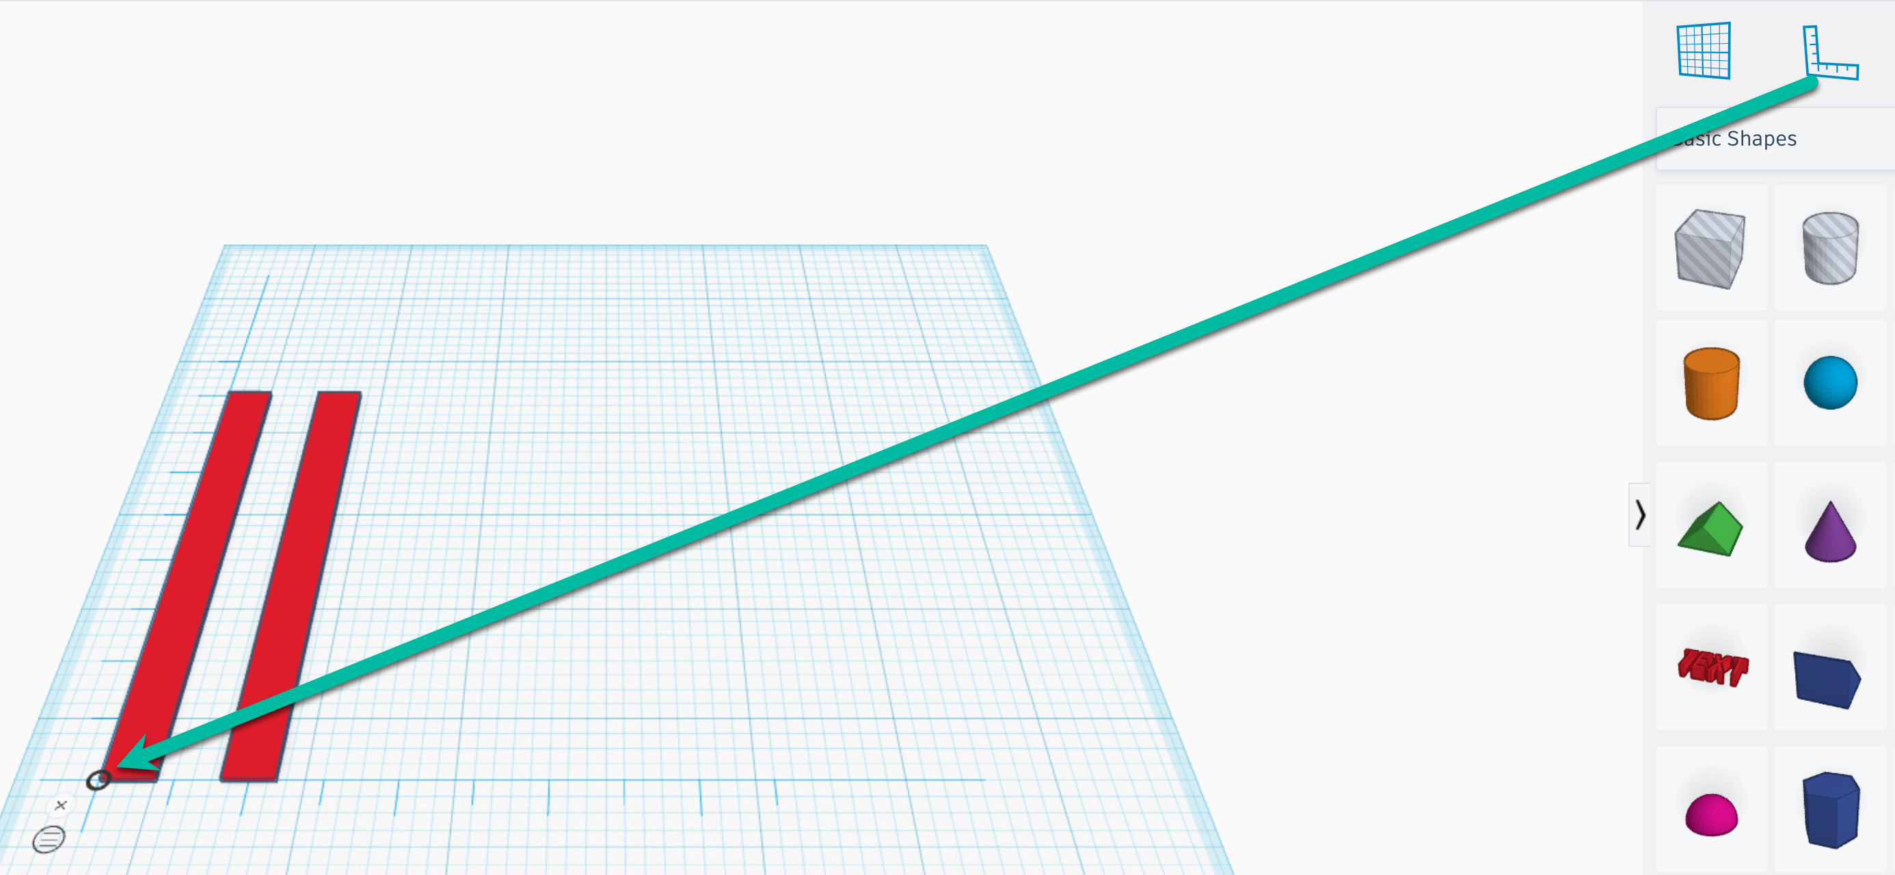
STEP 6 | With your shift key selected, click on both deckboards to view all measurements. Your numbers may be slightly different since you're not working with exact positioning yet. | 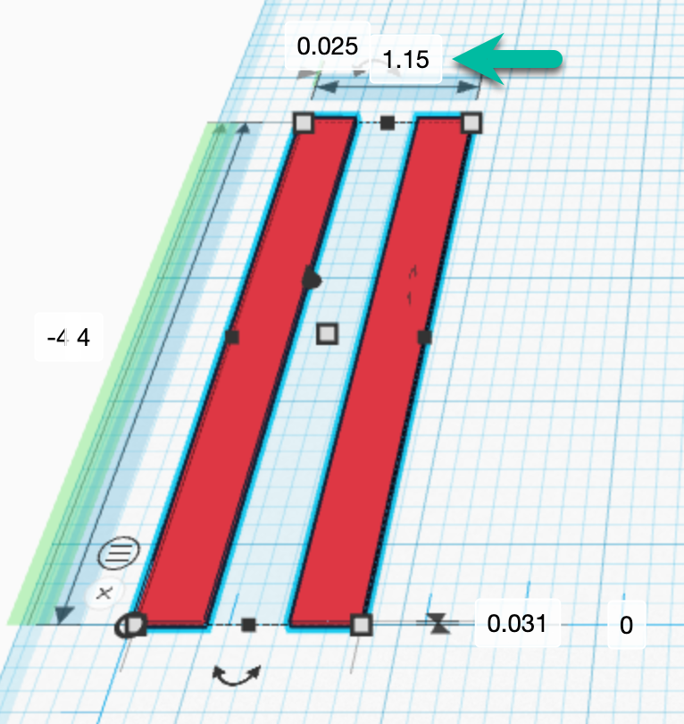
STEP 7 | The number 1.15 shows it includes the width of the deckboards and the space between them. Since your deckboards are on a 1:10 scale, the values of .35" (deckboard) + .76" (space), which represent your lead deckboard plus the space before the second deckboard sums as 1.11.  You can adjust the space by keying 1.11 into the value at the top of the deckboards. | 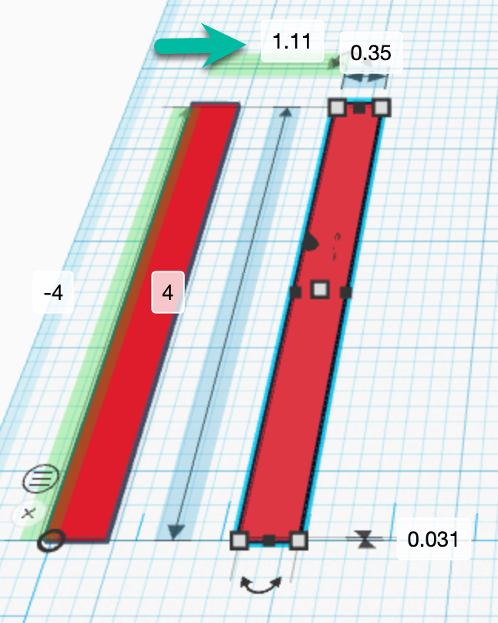
STEP 8 | Click into the workspace to unselect the two deckboards.  Click to select the right deckboard and key Ctrl+D (PC) or Cmd+D (Mac).  Use your right arrow to move the duplicated board to the right. You may see the board width adjust slightly, if so, rekey .35 as the width. | 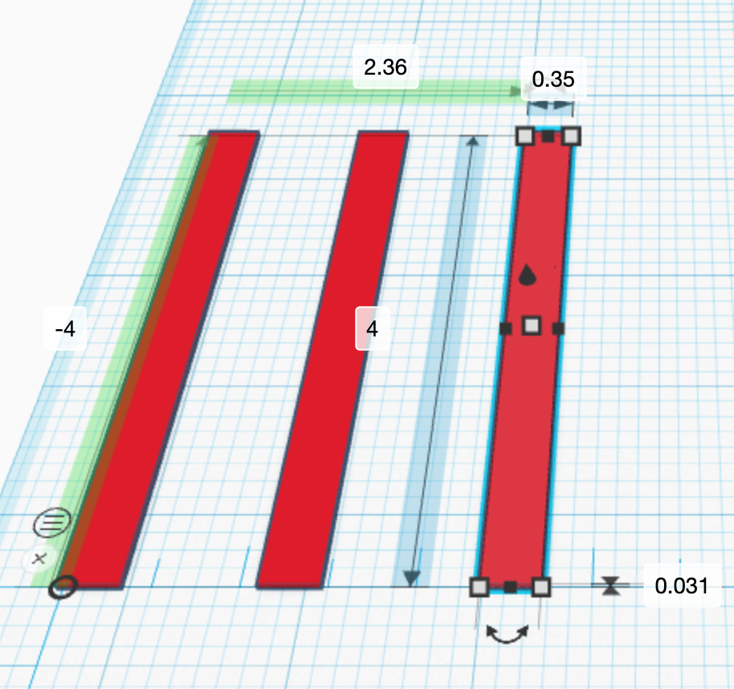
STEP 9 | The highlighted green measurement encompasses the .35" of the lead deckboard, the .76" first space, the .35" of the second deckboard, and the .76 space between the second and third deckboard.  The number on the highlighted green measurement, then should be:  .35 + .76 + .35 + .76 = 2.22  Adjust the value. | 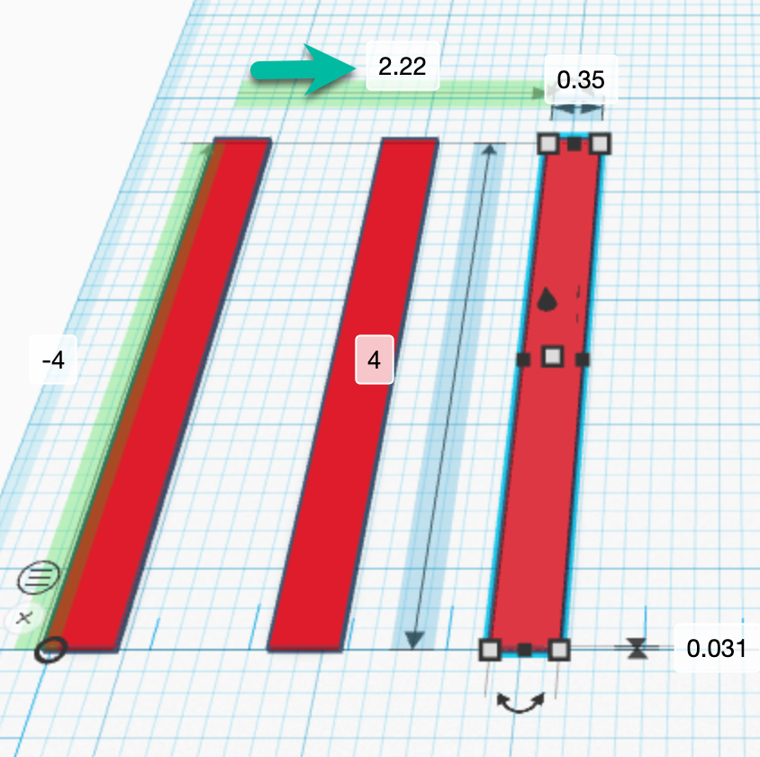
STEP 10 | Select your shift key and click on the two right deckboards. Since there are five deckboards total, you'll duplicate two and adjust spacing only between deckboards 3 and 4.  The number on the highlighted green measurement will be for three deckboards and three spaces:  (.35 $∙$ 3) + (.76 $∙$ 3) = 3.33
STEP 11 | Select shift and click on the two right deckboards so that when you adjust spacing, the two move together. You spaced them correctly earlier and will move them together now.
STEP 12 | Adjust your green highlight spacing value to 3.33. Note that 3.33 + 1.46 = 4.79 which rounds to 4.8. at your 1:10 scale, 4.8 represents 48", the deckboards now represent 40" in width and 48" in length.  Block pallets may have 6 or 7 deckboards, depending on the use case. In this activity, you will use 5. | 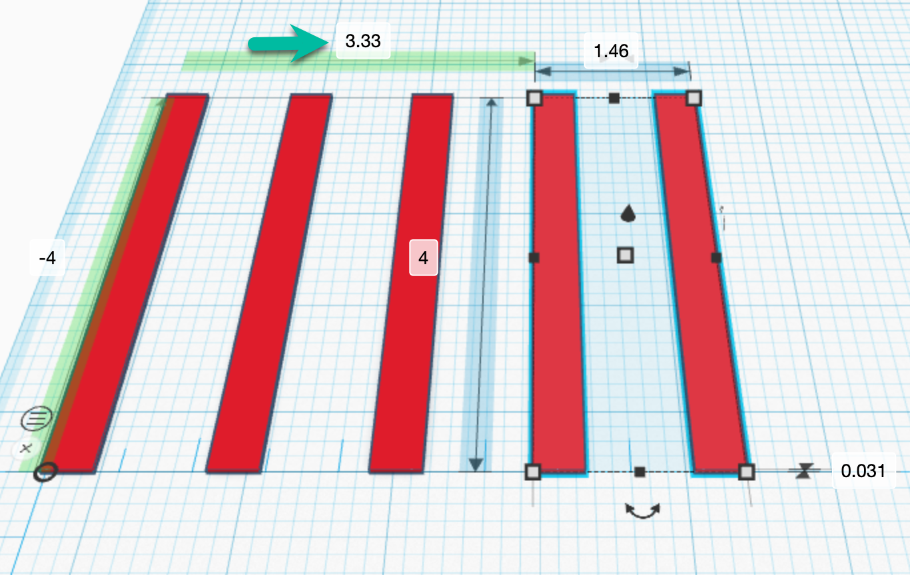
STEP 13 | Click into the workspace to deselect any deckboards, select the right deckboard and duplicate. Arrow to space it to the right. This will become the first stringer board. | 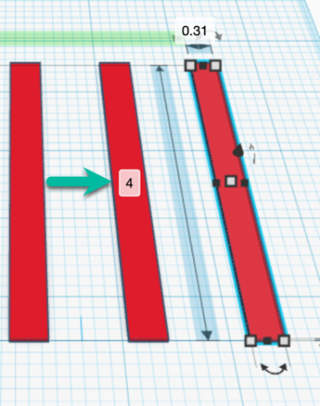
STEP 14 | Click into the workspace to release any deckboards selected.  To stack the first stringer across the deckboards, drag the Workplane tool, located above Basic Shapes onto one of the original five deckboards. | 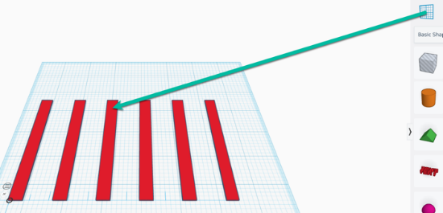
STEP 15 | You will see a transparent yellow rectangle that represents the Workplane tool and indicates where you are dropping the new workplane onto your workspace. | 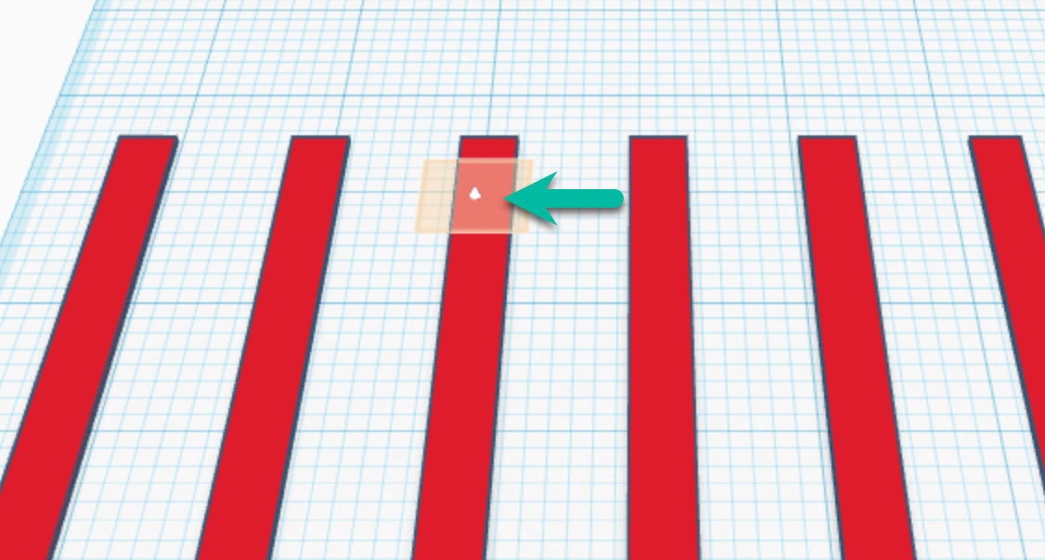
STEP 16 | Release and the yellow Workplane tool sets. | 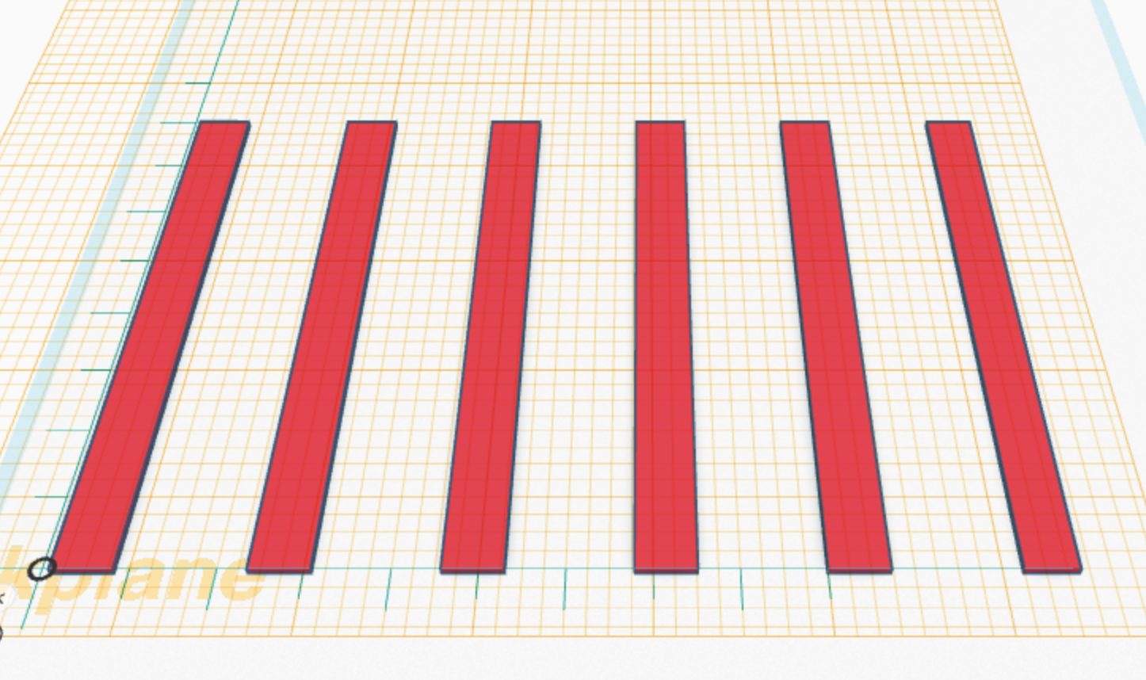
STEP 17 | Select the right stringer and the rotate tool, to position the stringer across the deckboards. | 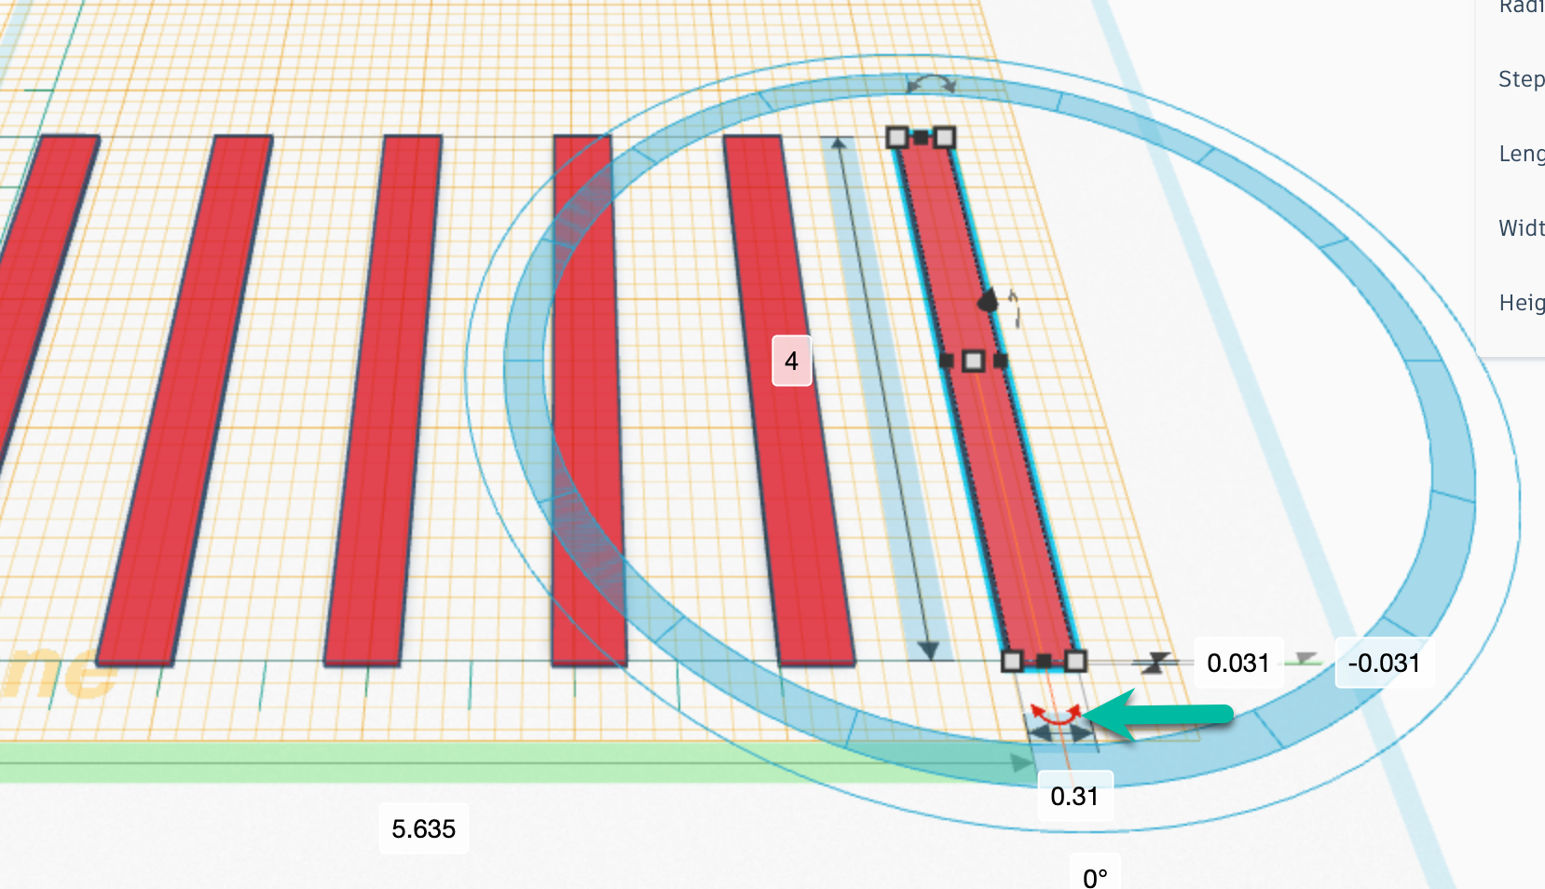
STEP 18 | With your mouse, select and rotate the stringer to 90°. | 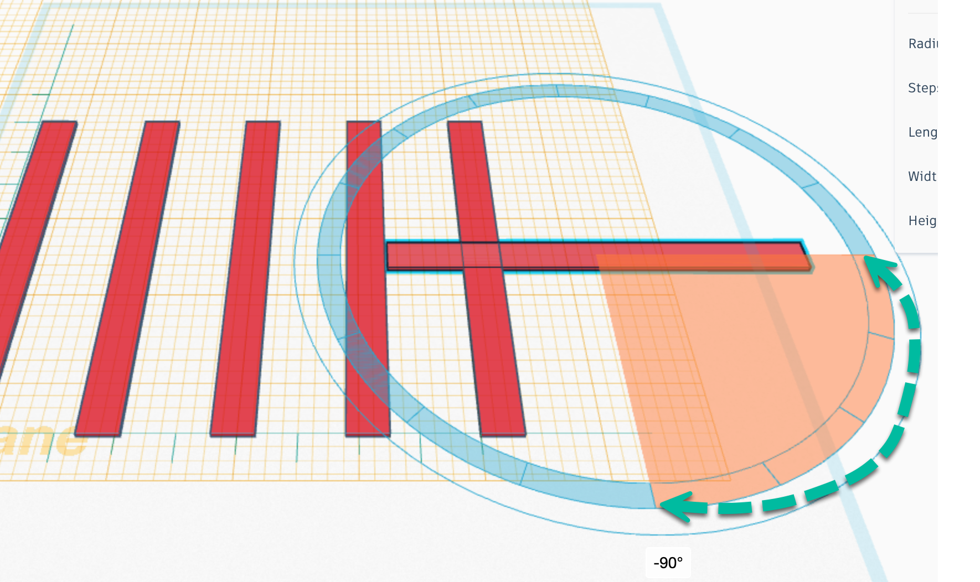
STEP 19 | Select the stringer and use your arrow key to position across the deckboards. | 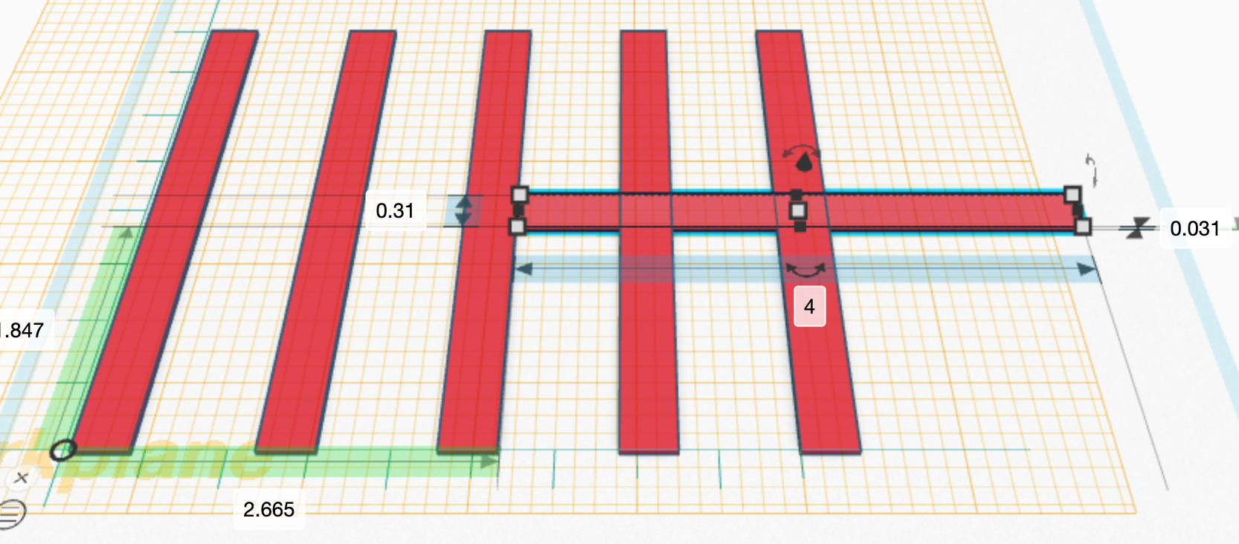
STEP 20 | To center, adjust the space value from the pallet width edge to the center stringer to 1.825".  1.825" + .35" + 1.825" = 4 = the 1:10 40" width of the pallet. | 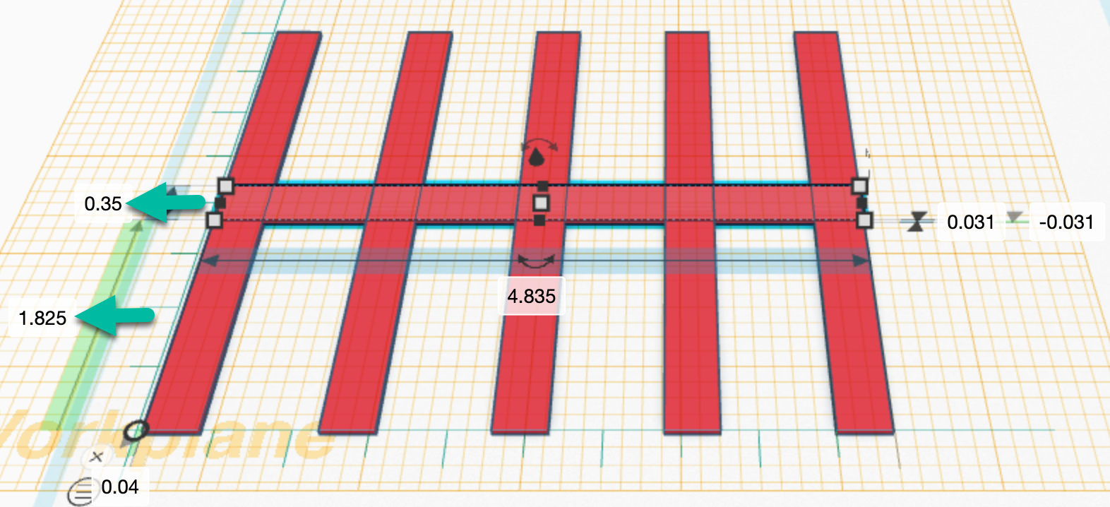
STEP 21 | Duplicate the stringer and arrow it to each end of the pallet. | 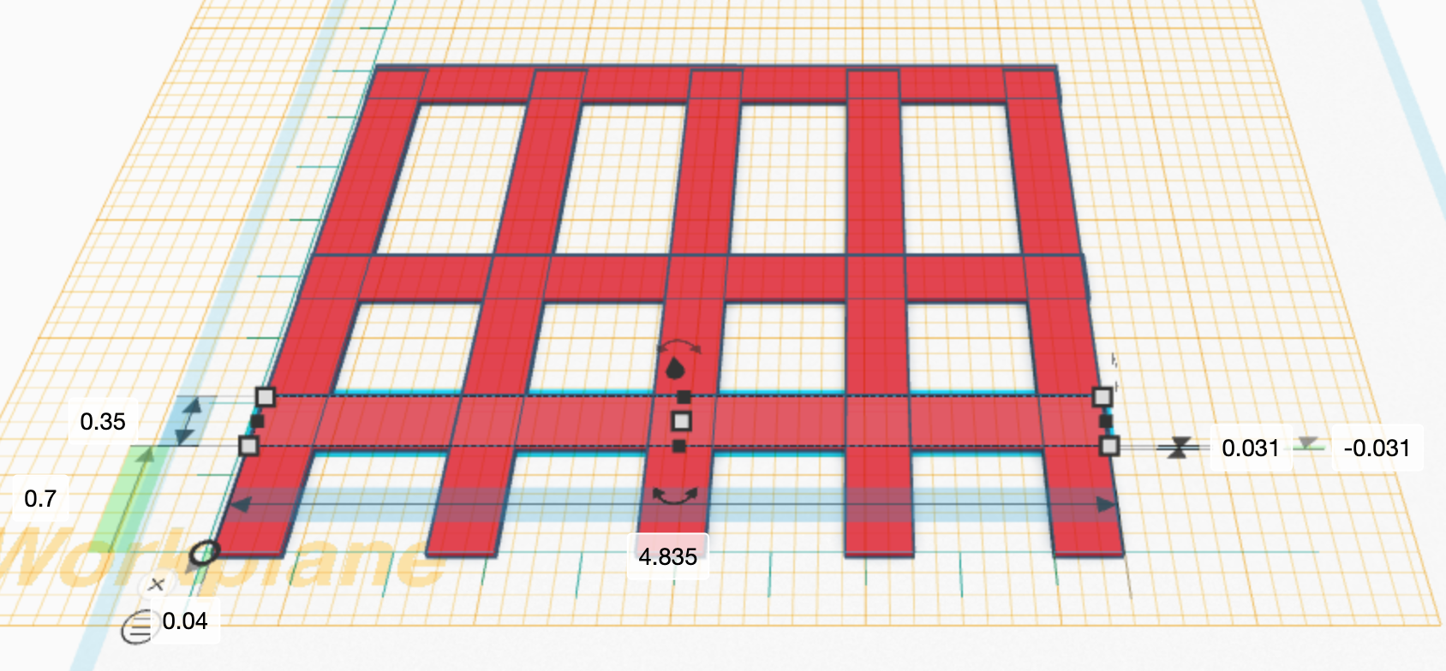
STEP 22 | For each stringer: position, adjust the value to 4.8, and key a D to drop the stringer onto the pallet. | 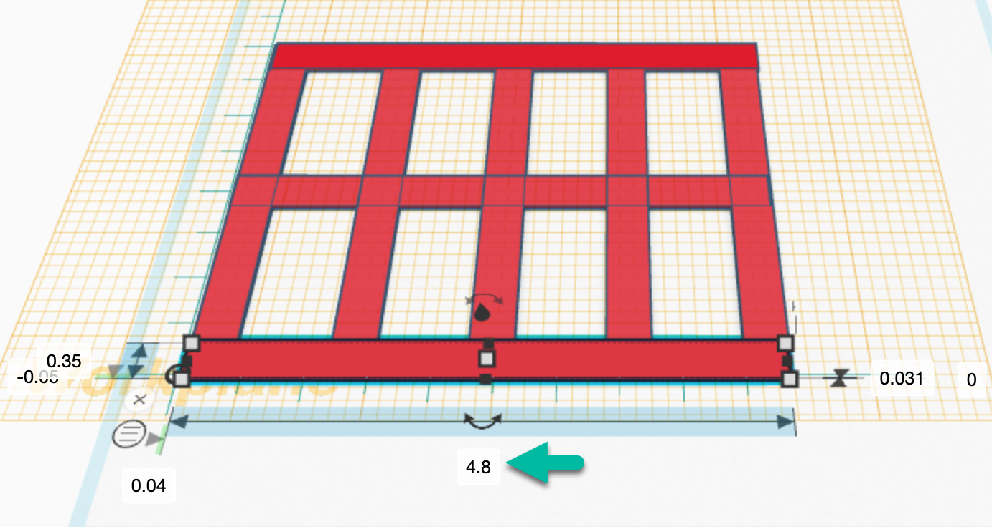
 |  | 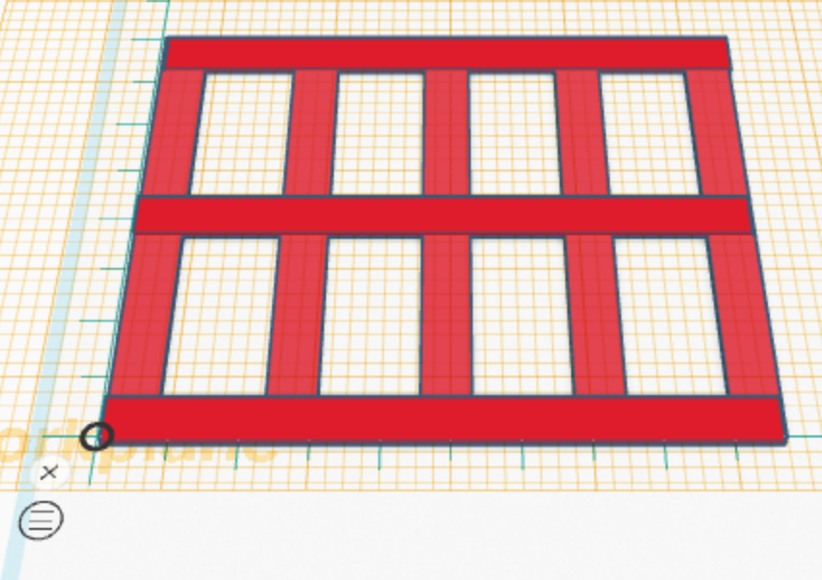
STEP 23 | Next, grab the Workplane tool and drag it onto the workspace to go back to workspace mode. | 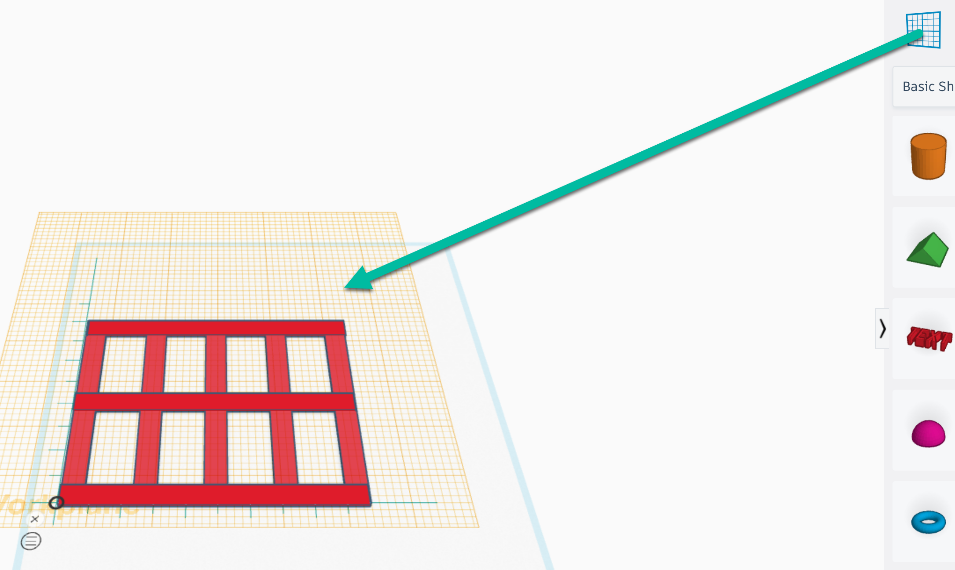
 |  | 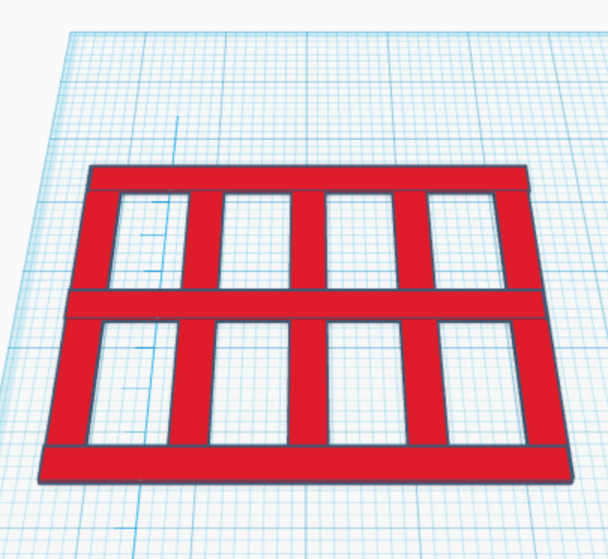
STEP 24 | Next, blocks will be added at the end of each stringer. Hover over and dismiss ruler by selecting the X next to the ruler O apex.
 | 1. Drag the Workplane tool onto a deckboard.  2. Drag a box onto the right front corner stringer  3. Adjust the values of the block to  .35" $∙$ .35" $∙$ .35 | 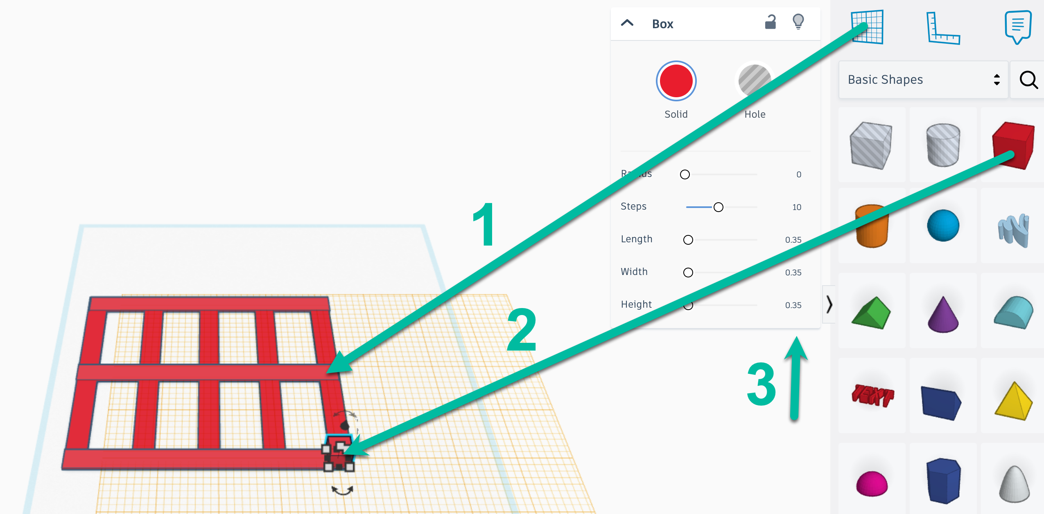
STEP 25 | Duplicate the front right corner and arrow the second block up to midspan.  Repeat for the top right block.  Duplicate the left blocks, experimenting with what order to duplicate. | 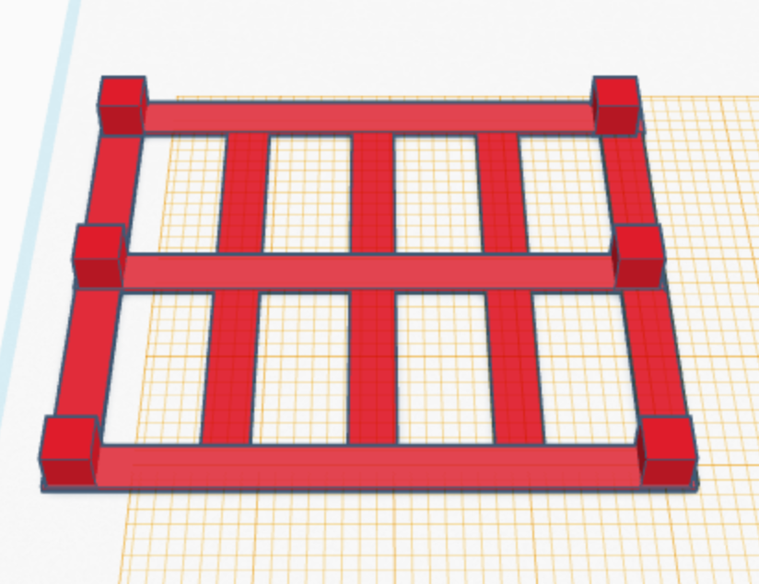
STEP 26 | Left of the workspace, toggle to flat view (bottom icon) and zoom in and out to position the blocks at the pallet edge.  If you want them to line up perfectly, in the workspace right corner, below Settings, change the Snap Grid menu to Off. | 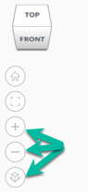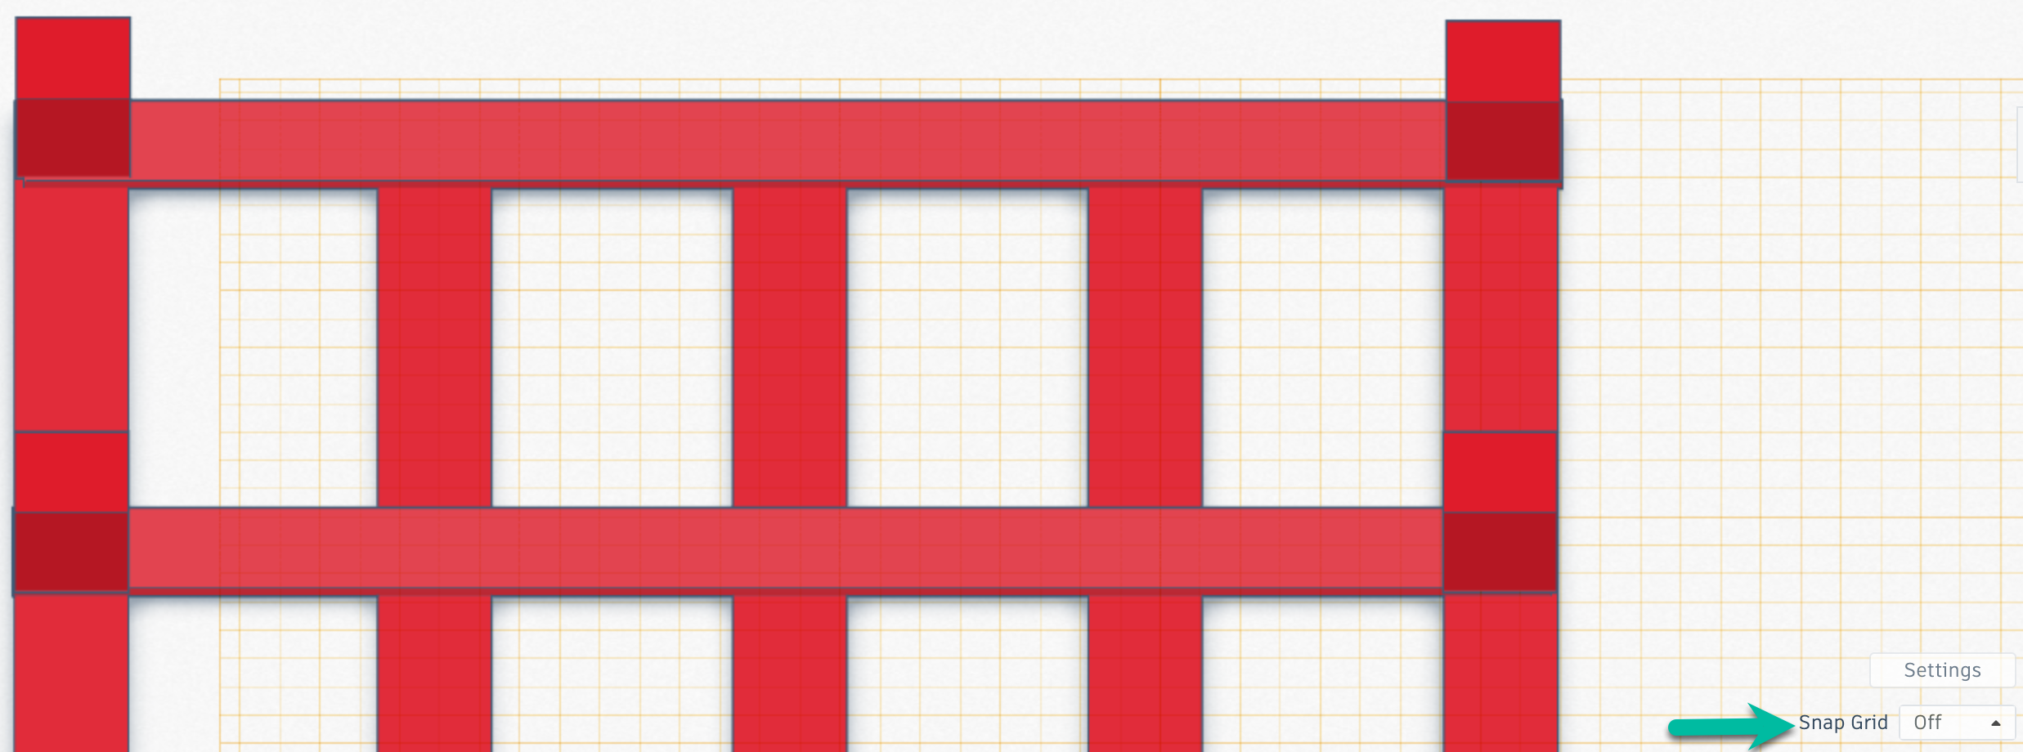
 | If you lose your place at some point, select the home icon. | 
STEP 27 | When you're satisfied with block placement, select each and key D.  Next, drag the Workplane tool onto the workspace. | 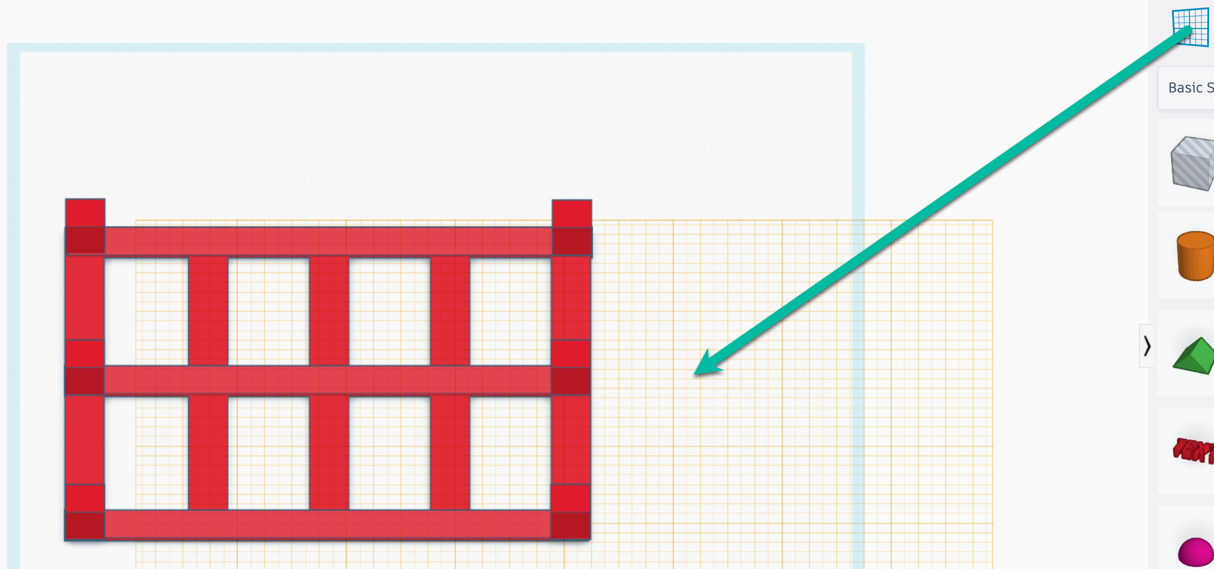
STEP 28 | Toggle flat to orthographic view. | 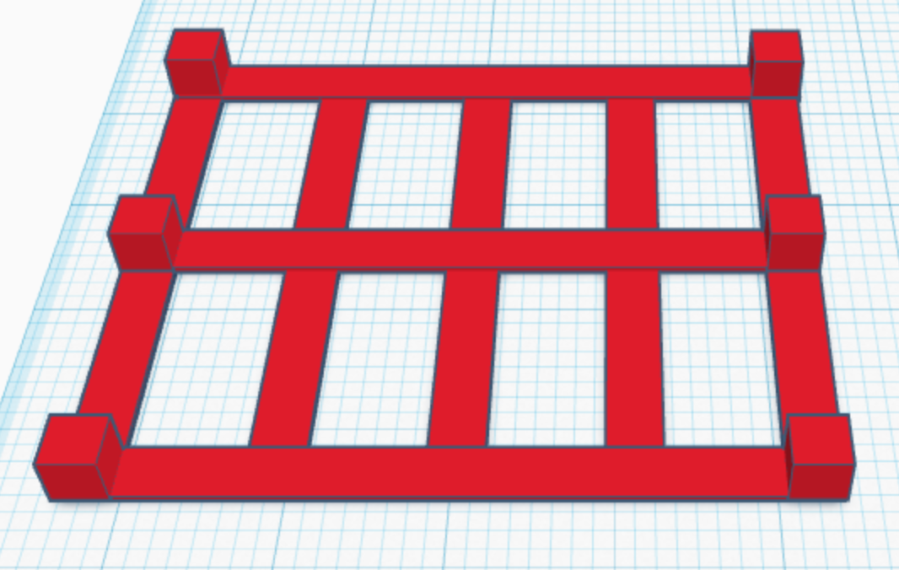
STEP 29 | Add three bottom deckboards over the blocks.  - Drag the Workplane tool to the top of one of the blocks  - Drag a box onto one of the blocks and size it to be a 4.8" x .35" x .031" bottom deckboard  - Rotate the bottom deckboard and position it on the blocks  - Duplicate for the other two deckboards  - Use Snap Grid, orthographic view, flat view, zoom in, and zoom out to detail placement  - D to secure the bottom deckboards  - Drag the Workplane tool onto the workspace | 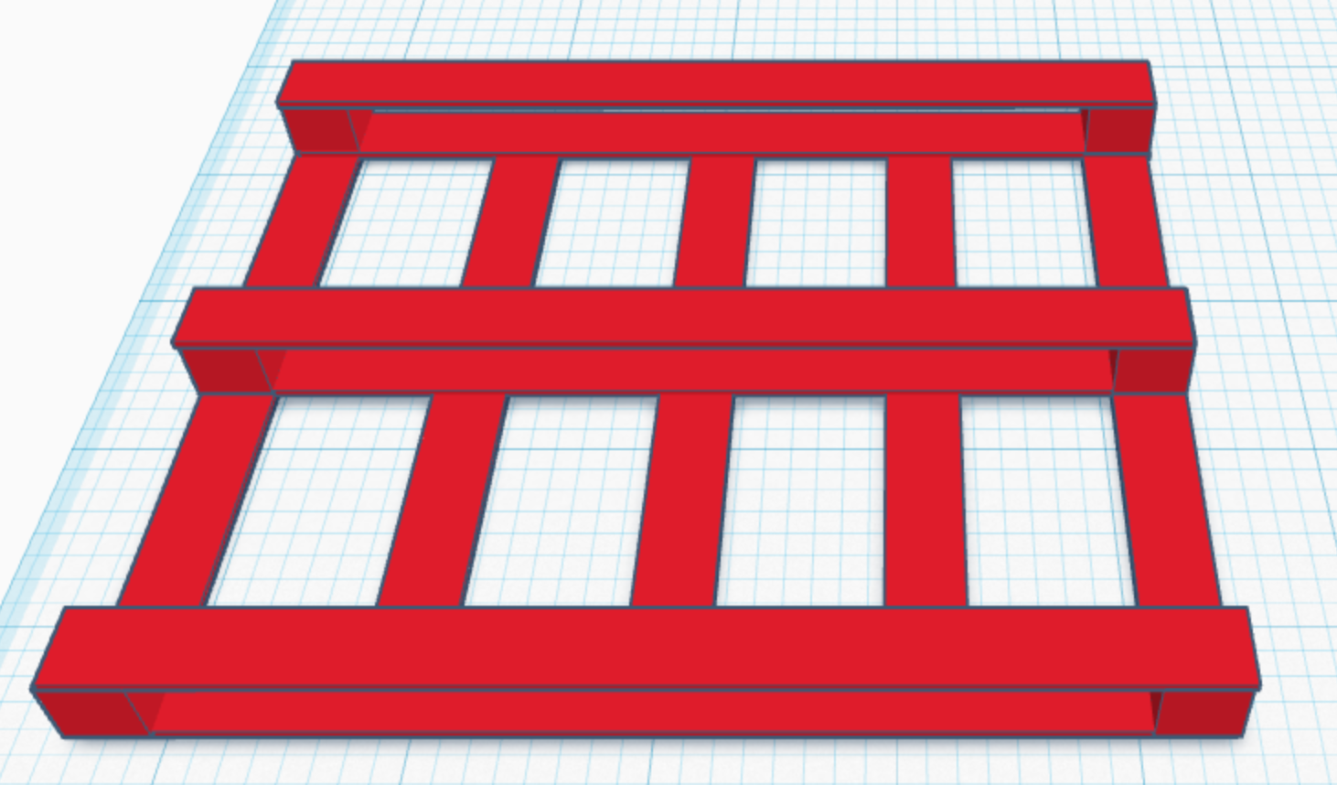
STEP 30 | Drag your mouse over the entire pallet, you will see blue lines highlight the selection.  Click on the Group button in the top right navigation. | 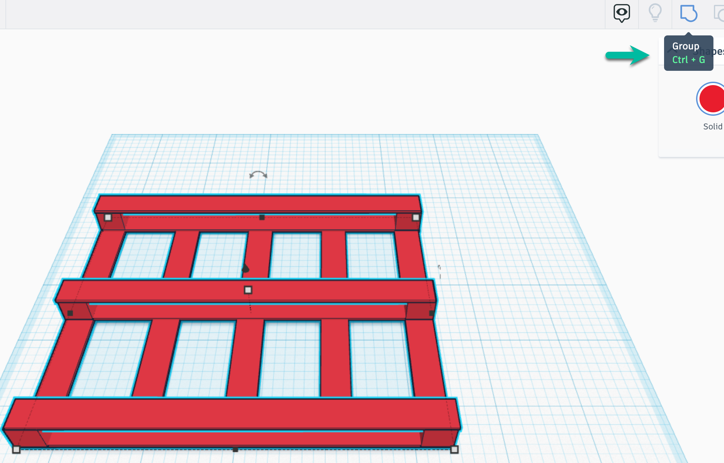
STEP 31 | Select the Red Solid color icon to change the pallet's color. All boards will change since you grouped them.  Pick one color or the Custom tab to create a color or select a hexadecimal value. | 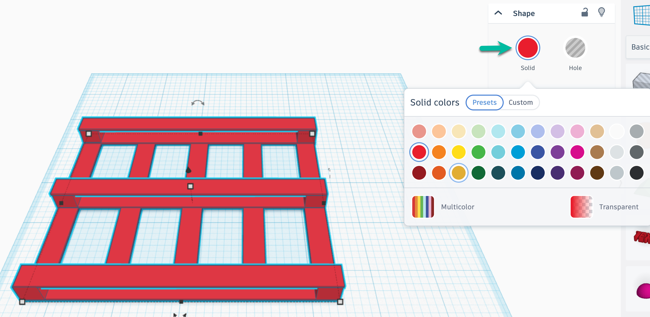
 |  | 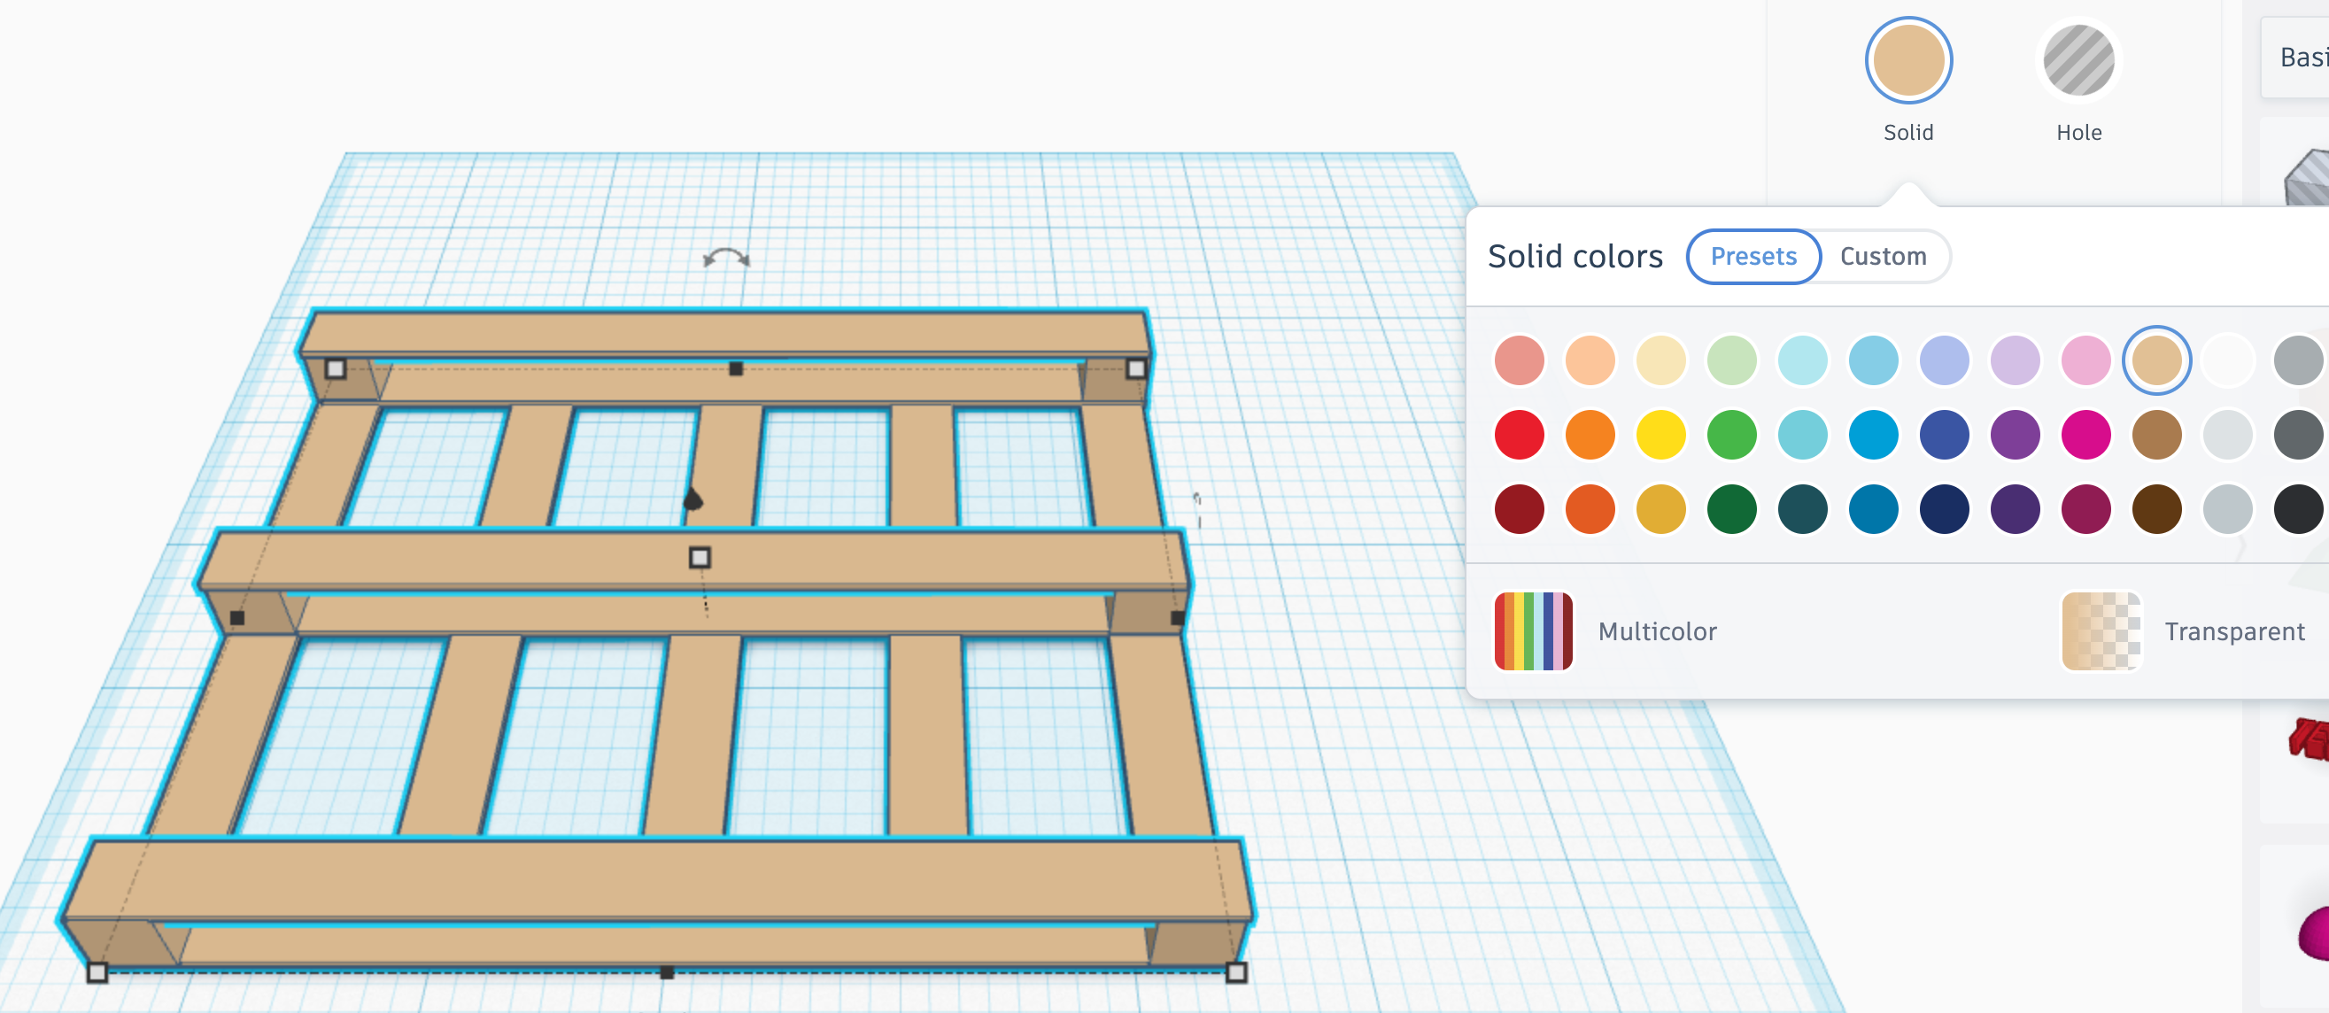
STEP 32 | Select the pallet and click on the double headed arrow to flip along that line.
 | 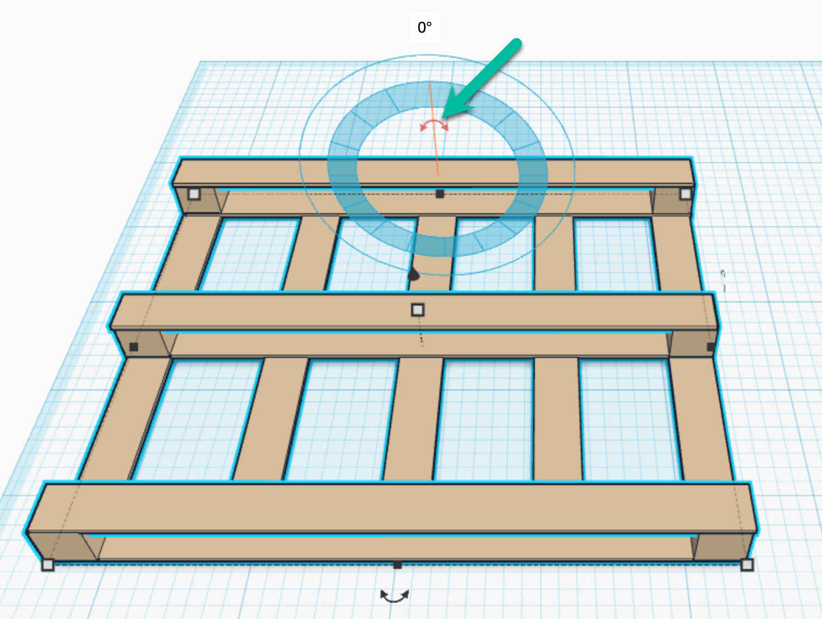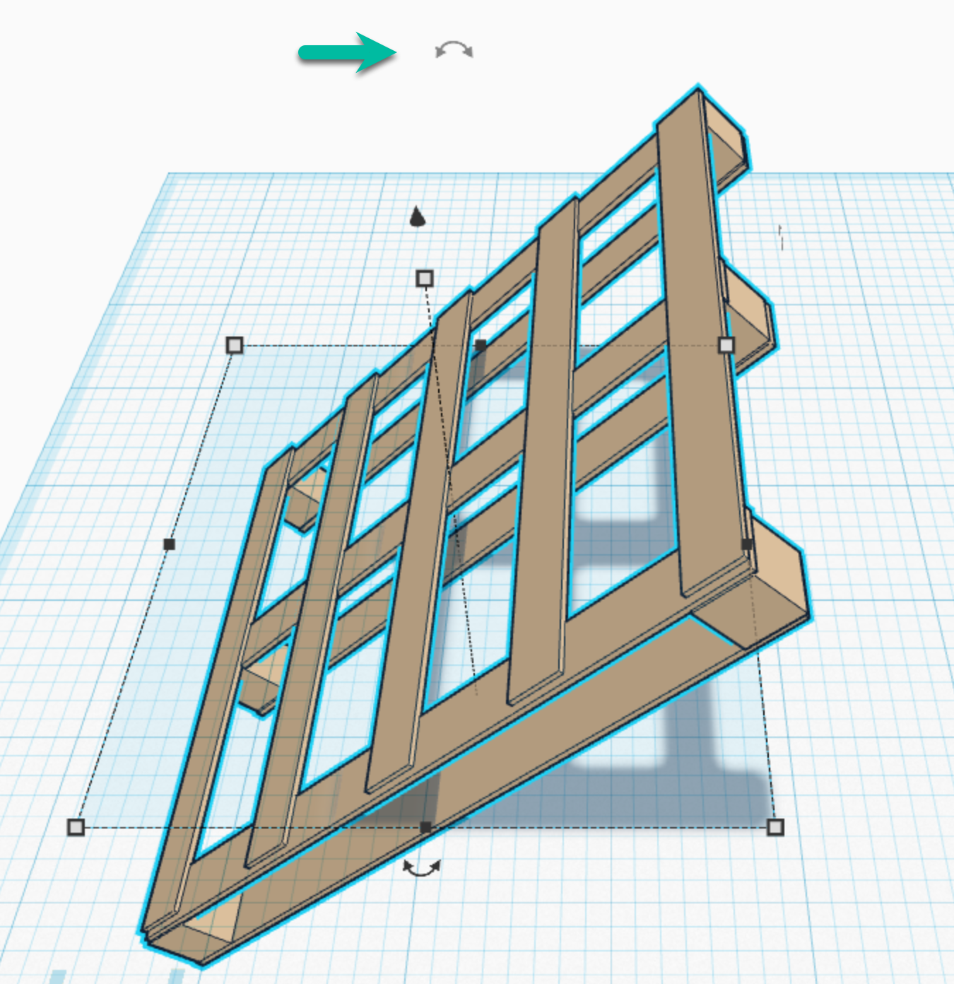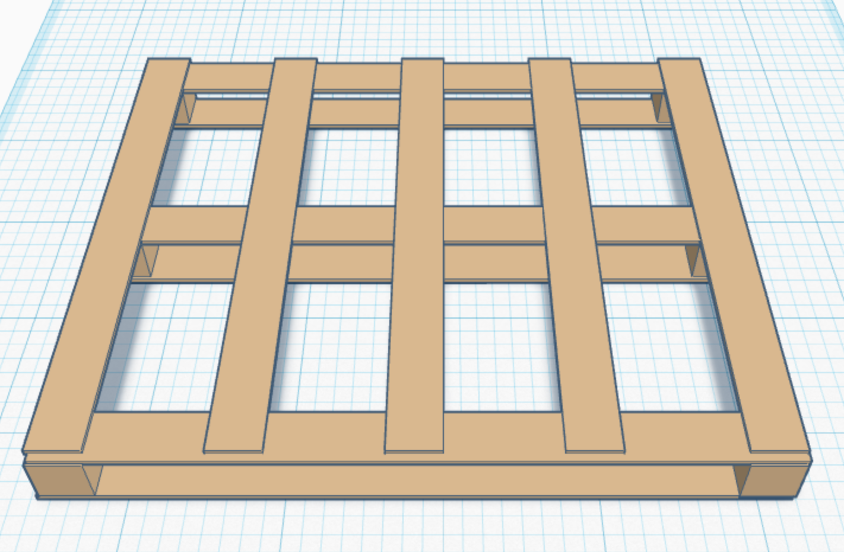
STEP 33 | To fine tune your pallet (the deckboards are 4' but sit a little short from the edge), select the pallet, and click on the ungroup icon. | 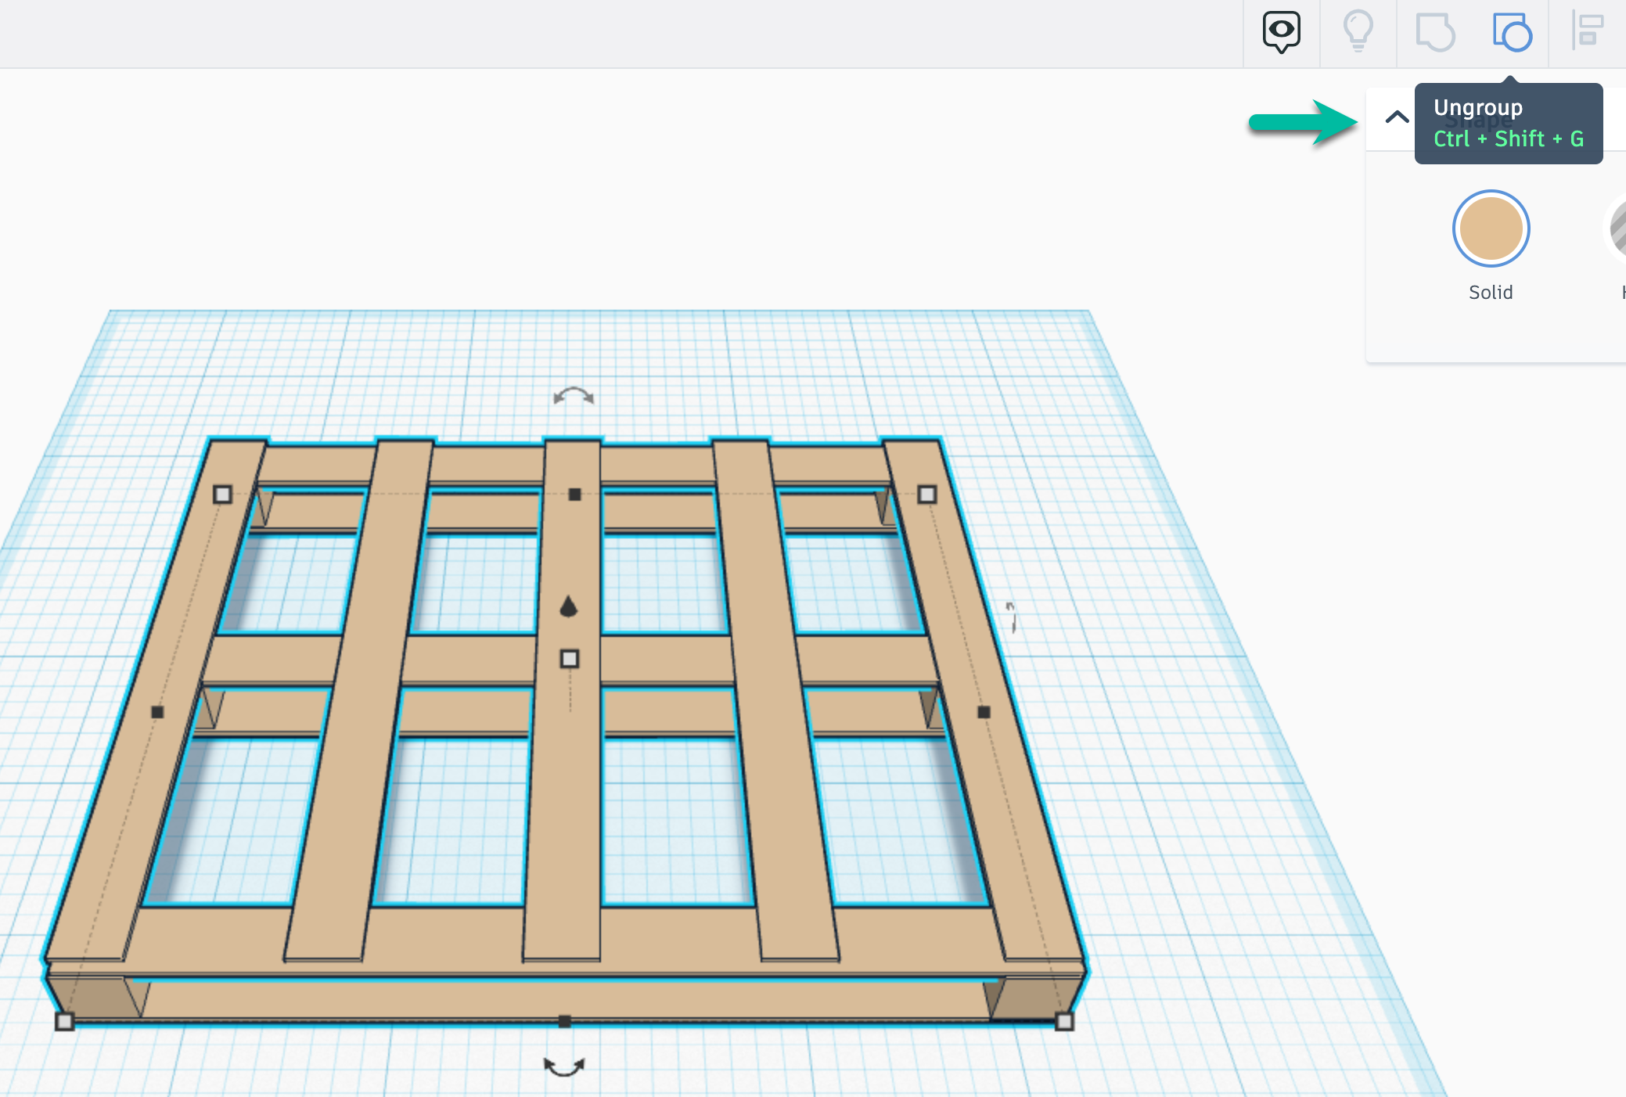
STEP 34 | Adjust your deckboards or any other portion of your pallet with your arrow key.  You may want to turn Snap Grid off if your arrow key snaps too short or long for your preferences.  Select FRONT to view the front of your pallet. | 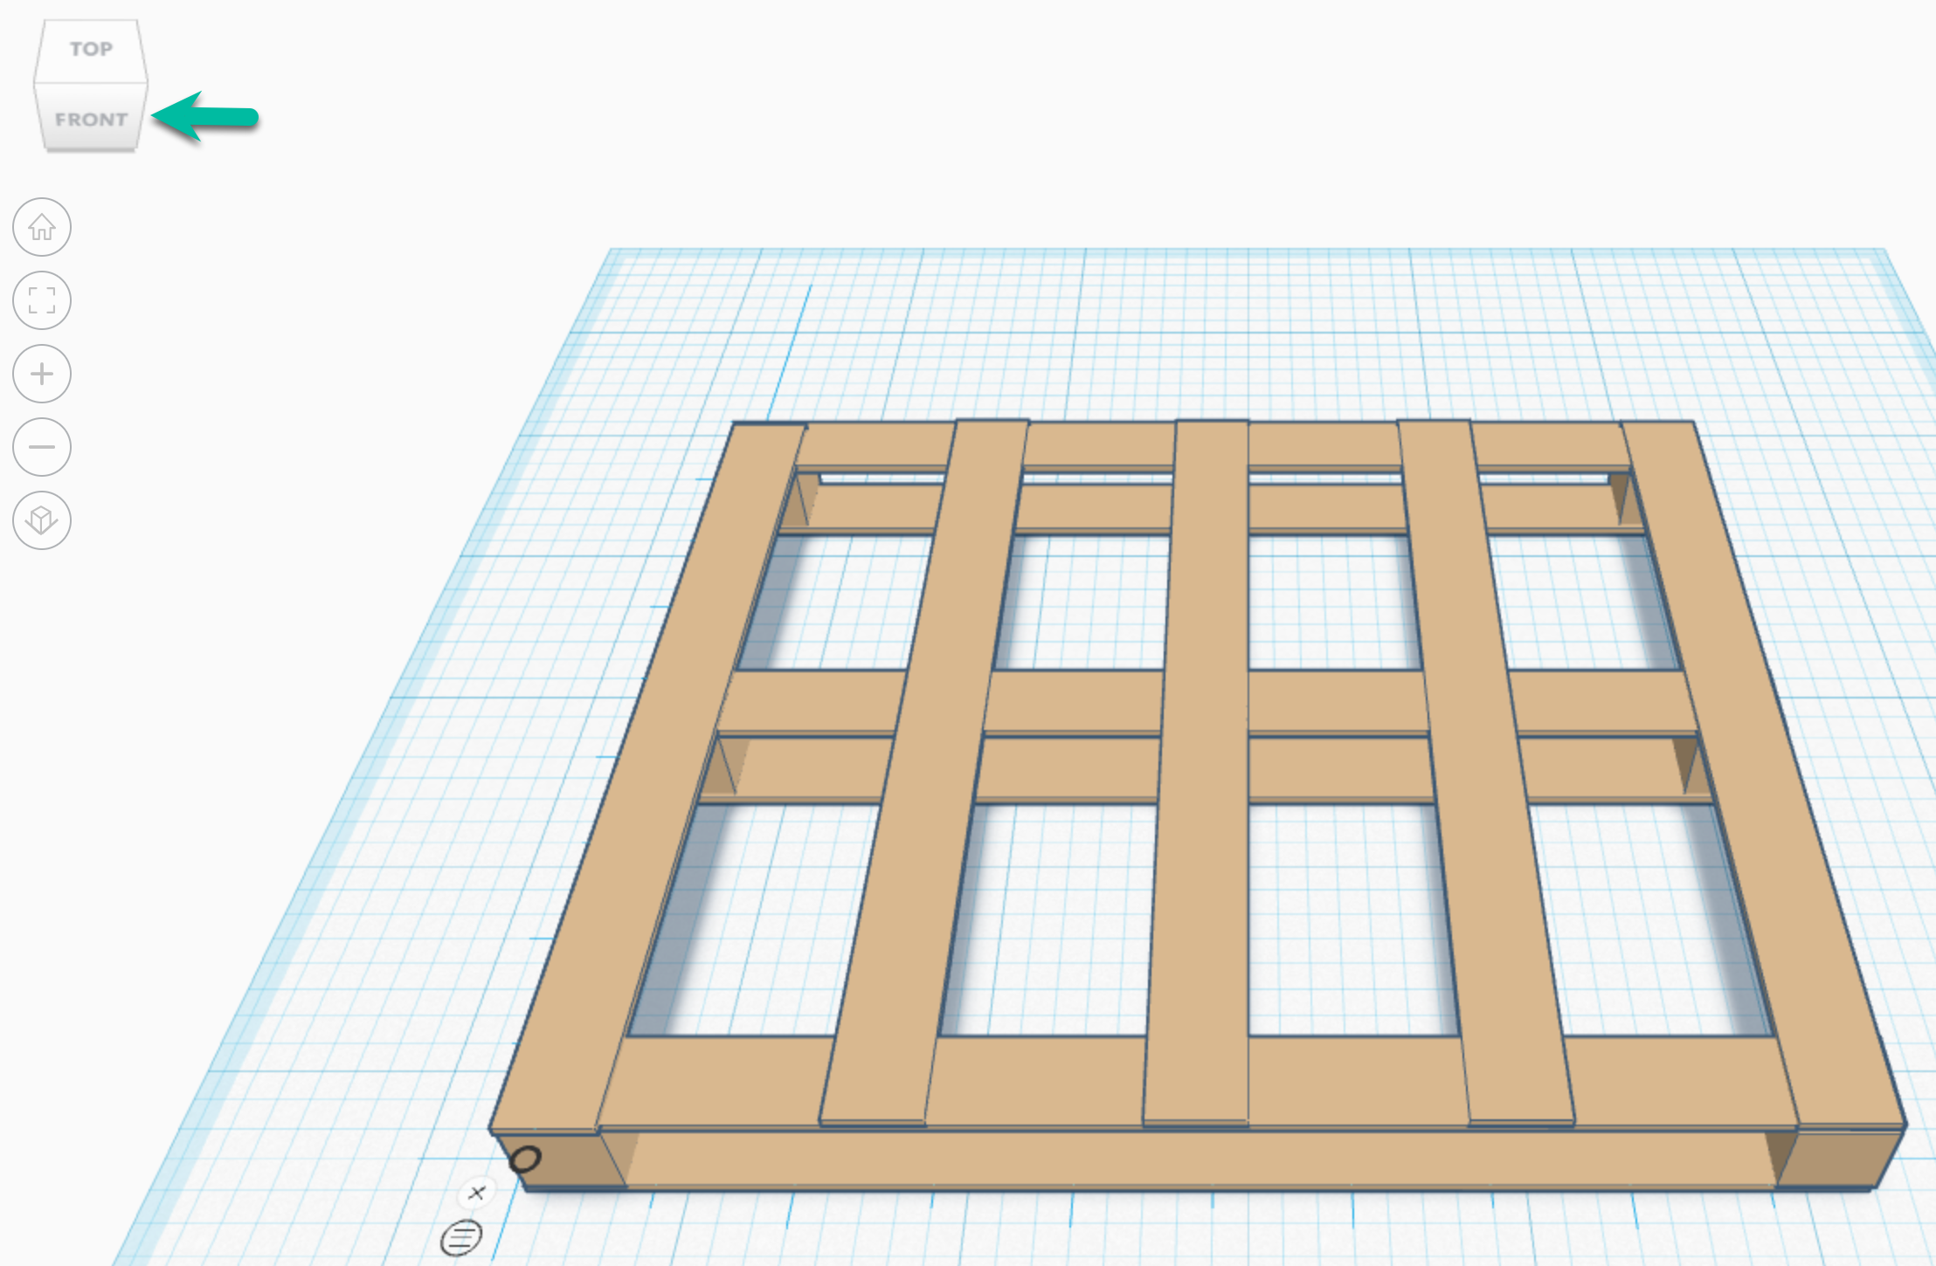
Your pallet represents how a simple geometric cube is essential to worldwide supply chains.

Earlier, you explored the priority to Maximize the Cube! Consider this:

Area (A)
Volume (V)
packing height
the measurement of the surface of the shape
the space occupied by an object
A typical standard pallet packing height is 48 inches (includes the height of the pallet + load)

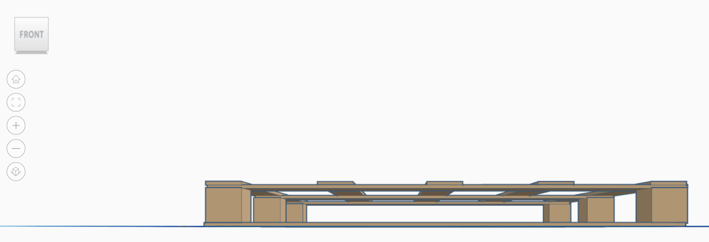

Your simplified pallet is made of

1 = .031"  2 = .031"  3 = .35"  4 = .031"  .443"  Reverse 1:10 = 4.43" |  | 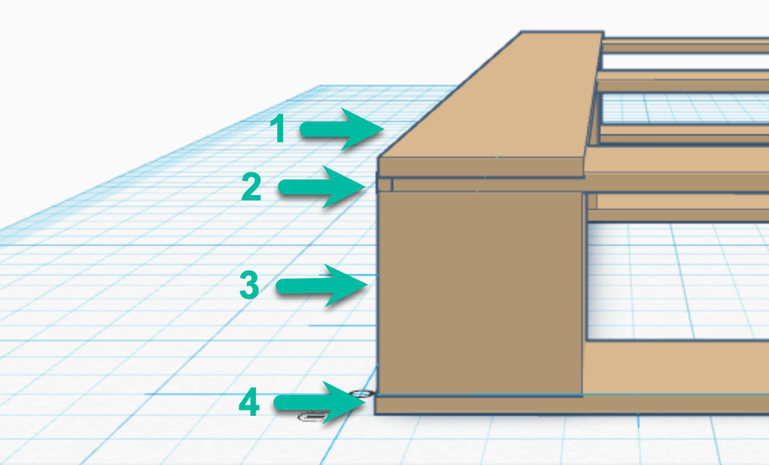

A standard pallet average height is close to 6", based on the thickness of each piece or additional pieces to add support for heavier loads.

STEP 35 | Select Top and each of the arrows to view your pallet from all angles.
TOP | SIDE
BOTTOM | FRONT

Since a standard pallet packing height is 48 inches (including the height of the pallet).

48" - pallet height 4.43" = 43.57"

The materials that will sit on your pallet can be 43.57" in height.

48" - pallet height 6" = 42"

The materials that sit on an average pallet can be 42" in height.

STEP 36 | Drag a Workplane to your pallet. | 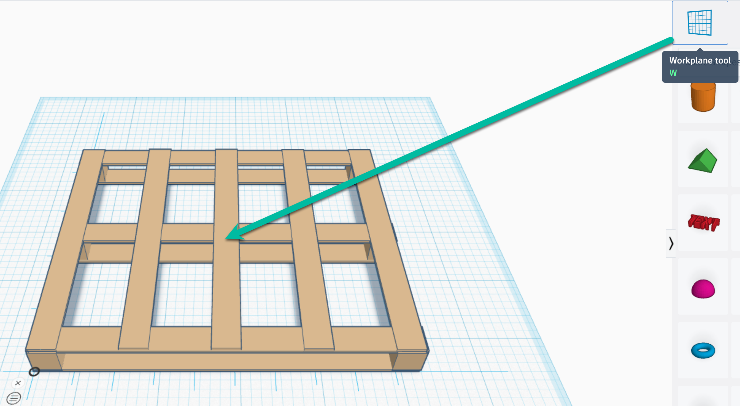
STEP 37 | Drag a box to your Workplane. | 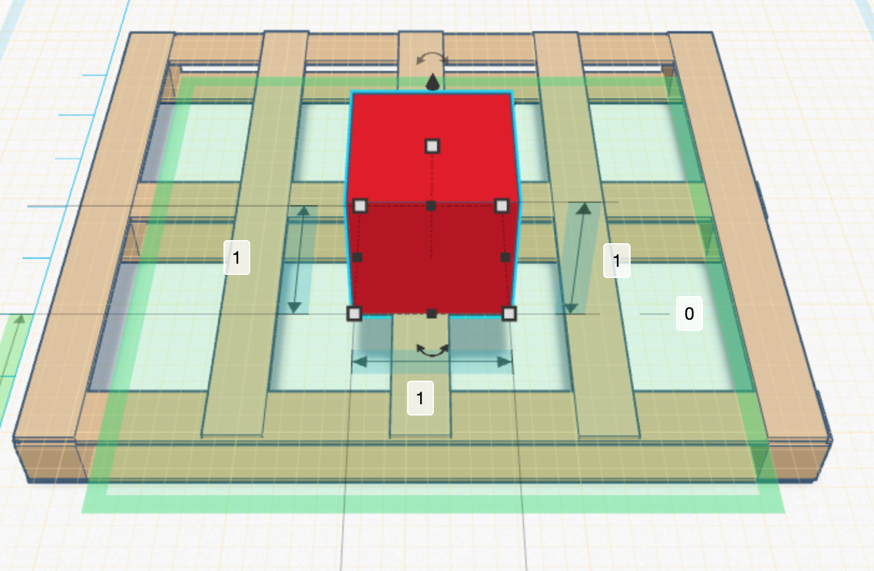
You already know a North American wooden block pallet measures 40" (width) x 48" (length). What is the largest size your box can be?
40" (width)
48" (length)
43.57" (height)

STEP 38 | Keeping your 1:10 ration in play (move one decimal place to the left), key in your dimensions. | 4.0" (width)  4.8" (length)  4.357" (height)

STEP 39 | Expand your box to fit the dimensions.
 | 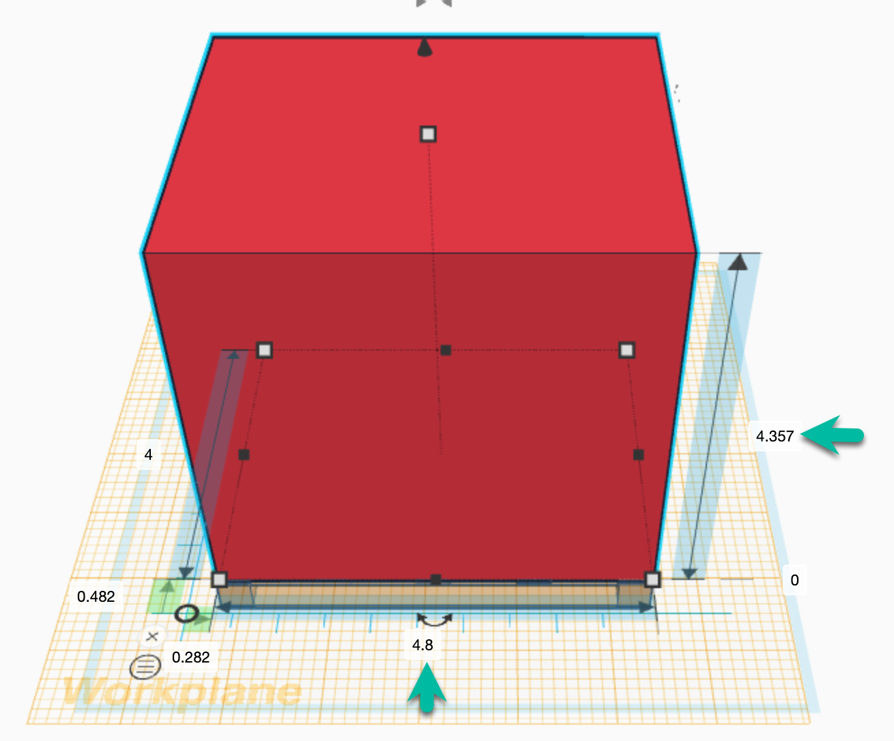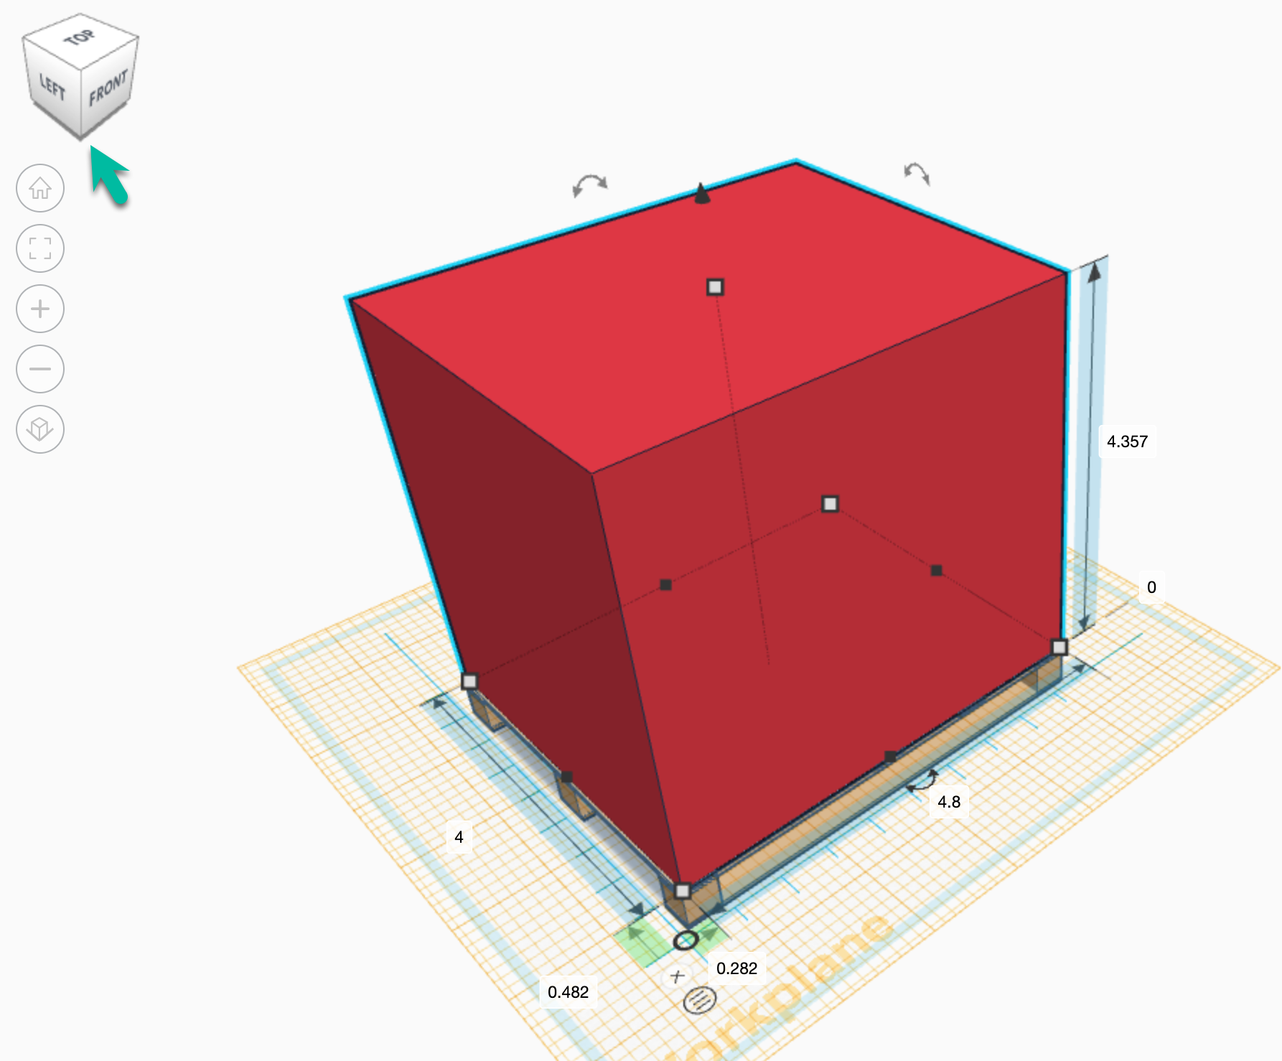
STEP 40 | Select side views and in between views to check on placement of the box on your pallet.  You may need to adjust the dimension boxes. | 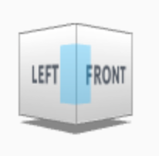

Terms

Staging, Storing, and Moving Pallets

Warehouse capacity refers to the available space for storing and organizing inventory, and filling orders. The physical capacity of a warehouse (the maximum number of pallets that can be stored vertically and horizontally at one time) is based on the weight and dimension of products, how much inventory is needed, and how much space the team needs to fill orders. Too much warehouse capacity and square footage are expensive (conditioned space) and tie up capital (money) when products sit on racks for weeks.

Understanding warehouse capacity is essential to optimizing the space. Considerations include:

Footprint square footage (ft²) or square metric footage (m²)
Space used for non-storage purposes
(loading area, picking, and packing workspace, offices, restrooms, etc.)

Storage space from the ground up (the maximum stack height),
including overhead objects (lights, racks)
Usable space = footprint square footage - non-storage square footage,
which is detailed below as Area (A).

Storage capacity = usable space in square feet $∙$ maximum stack height in feet,
which is described below as Volume (V).

Area (A)
Volume (V)
A = ( width $∙$ length )
V = ( width $∙$ length $∙$ height )
Area is the region within the sides or boundaries of an object
the space occupied by an object

You have two objects: pallet and box. Let's assume there are two available pallet sizes for your recommendation planning:

Example pallet 1 (your pallet)
Example pallet 2 (industry average pallet)
40" (width), 48" (length), 4.43" (height)
40" (width), 48" (length), 6" (height)

You need to know the area and volume of each loaded pallet. At first, the volume difference in pallet height of 6" - 4.43" seems small at 1.57". However, you'll assess whether the difference is small or large in a distribution warehouse with tens of thousands of pallets. You will use the pallets' geometric shapes, measures, and properties with their loads to describe objects and their role in effective distribution warehouse operations. Based on that information, you will apply concepts of density (in warehouse planning) based on area and volume for Builders USA recommendations.

Are you making the most of your available space?

To Maximize the Cube! you'll begin with calculating the area and volume of a cube. Before practicing with a formula, in the workplace you begin with industry data. Regardless of the height of example pallet 1 or 2, a standard loaded pallet measures 40" (width), 48" (length), 48" (height-pallet and load). 101.6cm x 121.92cm x 121.92cm.

Oh, wait! A cube is a solid shape with six square (equal) faces. Loaded pallets are not square, they are cuboid (who comes up with these names?). Cubes are a specific type of cuboid.

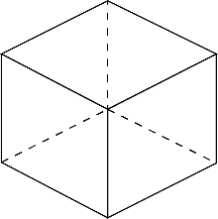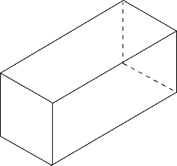
You know:

Calculating the area of a cube or a cuboid is width $∙$ length
Calculating the volume of a cube or a cuboid is width $∙$ length $∙$ height

In the case of a cube, since all sides are equal, a shortcut is

V = s³

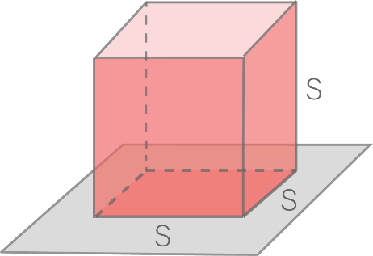

Volume of cube with side lengths s is V = s $∙$ s $∙$ s = s³

As you work with area and volume, your role is to consider how math will support your work with Builders USA. You begin with your assignment/goal to Maximize the Cube! at every decision level of warehouse planning and then resource mathematics to inform your efforts. At this point, the mantra Maximize the Cube! applies to loading pallets, trucks, racks, and warehouses. Although the warehouse efficiency addresses different object shapes, it's doubtful that Builders USA will change its mantra to Maximize the Cuboid!

To further question naming, cuboid volume is measured in cubic units (cubic feet or cubic meters). You'll assess volume, for Builders USA, as cubic feet.

V (volume) = W $∙$ L $∙$ H (width $∙$ length $∙$ height)

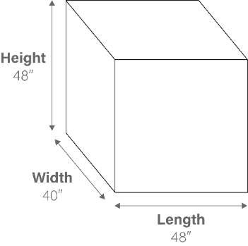
What is the area of a fully loaded pallet (both pallet and load)?

40" $∙$ 48" = 1,920 square inches
101.6cm $∙$ 121.92cm = 12,384.67 cm²

To convert square inches to square feet (ft²), divide:

1920/144 = 13.33 ft²
12,384.67/10,000 = 1.238m²

What is the volume of a fully loaded pallet (both pallet and load) in inches?

40" $∙$ 48" $∙$ 48" = 92,160"

a huge number because you're working with cubic inches.

To convert cubic inches to cubic feet, multiply by 0.0005787037 or divide by 1/1728 cubic feet (easier to remember).

Tip: Consider the order of where they keys are on a numeric keypad and think of a keyboard hack or shortcut. Mnemonics (the initial “m” is silent) are clues to help remember something, usually by associating the information with a visual image, sentence, or word. | 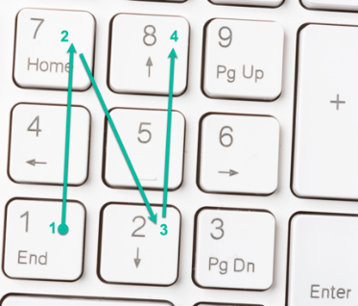

To convert cubic inches to cubic feet:

92,160/1728 = 53.333 ft³

What is the volume of a fully loaded pallet (both pallet and load) in metrics?

101.6cm $∙$ 121.92cm $∙$ 121.92cm = 1,511,347.45cm³

another huge number, reduced to m³.

1,511,347.45cm³/1,000,000 = 1.51m³

Your Turn

- What is the area of example pallet 1 (without its load)?

Example pallet 1 (your pallet): | ______________________________

- What is the volume of example pallet 1 (without its load)?

Example pallet 1 (your pallet): | ______________________________

- What is the area of example pallet 2 (without its load)?

Example pallet 2 (industry average pallet): | ______________________________

- What is the volume of example pallet 2 (without its load)?

Example pallet 2 (industry average pallet): | ______________________________

- Is there a difference, in ft² or in m² between the two example pallets? If not, why?

____________________________________________________________________

- What is the difference, in ft³ or in m³ between the two example pallets?

____________________________________________________________________

- What is the difference in ft³ or in m³ divided by the volume of example pallet 2 (difference/example pallet 2)?

____________________________________________________________________

- Convert the difference to a percentage (.xx = xx%).

____________________________________________________________________

Although sturdier pallets are essential for heavy loads, you can see the volume difference a simpler pallet contributes to Maximize the Cube! The percentage difference equates to that much more or less ft³ or m³ of product versus pallet.

Calculate the difference across warehouse contexts:

A container truck holds an average of 20-24 pallets.
20 pallets $∙$ the difference in ft³ or in m³ between the two example pallets = additional product per truckload.
____________________________________________________________________

Terms

Constraints

In a distribution warehouse, pallets, pallet jacks, forklifts, and articulated robotic arms are in constant motion. Floor space is expensive. You know about Builders USA Maximize the Cube! All the data you studied and the math you practiced inform your perspective.

Geometric constraints define relationships that force dependencies and limitations between entities. Think about the largest warehouses you have walked through, maybe Home Depot, Lowes, Costco, or others. Then, think about the safety of moving employees and customers among the racking systems while loading and unloading products. People, equipment, racks, and products are in a constant state of constraint defining relationships.

Geometric Constraint Solving is an approach for organizing shapes and objects in space using two-dimensional sketching and three-dimensional modeling.

You used Tinkercad to develop a three-dimensional model representing an object that serves as a model that informs questions of dimensions and constraints. Applying geometric methods to solve design problems begins with understanding shapes, objects, area, and volume. For Builders USA, this includes addressing warehouse physical constraints, planning and modeling to maximize warehouse efficiency, and minimize costs.

Physical Constraints
Maximize Efficiency
Minimizing Costs
Physical constraints include the equipment you modeled, OSHA and Builders USA safety compliance, and two warehouse flow configurations.
Maximize efficiency includes Maximize the Cube! at every level of operations from optimizing product on pallets to determining aisle width to configuring stacking pallets on racks.
Minimizing costs is often reached by addressing physical constraints and maximizing efficiency; simple, fast, and safe product movement in and out of the warehouse controls costs. If an expensive articulated robotic arm requires less area and allows for very narrow aisles, it may minimize overall costs.

Keeping your objects in mind, consider these additional distribution warehouse physical constraints that contribute to your assessment process.

1
Physical Constraints - types of warehouse aisles:

Conventional aisles
Narrow aisles
Very narrow aisles
Wide aisles that are typically 12'-13' (3.7-3.96m) wide and can accommodate a variety of equipment types. Standard aisles work best for standard pallets and forklifts.
Typically, 8'-10' (2.44-3.05m) wide and support reduced size equipment. Narrow aisles maximize space and increase storage (as much as 25% of warehouse space).
Typically, 6' wide or less and can increase floor space by 40-50%. Very narrow aisles are often designed for manual order picking where the operator travels horizontally and vertically along aisles.

2
Physical Constraints - equipment in warehouse aisles:

Pallet jack

Pallet jack minimum aisle width is 9'-11' (2.74-3.35m). Newer electric models may require only 4-5' (1.22-1.52m) of aisle space.

Forklift

Forklift minimum aisle width is calculated with a formula:

Right angle stack |  | Load length |  | Clearance |  | Pallet overhang
The operator drives a forklift down an aisle, turns at a right angle, places the forks under a pallet, lifts it up, backs out, and returns to driving down an aisle. The amount of space needed is called a right angle stack. |  | The length of the pallet (typically 48" | 1.22m). |  | Add 12" | .3m to the head and load lengths for maneuvering space, to turn and stack. |  | Add space for any additional overhang and an additional 6" | .15m for safety.

Articulated robotic arm

The space in which a robotic arm can move is called its work envelope. The size and shape of the work envelope is determined by the size of the robot and its degrees of freedom. Articulated robots are made of several interconnected links connected through joints designed to allow the robot to move with a high degree of freedom (DOF) that allows the robot to move in various directions. The two types of joints include revolute and prismatic.

Revolute joints
Prismatic joints
Revolute joints are rotary joints that allow rotation along an axis.
Prismatic joints are linear joints that allow movement in a straight line.

In distribution warehouses, robotic arms often load and unload boxes from racks, lift and sort items of varying shapes and sizes, and perform repetitive warehouse tasks. The needed aisle and floor space is determined by the motion of the robotic arm and the safety space between robots and humans working together. For example, picking, sorting, packaging, transporting, and restocking requires differing workflows and space needs.

Stacker cranes

Stacker cranes for pallets stack items in warehouses.

Increase high load capacity by reaching heights up to 131' (39.92m) operating in 5' (1.52m) aisles.
Vertical mast (single or double) that moves up and down the mast using a motorized drive system.
Uses a bottom rail track installed on a concrete slab along with an upper guide rail to stabilize the crane.

Automated stacker cranes
  - Are controlled by a computer system that directs movements and manages flow of materials.
  - Can move pallets up to 148' (45.11m) high operating in 5' (1.52m) aisles.
  - Use sensors and cameras to monitor inventory levels and optimize storage and retrieval.

Conveyor systems (five most common)

O-ring belt conveyor | Uses motors and sensors to control the movement of products. Ideal for packaging and low-cost option.
Belt conveyors | Provide grip for slight incline or decline. Suitable for small items and allow for repeatable positioning.
Heavy-duty conveyors | Move up to 793 pounds (approx. 359.73 kilos), depending on roller configuration, for large items without a pallet.
Heavy-duty pallet conveyors | Move up to 1,100 pounds (approx. 499 kilos), depending on pallet configuration.
Timing belt conveyors | Provide flexibility for larger products with options for multiple lengths and customization of spacing between belts.

Autonomous mobile robots (AMRs)

  - Uses include order picking operations, zone picking, goods-to-person, and autonomous piece picking or flexible sortation.
  - Pick-and-place AMRs use machine vision technology to identify, grab, and move objects from one location to another while avoiding obstacles.
  - Complements human workers; one human operator contributes to filling orders on several AMRs, reducing operator walking time.
  - Use maps to dynamically navigate through the warehouse, identifying and avoiding obstacles.

Task 1

Constraints

Importantly, constraints balance with opportunities. Constraints are not defined as "what won't work." Instead, they create awareness of challenges to address during the planning phase of projects.

You consider constraints when:
- thinking about traffic on a Friday afternoon versus a Saturday morning.
- accepting free shipping for an online purchase knowing your package will be slower to arrive than if paying for overnight shipping.
- ordering a pizza moments before a major sporting event starts on TV.

Considering constraints helps you to reconsider, reroute, and adapt.

Carrying a too heavy load is one of the leading causes of forklift accidents. Operators need to consider factors like lift height, load weight, and their forklift's condition.

Mass is the amount of matter an object contains.
Volume is how much space an object takes up.
Calculating the total mass, a forklift can carry begins with its rated capacity and net capacity.

Rated capacity is the recommended maximum weight listed on a forklift's data plate.

Net capacity (or payload capacity) is the actual weight a forklift can carry, considering its de-rated capacity (reduced weight allowed due to environmental challenges), mast type, and volume.

- What constraints do you see in the following images?
__________________________________________________________________________
__________________________________________________________________________

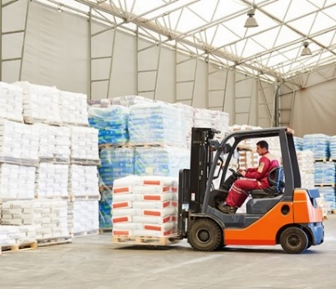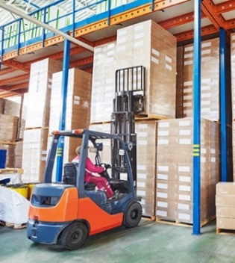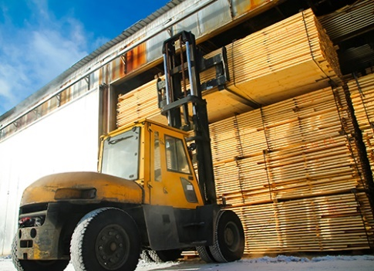

Articulated robotic arms attach to a solid surface (floor, table, etc.) with a floor-mounted or mobile pedestal. What constraints might an ARM pedestal add to warehouse workflow?
__________________________________________________________________________

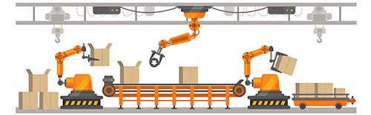

The five typical components of warehouse flow:

The Receiving Area | where incoming trucks are unloaded, product is received, and inventory is recorded.
Staging Area | when products are received, used to determine where they will be placed within the inventory warehouse system. Before product is shipped, the staging area prepares orders to be delivered to home centers.
The Shipping Area | holds completed orders and loads them onto trucks to be delivered to home centers.
Dynamic Storage | holds inventory that doesn't have a fixed warehouse location. These products are often in high demand and need to be available closer to packing areas.
Static Storage | holds inventory product that have a specific location in the warehouse. Products are usually organized on racking systems to stack and fit materials in the space provided.

The following diagrams show two common warehouse flow configurations:

I-Shaped Warehouse Flow  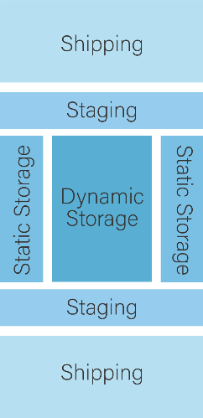 | U-Shaped Warehouse Flow  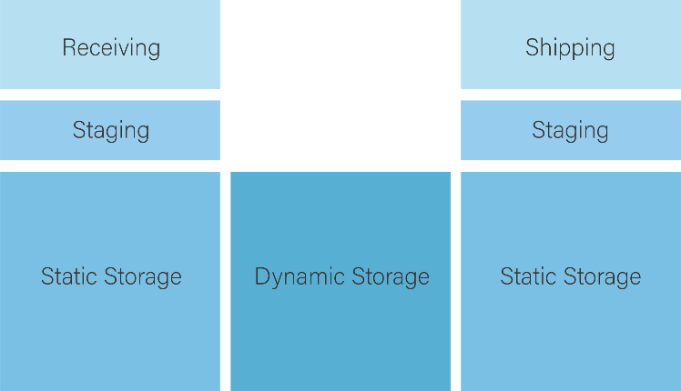

The warehouse flow configurations give you an idea of how loaded and unloaded pallet jacks, forklifts, and articulated robotic arms will move throughout the warehouse. Based on your Geometric Constraint Solving, organizing shapes and objects in space using two-dimensional sketching and three-dimensional modeling:
- What two examples of constraints or data regarding pallet jack operations should Builders USA consider with the two warehouse flow options?
__________________________________________________________________________
__________________________________________________________________________

- What two examples of constraints or data regarding forklift operations should Builders USA consider with the two warehouse flow options?
__________________________________________________________________________
__________________________________________________________________________

- What two examples of constraints or data regarding articulated robotic arm operations should Builders USA consider with the two warehouse flow options?
__________________________________________________________________________
__________________________________________________________________________
Based on physical constraints data provided:

- What example of constraints or data regarding stacker cranes and automated stacker crane operations should Builders USA consider with the two warehouse flow options?
__________________________________________________________________________
__________________________________________________________________________

- What example of constraints or data regarding conveyor systems or autonomous motor robots’ operations should Builders USA consider with the two warehouse flow options?
__________________________________________________________________________
__________________________________________________________________________

Task 2

Environmental Constraints

Business activity is constrained by the environment in which the business operates. Environmental constraints include physical or social conditions such as:

- Competitor actions.
- Legal requirement constraints.
- Social expectations and requirements (society
expects business to operate ethically) constraints.
- Economic constraints.
- Technology constraints.
- Natural resource constraints.

Researching and preparing the Builders USA use case informed the following environmental constraints:

Across the U.S., tens of thousands of acres of land in semi-rural neighborhoods, close to highways and airports but outside typically high-rent counties, have been purchased by investors looking to sell or build and lease new and massive commercial spaces to the world's biggest movers and producers of goods, including Target, Walmart, Tesla, Ikea, Boeing, Michelin, Nike, and John Deere, to name a few. Because of historic divisions by interstate in America, there is a greater likelihood of finding a warehouse in a neighborhood with more residents of color and a larger share of low-income residents than typical for the metro region nearby (Waddell).

In one neighborhood with two Amazon warehouses, residents contend with 6,000 daily vehicle trips, including more than 2,300 diesel truck trips. Residents and environmental groups joined several communities to voice health concerns—increased per capita asthma and lung disease rates and chronic nosebleeds—near industrial developments with emissions from cargo traffic. Some cities restricted new construction of industrial-use spaces, and groups challenged land-use decisions with lawsuits while urging California's governor to intervene (Torres).

The California Inland Empire's labor force has grown by 47.5% in the last 20 years, outpacing nearby counties and the state, which saw a 12.5% increase. The logistics sector employs more people in the two-county region than any other sector, at 17% of employed adults. At the same time, the Inland Empire tends to post relatively lower-paying jobs than surrounding counties and the nation on average. Declining housing affordability continues to hamper home buying for the 4.7 million people in the counties, with the share of households that can afford a median-priced home falling to 21% from 28% in Riverside County and to 30% from 39% in San Bernardino County in recent years ("Regional Briefing Book, December 2022").

The logistics industry's average hourly pay of about $20 per hour falls roughly $8 per hour short of the national rate for all occupations ("The U.S. Warehouse Capital Boomed During the Pandemic. Now It's Facing a Slowdown").

Builders USA considers livable wage jobs and socioeconomics as a mission priority. Environmental constraints data is essential to Builders USA's business activity and community acceptance. Data regarding pallets and racking differs from data regarding environmental traffic and socioeconomic hourly pay concerns; however, the success of the distribution warehouse relies on the entire ecosystem, from ships arriving at The Port of Long Beach to job and salary opportunities in the warehouse. Constraints, efficiency, and minimizing costs address success for all parties.

- What two environmental constraints do you consider essential for Builders USA to address with the community near the distribution warehouse site?
__________________________________________________________________________
__________________________________________________________________________
- How might you incorporate environmental constraints in considering Builders USA warehouse planning?
__________________________________________________________________________
__________________________________________________________________________

Milestone 3 Check-in

Critically assess and discuss the following Milestone 3 questions:

- How have shapes and objects, with their area and volume, informed your perspective on distribution warehouse planning?
__________________________________________________________________________
__________________________________________________________________________
__________________________________________________________________________

- How will objects built and workflow configurations introduced inform your recommendations to Builders USA?
__________________________________________________________________________
__________________________________________________________________________
__________________________________________________________________________

- What objects and configurations will support addressing physical constraints, maximizing efficiency, or minimizing cost?
__________________________________________________________________________
__________________________________________________________________________
- How can data regarding environmental constraints contribute to a successful Builders USA distribution warehouse buildout?
__________________________________________________________________________
__________________________________________________________________________
- What is the role of geometry and geometric constraint solving in supporting Builders USA planning priorities?
__________________________________________________________________________
__________________________________________________________________________

References

Collins, Jeff. “4.1 million-square-foot warehouse in California will be Amazon's biggest ever.” The Seattle Times, 5 June 2022, https://www.seattletimes.com/business/4-1-million-square-foot-warehouse-in-california-will-be-amazons-biggest-ever/. Accessed 18 April 2023.

Hagman, Curt. “The Inland Empire benefits from the warehouse industry.” San Bernardino Sun, 25 January 2023, https://www.pressenterprise.com/2023/01/25/the-inland-empire-benefits-from-our-warehouses/. Accessed 18 April 2023.

Jozsa, Evelyn. “U.S. National Industrial Report March 2023.” CommercialEdge, 28 March 2023, https://www.commercialedge.com/blog/national-industrial-report/. Accessed 18 April 2023.

Kaneko, Ann. “Warehouses Pave Over Historic Dairy Lands in Ontario and Chino.” KCET, 2 May 2022, https://www.kcet.org/shows/earth-focus/warehouses-pave-over-historic-dairy-lands-in-ontario-and-chino. Accessed 18 April 2023.

King, Kate. “Rapid Warehouse Growth Sparks Local Resident Backlash Across the U.S.” The Wall Street Journal, 28 March 2023, https://www.wsj.com/articles/rapid-warehouse-growth-sparks-local-resident-backlash-across-the-u-s-53502618. Accessed 18 April 2023.

Newton, Jim, and John Osborn. “Inland Empire warehouse fallout spans class, racial divides.” CalMatters, 23 February 2023, https://calmatters.org/commentary/2023/02/inland-empire-warehouse-class-divide/. Accessed 18 April 2023.

Olalde, Mark. “Environmental groups settle with World Logistics Center.” The Desert Sun, 30 April 2021, https://www.desertsun.com/story/news/environment/2021/04/30/environmental-groups-settle-world-logistics-center/4883449001/. Accessed 18 April 2023.
"Regional Briefing Book, December 2022.” Southern California Association of Governments, December 2022, https://scag.ca.gov/sites/main/files/file-attachments/briefing_book_2022_final.pdf?1669774904. Accessed 18 April 2023.

“South Ontario Logistics Center Specific Plan (PSP19-001 and PGPA19-004).” CEQAnet, 4 March 2022, https://ceqanet.opr.ca.gov/2021010318/5. Accessed 18 April 2023.

Torres, Ivette. “ISR Research Draft Report.” Earthjustice, April 2021, https://earthjustice.org/wp-content/uploads/warehouse_research_report_4.15.2021.pdf. Accessed 18 April 2023.

Saraiva, A., & Albright, A. "The U.S. Warehouse Capital Boomed During the Pandemic. Now It's Facing a Slowdown.” Supply Chain Brain,, 5 April 2023, https://www.supplychainbrain.com/articles/36950-the-us-warehouse-capital-boomed-during-the-pandemic-now-its-facing-a-slowdown. Accessed 18 April 2023.

Waddell, Kaveh. “When Amazon Expands, These Communities Pay the Price.” Consumer Reports, 9 December 2021, https://www.consumerreports.org/corporate-accountability/when-amazon-expands-these-communities-pay-the-price-a2554249208/. Accessed 18 April 2023.

